***Note:*** *The Proposal Template used in ECE 4011 and ECE 4012, senior design, is modeled on commercial business proposals and contains elements of R&D proposals. Real-world examples of engineering proposals are not available because of the proprietary nature of the information disclosed therein.* ***The Project Proposal should be submitted on T-square (Teamname_Proposal.pdf) as well as to your team’s faculty advisor and sponsor (if applicable).***

**Autonomous Inventory Tracking Using Robotic RFID Scanning**

ECE4011 Senior Design Project

Robotic RFID Scanner

Dr. Gregory Durgin

Calvin Burran, cburran@gatech.edu

Shelby Conway, [sconway32@gatech.edu](mailto:sconway32@gatech.edu)

Brandon Goddard, bgoddard6@gatech.edu

Josh Hoeft, jhoeft6@gatech.edu

Caleb Martinez, cmartinez38@gatech.edu

Yu Jun Qin, yqin70@gatech.edu

Dustin Snyder, dsnyder35@gatech.edu

Submitted

July 19, 2019

**Table of Contents**

**Executive Summary (5 pts)** ii

1. **Introduction (10 pts)** 1
   1. Objective xx
   2. Motivation xx
   3. Background xx
2. **Project Description and Goals (15 pts)** xx
3. **Technical Specification (15 pts)** xx
4. **Design Approach and Details (20 pts)**
   1. Design Approach xx
   2. Codes and Standards xx
   3. Constraints, Alternatives, and Tradeoffs xx
5. **Schedule, Tasks, and Milestones (10 pts)** xx
6. **Project Demonstration (5 pts)** xx
7. **Marketing and Cost Analysis (5 pts)** xx
   1. Marketing Analysis xx
   2. Cost Analysis xx
8. **Current Status (5 pts)** xx
9. **Leadership Roles (5 pts)**  xx
10. **References (5 pts)** xx

**Appendix A** xx

**Appendix B** xx

**Executive Summary**

Autonomous Inventory Tracking Using Robotic RFID Scanning (AITURRS) is a cross functional and scalable system that can locate assets autonomously. The robot will navigate an environment using computer vision and record the locations of the assets using Radio Frequency Identification (RFID). The scanner will be connected to a microcontroller which will process the current location information. An updated database will be maintained and show a list of the devices in each rack/location. The microcontroller will also control a motor that will move the system to the adjacent location, eventually scanning and updating the location information of the entire environment. Development of the prototype would cost $438.40 excluding wages with an ideal final market price of $3,299.00.  
 RFID technology is currently used in industry to locate and track assets. In many cases these assets are moved frequently, and the locations are often inaccurately recorded. This results in large write-offs, or shrink, and inefficient methods of manually locating assets are utilized to mitigate losses. An example of this particular issue can be observed in server labs. These labs contain hundreds of server racks filled with various devices, line-cards, and additional modular components. Up-to-date location information is important to both the engineers and supported clients in order to reduce the probability of lost data or hardware. Devices and components in the server racks can use RFID tags to identify them by serial number, but these must be manually tracked. The need for frequently updated location information can also be applied to warehouses that store products in different locations. Current technology uses RFID scanners at entry and exit points that show only if the device has entered or exited the building. This technology is limited by the fact that it does not indicate specific location of devices within the area.

**Autonomous Inventory Tracking Using Robotic RFID Scanning**

**1. Introduction**

AITURRS is a mobile robotic platform with an RFID scanner capable of self-navigating a warehouse and updating an inventory database. The team is requesting $438.40 to develop a prototype of the system.

* 1. **Objective**

The objective of AITURRS is to create a self-operating robot capable of maneuvering around an environment using the Pixy 2 vision sensor and associated object-tracking software. Using a mounted RFID scanner, the robot will read tags associated with individual assets, and determine the location and ID of the asset with a microcontroller. It will transmit that data wirelessly through the internet to an online database holding the location information of all items in inventory. To account for the various heights of the shelves, the RFID scanner will be mounted on an arm to provide vertical position adjustment.

* 1. **Motivation**

The main motivation of AITURRS is to provide easy access to accurate inventory information for large warehouses and laboratories. This is much more cost effective than the current system most warehouses use of manually scanning and tracking inventory where the warehouse may need to be shut down for a day [1]. By reducing the amount of time and manual labor that is necessary to track assets at a large scale, the team hopes to improve market prices of various services and products provided by these companies because AITURRS helps reduce costs at the distribution level of products.

* 1. **Background**

Autonomous robotics operating in warehouses is a relatively new technology. One of the current leading companies on solving warehouse logistics issues with autonomous robots is called Fetch Robotics [2]. Fetch Robotics offers several different autonomous robots that perform various warehouse case tasks that include material transport, platforms for research, and data collection in the form of an RFID scanning robot. Due to the nature of the product, there is no technical information on how this company conducted research and development for their robots; however, there is information located on their website that gives baseline information on how the RFID scanning robot works.

This specific RFID tracking robot is capable of scanning multiple RFID tagged items up to a 25 foot range, depending on the density of the products and other warehouse environmental factors. It contains three mounted powerful RFID scanners set at different angles for scanning products at different heights in the warehouse. The RFID scanners are powerful and accurate enough to pick up on all products in the aisle in one pass. The way the designers created this robot was to maximize efficiency of scanning, to provide real-time information on where inventory is in the warehouse, and to save human work hours for higher level tasks.

**2. Project Description and Goals**

The proposed design is an autonomous RFID scanning robot that can move around a space on its own and scan inventory items with RFID tags to be recorded in internal memory. The robot should be capable of following a line on the ground that will be detected by a camera that acts as the eyes of the robot. As the robot follows along this line, it will simultaneously detect RFID tags on either side of it that will be on shelves or other such containers. The finished product will be marketed to warehouses and laboratories to provide accurate and continuously updated inventory information. Project goals include the following:

**General**

* Robot that can operate autonomously based on location
* Target market value is $3,299.00

**Robot Capabilities**

* Line detection to control movement
* Transmit data to online database
* Arm with vertical movement to accurately scan shelves of different heights

**RFID Scanner**

* Detect tags to indicate when inventory is located
* Scan tags to procure pertinent information about the detected inventory
* Record data and send information about the inventory to Raspberry Pi

1. **Technical Specifications**

**TABLE 3.1** Specifications for RFID Scanner

|  |  |
| --- | --- |
| **Feature** | **Specification** |
| Bandwidth | 865-928 MHz |
| Transmit Power | +10 - +31.5 dBm |
| Max Receive Sensitivity | -84 dBm |
| Power Supply | 24Vdc/2.1A |

**TABLE 3.2** Specifications for Robotic Platform and Arm

|  |  |
| --- | --- |
| **Feature** | **Specification** |
| Robotic Arm Vertical Range of Motion | 2-5ft |
| Robotic Arm Repeatability | +/- 1.00mm |
| Battery Life | 4Hrs |
| Weight | < 30lbs |
| Dimensions(Length, Width, Height) | 0.5m x 0.3m x 1.2m |
| Power Supply | 24 V DC |

1. **Design Approach and Details**
   1. **Design Approach**

The robot will consist of an RFID reader, microcontroller, motor control system, and vision system. Figure 4.1.1 shows the block diagram of the entire system.

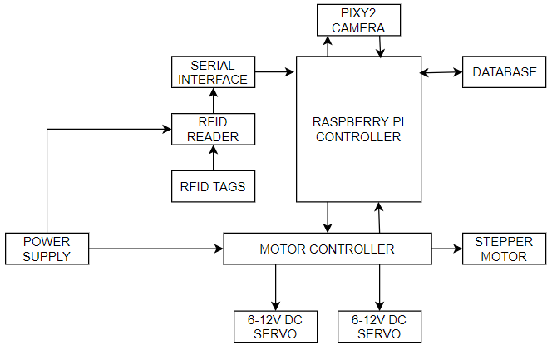

*Figure 4.1.1. Block diagram of the RFID robot system*

The RFID reader will be attached to a vertical arm. This arm will have a linear actuator capable of adjusting the elevation of the RFID reader. A motor controller will provide consistent 5V power to the Raspberry Pi microcontroller while providing variable current at higher voltages to the two DC servo motors and the stepper motor. The two DC motors drive the forward locomotion of the robot while the stepper motor is used to ensure accurate rise/descent of the RFID reader.

For movement control, the team has decided to use the Pixy 2 Camera. The Pixy 2 will allow the robot to track a dark line on a white background. The line tracking program also allows you to have barcodes to the right or left of the line to be used for locational landmarks to give position and turn commands. *Figure 4.1.2* shows a navigation path for the RFID robot.

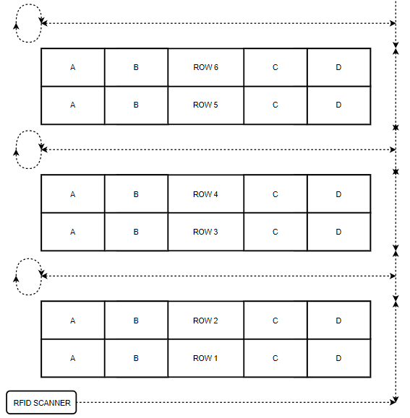

*Figure 4.1.2. Robot movement using Pixy 2 line-tracking*

The robot will use the data provided by the Pixy 2 camera to navigate through various environments. The movement pattern is to be determined to ensure every location is scanned by the RFID reader. In the environment shown in *Figure 4.1.2*, the robot would move along the line with the RFID reader mounted at 180 degrees, perpendicular to the robots motion. This allows for every location to be scanned and all assets to be located optimally. *Figure 4.1.3* depicts a possible row configuration for the environment layout depicted in *Figure 4.1.2*. Each row contains designated locations as well as individual assets.

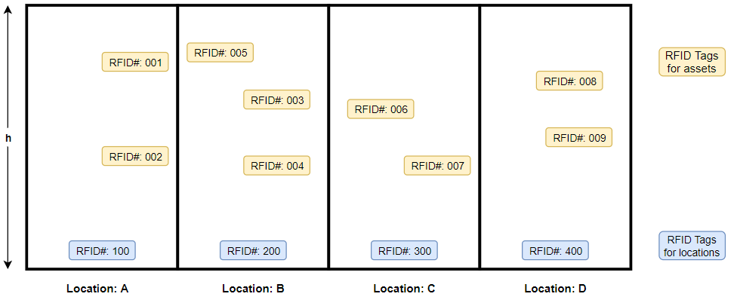

*Figure 4.1.3. Diagram of asset locations within a row*

The robot will navigate linearly along a theoretical row as shown in *Figure 4.1.3* and path the length of the row. Each asset contained in a location will have a passive RFID tag. In order to collect accurate data, the reader will need to be within read range of all tags. The desired read range for this design is currently estimated to be at least 3-5 feet. This prototype will be designed to read tags at multiple heights with a platform that accommodates varying actuator arm lengths. The vertical actuator will raise/lower the RFID reader the full height of the location to ensure all tags are within the read range. Table 4.1.1 depicts the desired output once the robot navigates along the row represented in *Figure 4.1.3.* The microcontroller software will aggregate the tag data obtained, dividing the asset tags hierarchically based on their respective locations.

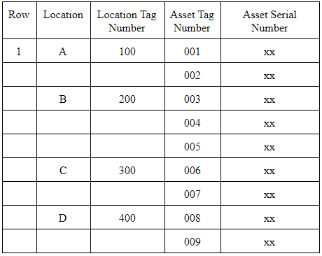

Table 4.1.1: Target output for the Robotic RFID reader after navigating *Figure 4.1.3*

Additional information can be stored in the database and associated with individual tags. This database will hold location data for all assets within the environment and update the locations if the assets are moved. It is important that all assets remain within read range of the robot.

The team’s critical path towards creating a prototype consists of scanner software development, locomotion software development, mounting the hardware components, testing software with hardware, and final device testing in test environment. *Figure 4.1.4* illustrates the key decisions and discoveries needed to integrate accurate location tracking with reliable movement.

*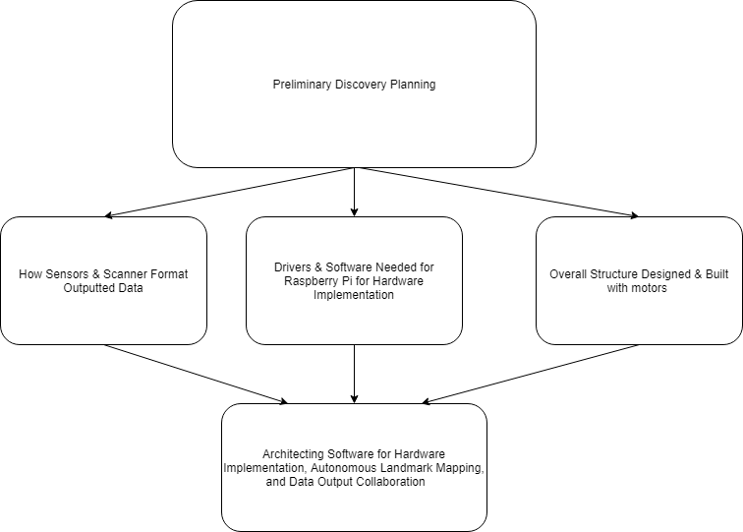Figure 4.1.4. Solution to Finishing Critical Path.*

An achievable read range will be determined after interrogation range testing. Optimal reader mount configuration will be determined based on these results. The team will integrate the motion control and reader software after data types have been confirmed and components finalized.

* 1. **Codes and Standards**

Radio Frequency (RF) is monitored by the FCC in Section 2.106 of the Commission’s Rules within the Table of Frequency Allocations [3]. An important restriction to consider is although Low Frequency (125–134.2 kHz and 140–148.5 kHz) and High Frequency (13.56 MHz) tags can be used globally without a license, any Ultra-High Frequency (865–928 MHz) tags could not because there is not yet just one global standard for this newer technology.

Another important standard to consider in the design of this project is IEEE 802.11 which is a popular wireless standard. It is part of the IEEE 802 set of LAN protocols for implementing Wi-Fi computer communications in various frequencies [4]. This 802.11 protocol ensures that equipment will listen to a channel for other users before transmitting by using the network multiple access method carrier-sense multiple access with collision avoidance.

The ISO approved the EPC Gen 2 Class 1 UHF standard as an amendment to its 18000-6 standard in 2006. This standard details parameters for sending and receiving data from UHF tags. This includes specifying frequencies and channels to be used for UHF as well as bandwidth and frequency hopping. The 6c amendment specifically targets item management using devices operating in the 860 MHz to 960 MHz range to help them share an interoperable interrogation and software infrastructure [5].

* 1. **Constraints, Alternatives, and Tradeoffs**

One significant constraint for this project is the power. Since it’s beyond the scope of the project to develop a new power supply, the design will have to rely on commercially available options. It may be difficult finding batteries with sufficient energy capacity while being small enough and light enough as to not impede movement.

A second constraint is the locomotion of the device. Since the robot is intended for use in warehouses, a low turn radius may be desired. This is an issue for wheeled locomotion, especially for an Ackermann steering configuration. If a form of skid steering is implemented, slippage could arise as an issue.

Finally the RFID scanner itself exhibit constraints. RFID scanners are inherently limited in their read distance and read angle, and working outside of those ranges will significantly impact accuracy.

The first major trade-off our team has considered is the use of a ultra-high frequency (UHF) scanner. This UHF can be more easily interfered with, but typically has longer read range and faster data read rate. UHF is also a newer technology and therefore would cause the cost of developing our project to increase.

Another trade-off is the power source type of the RFID tags, of which the team has chosen passively powered tags. Passively powered tags are powered by the radiated electromagnetic waves sent from the reader, while actively powered tags have an external power source (such as a battery). Passively powered tags are less expensive, but must be close enough to the reader to maintain a sufficient power density incident on the tag.

1. **Schedule, Tasks, and Milestones**

The GANTT Chart in Appendix A shows the tasks that must be completed. The schedule for the tasks is shown as well. Each task has been allotted a number of days to be completed based on estimated difficulty.

Those tasks in the critical path, indicated with red arrows in the PERT Chart in Appendix B, are the riskiest because they rely on the most tasks to be completed before they can be started. Therefore, they are placed on the critical path to indicate that they will take longer than all the other steps of the project.

1. **Project Demonstration**

Prototype testing will be done throughout the design process by carrying out measurements and trials under varying RF and mechanical circumstances. An important aspect in our design process is the interaction between our RFID scanner and compatible tags that have to be scanned from a moving robot. Prototypes will be developed by testing various RF interrogation ranges, reading speeds, tag collisions, optimal scanning orientations and heights, and other interference factors from the environment. Regarding the robot itself, the locomotive system will be tested against its tracking system (Pixy 2 camera) and the power constraints of elevating the scanner.

The final project will be demonstrated by having the robot follow a general path in front of a series of containers. The objects within the containers will have an assortment of sizes and will be placed next to one another to fill the container. Each object will have its own corresponding RFID tag attached, and the robot will then be set to autonomously navigate and scan across the containers. This will consist of correctly operating DC motors, navigation, mechanical weight distribution, and elevation capabilities of the RFID scanner. Once the scanning phase is complete, the robot will enter a resting (or rescan) phase and the database containing the order of the objects will be correctly updated. This will signify an accurate RFID reader and correct data transfer between our microcontroller and another network accessible computer. The general methodology and process of the overall system will be further verified by randomly rearranging the objects within the containers and initiating a scan by the robot to update the database accordingly.

1. **Marketing and Cost Analysis**
   1. **Marketing Analysis**

The target market consists primarily of warehouses and laboratories that need to keep track of large inventories. However, the idea could be scaled down to be used at other community buildings such as libraries, supermarkets, etc. The number of warehouses currently in business in the U.S is difficult to get an accurate estimate on, but it has been reported by Armstrong & Associates that the warehouse industry in the United States is valued at an estimated $40.5 billion for 2017 [6]. This implies that there is capital to invest into new technologies to improve the efficiency of these facilities. The primary objective from this initial round of marketing would be to recover the capital used to produce the product and then generate a modest profit to encourage future development and the addition of new features.

* 1. **Cost Analysis**

Table 7.2.1 Component Costs for Prototype

|  |  |
| --- | --- |
| Part | Cost |
| Raspberry Pi 4 | $118.90 |
| Pixy Camera | $60.00 |
| Motor Driver | $25.00 |
| Stepper Motor | $70.00 |
| Chassis | $35.00 |
| Erector Set | $25.00 |
| Battery | $104.50 |
| **Total** | **$438.40** |

Table 7.2.2 Time Spent per Engineer

|  |  |
| --- | --- |
| Task | Hours |
| Weekly Meetings | 30 |
| Reports | 20 |
| Research | 15 |
| Presentations | 4 |
| Fabrication | 30 |
| Assembly | 10 |
| Testing | 10 |
| **Total** | **119** |

Table 7.2.3 Cost per Engineer

|  |  |  |  |
| --- | --- | --- | --- |
| Salary | Hours | # of team members | Total Cost |
| $65,000 | 119 | 6 | $22,312.50 |

The following assumes that the initial development above is completed and factored in. Further assume that the only labor required for scale manufacturing is assembly and testing (10 hours combined) at a laborers wage of $15/hr with overhead factored in at roughly 3 times the hourly wage based on an arbitrary model. A team of sales representatives will also need to be hired part time to sell the product, and the team will assume they will work 20 hours/week at $18/hr (also factoring in 3 times salary to account for overhead). A reach goal is set at 1000 units sold over the course of 5 years. So the total cost of the manufactured units plus the development cost and labor:

$22,312.50 + 10 hours*$43.00 dollars/hr*1000 units + 2reps* 20 hours/week*54 dollars/hr*50 weeks*5 years + $438.40 dollars/unit*1000 units = $1,430,712.50

To perform the amortization over 5 years, it is assumed that the investment is raised in a venture stage received as a loan with 6% interest. In the end, the goal is to either repeat the process over the next 5 years, or generate enough profit to grow the company and research new features.

$\frac{\frac{0.06}{250}(1+\frac{0.06}{250}){}^{1000}}{(1+\frac{0.06}{250}){}^{1000}-1}*\$1,430,712.50 = \$1,609.42$

The above calculates what each robot must be sold at assuming 250 robots are sold per year over the course of 5 years at 6% yearly interest rate on the loan.

If the team wants to make double what the robot costs as profit for future investment ventures, the future value of this capital raised through robot sales assuming the team is selling each robot for $3,299.00 where i is normal inflation of ~2%:

$\frac{(1+\frac{0.02}{250}){}^{1000}-1}{\frac{0.02}{250}}*\$3,299.00 = \$2,497,466.99$

This cost puts the product at an extreme advantage over competitors as it is still an early market, and this design would be sold for almost a tenth of what the current accepted product for warehouses is.

1. **Current Status**

As the budget has not been approved yet for the project, progress thus far has been slow. However, some initial groundwork has been laid for future developments.

**General**

* Jira setup for internal task breakdown and sprint management
* Bitbucket setup for code collaboration
* Gantt chart for timing of deliverables
* Fall semester roles assigned

**Raspberry Pi**

* Pixy 2 general line tracking capabilities demo
* Servo motor moved off of pin call

**RF Technology**

* Scanner secured from Dr. Durgin
* RF Lab access granted for testing scanner capabilities

1. **Leadership Roles**

The leadership roles for ECE4011 are split as follows:

-Shelby serves the role of Documentation Coordinator for this semester. As Documentation Coordinator, she keeps track of group assignments and which parts each team member is responsible for individually.

-Brandon as RFID Technology Reference Lead shares the information from and serves as a sounding board for ideas about the various potential trade offs for the different types of RFID technology.

-Caleb as Software Team Lead coordinates the programming efforts of the team as well as setting up the bitbucket and Sourcetree that the team can use to collaborate on the code as well as see the work that other team members have done.

-Dustin as Design and Testing Lead organizes the team suggestions for different potential design ideas as well as the optimal environment for testing different aspects of the project.

-Jun as Webmaster coordinates the efforts for documenting the progress of the team and project on the team website.

-Calvin as Version Control/Agile Planning) organizes the team with Sprint planning through Jira. Calvin also serves as Advisor Interface this semester asking Dr. Durgin about any questions or concerns the team deals with during the planning stages of the project.

-Josh as Hardware Team Lead conducts research into the best and most cost effective hardware options for the prototyping of the project.

The leadership roles for ECE4012 are as follows:

-Shelby will serve as the Documentation Coordinator again this semester coordinating and organizing the individual and group documentation of various stages of the project. Shelby will also take over the role of Advisor Interface this semester to facilitate asking questions to Dr. Durgin as she will be in an Electromagnetics Applications class with him as well in the Fall.

-Brandon will take on the role of Web/Communications Coordinator. His job is to ensure that the pieces of the project will work together across the different areas as well as organizing the efforts in the data being uploaded from the Raspberry Pi to the website.

-Caleb will serve as Lead Software Developer during 4012. In this position, he will lead the efforts in ensuring all the code works as well as assigning different portions of the programming to different team members.

-Dustin will serve as EXPO Coordinator this semester. In this role, he will ensure all necessary parts for the EXPO presentation are prepared as well as conduct final inspection of all the pieces of the project. He will also help to prepare the team for any questions that may be asked at EXPO.

-Jun will serve as Webmaster again this semester by coordinating the efforts for documenting the progress of the team and project on the team website.

-Calvin will serve as RF Testing and Integration Lead this semester. He will designate different tests that need to be completed to understand the capabilities of the RF scanner as well as help to answer questions about the technology.

-Josh unfortunately will not be on the team in the Fall due to an internship in Louisiana. Good luck Josh!

1. **References**

[1] AccountingTools, “Inventory count procedure”. [Online]. Available: <https://www.accountingtools.com/articles/2017/5/16/inventory-count-procedure> [Accessed July 19, 2019

[2] Fetch Robotics, “RFID Tracking Transformed: TagSurveyor from Fetch Robotics”. [Online]. Available: <https://fetchrobotics.com/products-technology/datasurvey/tagsurveyor/> [Accessed July 17, 2019].

[3] Federal Communications Commission, *FCC S2.106 Table of Frequency Allocations*. Government Publishing Office [US], 2002. [Online]. Available: <https://www.govinfo.gov/content/pkg/CFR-2002-title47-vol1/pdf/CFR-2002-title47-vol1-sec2-106.pdf>

[4] IEEE Standards Association, “Telecommunications and information exchange between systems Local and metropolitan area networks,” IEEE 802.11-2016, 14 Dec., 2016. [Online] Available: <https://standards.ieee.org/content/ieee-standards/en/standard/802_11-2016.html>

[5] M. O’Connor, “Gen 2 EPC Protocol Approved as ISO 18000-6C,” *RFID Journal* Jul. 11, 2006. [Online]. Available: <https://www.rfidjournal.com/articles/view?2481> [Accessed July 19, 2019].

[6] Roanoke Trade, “New Report Provides Key Info on U.S. Warehousing Market”. [Online] Available: <https://www.roanoketrade.com/new-report-provides-key-info-on-us-warehousing-market/> [Accessed July 19, 2019].

**Appendix A- Project GANTT Chart**

*See next two pages for Project GANTT Chart.*

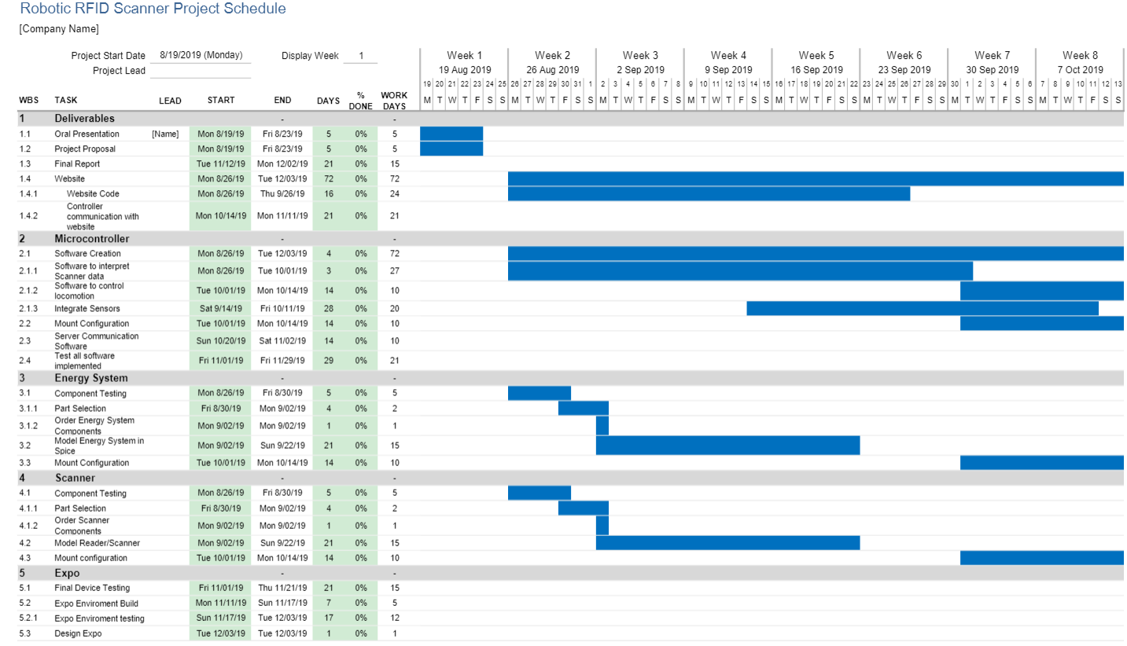

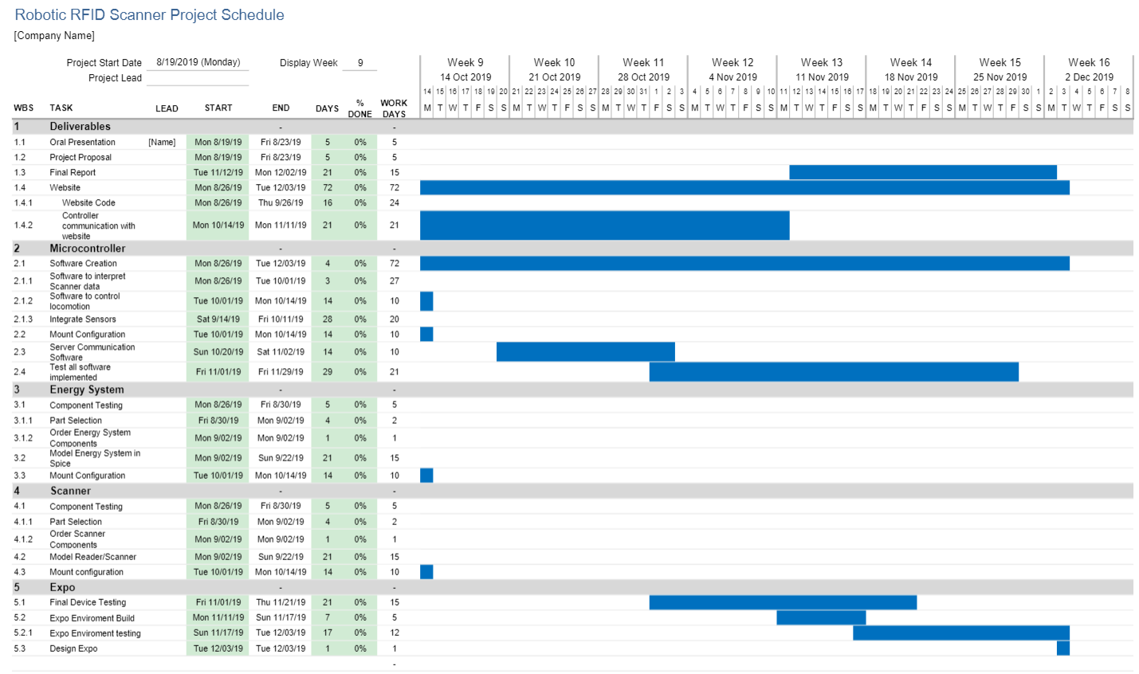

**Appendix B- Project PERT Chart**

*See next page for Project PERT Chart*

