Autonomous Inventory Tracking Using Robotic RFID Scanning

ECE4012 Senior Design Project

Robotic RFID Scanner
Dr. Gregory Durgin

Calvin Burran, cburran@gatech.edu
Shelby Conway, sconway32@gatech.edu
Brandon Goddard, bgoddard6@gatech.edu
Caleb Martinez, cmartinez38@gatech.edu
Yu Jun Qin, yqin70@gatech.edu
Dustin Snyder, dsnyder35@gatech.edu

Submitted

December 12, 2019
Table of Contents

Executive Summary (5 pts) iii

1.Introduction (10 pts) 4

1.1 Objective 4
1.2 Motivation 4
1.3 Background 5

2. Project Description and Goals (15 pts) 5

3. Technical Specification (15 pts) 7

4. Design Approach and Details (20 pts)

4.1 Design Approach 8
4.2 Codes and Standards 13
4.3 Constraints, Alternatives, and Tradeoffs 13

5. Schedule, Tasks, and Milestones (10 pts) 15

6. Project Demonstration (5 pts) 15

7. Marketing and Cost Analysis (5 pts) 16

7.1 Marketing Analysis 16
7.2 Cost Analysis 17

8. Conclusion 19

9. Leadership Roles (5 pts) 20

10. References (5 pts) 23

Appendix A 25

Appendix B 28
Executive Summary
Autonomous Inventory Tracking Using Robotic RFID Scanning (AITURRS) is a cross functional and scalable system that can locate assets autonomously. The robot will navigate an environment using computer vision and record the locations of the assets using Radio Frequency Identification (RFID). The scanner will be connected to a Raspberry Pi which will process the current location information. An updated database will be maintained and show a list of tags and associated items in each location. The Raspberry Pi will also control a motor that will move the system to the adjacent location, eventually scanning and updating the location information of the entire environment. Development of the prototype would cost $923.90 excluding wages with an ideal final market price of $3,299.00.
RFID technology is currently used in industry to locate and track assets. In many cases these assets are moved frequently, and the locations are often inaccurately recorded. This results in large write-offs, shrink and misplaced items; inefficient methods of manually locating assets are utilized to mitigate losses associated with poor inventory management. An example of this particular issue can be observed in server labs. These labs contain hundreds of server racks filled with various devices, line-cards, and additional modular components. Up-to-date location information is important to both the engineers and supported clients in order to reduce the probability of lost data or hardware. Devices and components in the server racks can use RFID tags to identify them by serial number, but these must be manually tracked. The need for frequently updated location information can also be applied to warehouses that store products in different locations. Current technology uses RFID scanners at entry and exit points that show only if the device has entered or exited the building. This technology is limited by the fact that it does not indicate specific location of devices within the area.
Autonomous Inventory Tracking Using Robotic RFID Scanning
1. Introduction
AITURRS is a mobile robotic platform with an RFID scanner capable of self-navigating a warehouse and updating an inventory database. The team utilized $438.40 to develop a prototype of the system.
  - Objective
The objective of AITURRS is to create a self-operating robot capable of maneuvering around an environment using the Pixy 2 vision sensor and associated object-tracking software. Using a mounted RFID scanner, the robot will read tags associated with individual assets, and determine the location and ID of the asset with a microcontroller. It will transmit that data wirelessly through the internet to an online database holding the location information of all items in inventory.
  - Motivation
The main motivation of AITURRS is to provide easy access to accurate inventory information for large warehouses and laboratories. This is much more cost effective than the current system most warehouses use of manually scanning and tracking inventory where the warehouse may need to be shut down for a day [1]. By reducing the amount of time and manual labor that is necessary to track assets at a large scale, the team hopes to improve market prices of various services and products provided by these companies because AITURRS helps reduce costs at the distribution level of products.

  - Background
Autonomous robotics in warehouse operations is a relatively new technology. One of the current leading companies on solving warehouse logistics issues with autonomous robots is called Fetch Robotics [2]. Fetch Robotics offers several different autonomous robots that perform various warehouse case tasks that include material transport, platforms for research, and data collection in the form of an RFID scanning robot. Due to the nature of the product, there is no technical information on how this company conducted research and development for their robots; however, there is information located on their website that gives baseline information on how the RFID scanning robot works.
This specific RFID tracking robot is capable of scanning multiple RFID tagged items up to a 25-foot range, depending on the density of the products and other warehouse environmental factors. It contains three mounted powerful RFID scanners set at different angles for scanning products at different heights in the warehouse. The RFID scanners are powerful and accurate enough to pick up on all products in the aisle in one pass. The way the designers created this robot was to maximize efficiency of scanning, to provide real-time information on where inventory is in the warehouse, and to save human work hours for higher level tasks.
2. Project Description and Goals
The proposed design is an autonomous RFID scanning robot that can move around a space on its own and scan inventory items with RFID tags to be recorded in internal memory. The robot was capable of using the Pixy camera to accurately follow lines defined with black electrical tape that sufficiently contrasts with the floor. The robot stops at predefined locations by reading barcodes that are fixed to the floor. This has the effect of dividing the area into physical lots used for identifying the location of each object (tag). The RFID receiver then begins reading each tag in its field of view; using the capability of the receiver to track Tx/Rx phase at different frequencies combined with received signal strength we make approximate distance measurements. The measurements are then accurately mapped to accurate distances using a calibration profile within an error range of approximately 1 ft. The minimum-distance and maximum RSSI decisions are then uploaded to an offsite database for collection and viewing. Project goals include the following:
General
- Robot that can operate autonomously based on location
- Target market value is $3,299.00
Robot Capabilities
- Line detection to control movement
- Transmit data to online database
The robot consisted of line tracking to control movement through environment mapping. In addition, the robot is able to use barcodes along the tracked line to have distinct locations to relate back to the user. Another added capability was a LED signal indicator on the rear of the robot, whereby a red LED light indicated the robot was in a scanning operation and a green LED indicated the robot was in a movement operation. After AITURRS completed a run, we were able to transmit the data for each tag back to the database and then make decisions for the current location of assets based on the received data from the antena. The decisions then would update the GUI in real time to give localization of assets.
RFID Scanner and Decision Making
- Detect tags to indicate when inventory is located
- Scan tags to procure pertinent information about the detected inventory
- Record data and send information about the inventory to Raspberry Pi
Future Work
- Integrate RADAR capabilities to map physical space and overlay tag locations.
- Add telescopic and pan/tilt functionality to antenna platform to allow for a three-dimensional field of view.
- Adding a logistic regression algorithm to statistically estimate where assets are (no hard decisions)
While we researched current projects similar to AITURRS, we came across some recurring problems. One of these problems consisted of the environment not having good bandwidth for internet access. We formulated a solution to this problem with adding a raspberry pi to the mix that would have an Ubuntu image to house our database and GUI with the ability to act as a local area network. With this solution, a person would just have to be in close proximity to AITURRS to access the GUI.
- Technical Specifications
Table 3.1 Specifications for RFID Scanner
Feature | Specification
Bandwidth | 865-928 MHz
Transmit Power | +10 - +31.5 dBm
Max Receive Sensitivity | -84 dBm
Max Communication Distance | 30 ft
Power Supply | 24Vdc/2.1A

Table 3.2 Specifications for Robotic Chassis
Feature | Specification | Measured Value
Battery Life | 4Hrs | 2.5Hrs
Weight | > 30 lbs | 15.6 lbs
Dimensions (Length, Width, Height) | 0.5m x 0.3m x 1.2m | 0.38m x 0.12m x 0.9m

- Design Approach and Details
  - Design Approach
The robot will consist of an RFID reader, a raspberry pi controller, motor control system consisting of two h-bridges, and a Pixy2 camera for object recognition. Figure 4.1.1 shows the block diagram of the entire system.
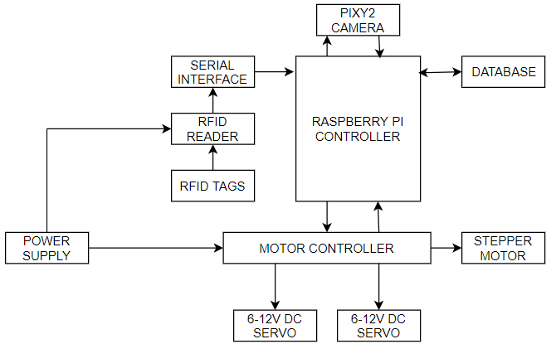
Figure 4.1.1. Block diagram of the RFID robot system
The RFID antenna is attached to a vertical arm that is immovable. Two H-bridge amplifiers provide variable power to the DC motors defined by the PWM signal incident on their gates. A separate 5V DC battery drives the Raspberry Pi, the Pixy Camera and the RFID Reader in a serial/parallel fashion. The Pixy 2 integrated computer vision system is the primary means of navigation for the robot. Pixy 2 detects contrast between different objects and generates a vector that acts as the heading. The heading is fed to a PID control algorithm to modulate power/direction to the two H-bridge controllers to keep the robot on track. The line tracking program also allows for the reading of barcodes to the right or left of the line to be used as landmarks to return position data. Figure 4.1.2 shows a navigation path for the RFID robot.
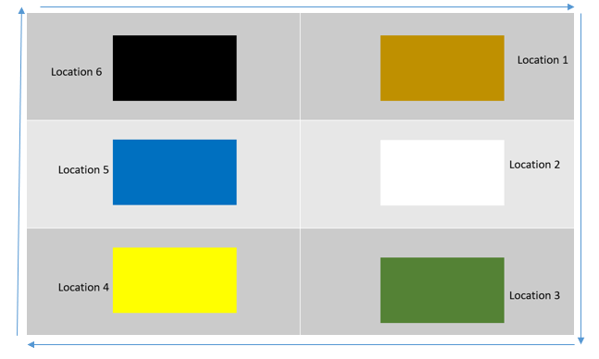
Figure 4.1.2. Robot movement using Pixy 2 line-tracking
The path the robot follows is determined to ensure every item is scanned by the RFID reader during one full lap. The environment used for the final demo is shown in Figure 4.1.2. Here, the robot moves along the outer path (highlighted in blue) with the RFID reader mounted perpendicular to the robot’s direction of motion.
In order to collect accurate data, the reader will need to be within read range of all tags. The desired read range for this design is currently estimated to 28 inches to accommodate the field of view for the antenna [3]. Boundary decisions are made utilizing minimum-distance decisions where distance is measured in a way outlined in [4,5] and cross-verified with maximum received signal strength. Initially the distance decisions were inaccurate due to various phase offsets caused by multipath and cabling, this error was addressed by first scanning the environment at many different known distances and using linear regression to create a one to one mapping of measured distance to actual distance. Figures 4.1.3-4.1.5 depict the obtained output once the robot navigated along the path represented in Figure 4.1.2. The Raspberry Pi software aggregates the tag data obtained, dividing the asset tags hierarchically based on their respective locations.

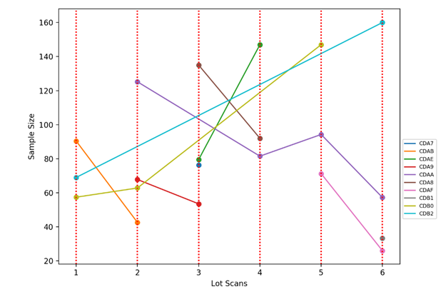
Figure 4.1.3. Graph of sample size versus lot scans
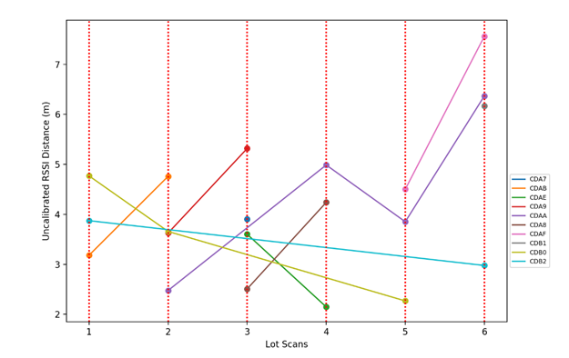
Figure 4.1.4. Graph of RSSI distance versus lot scans
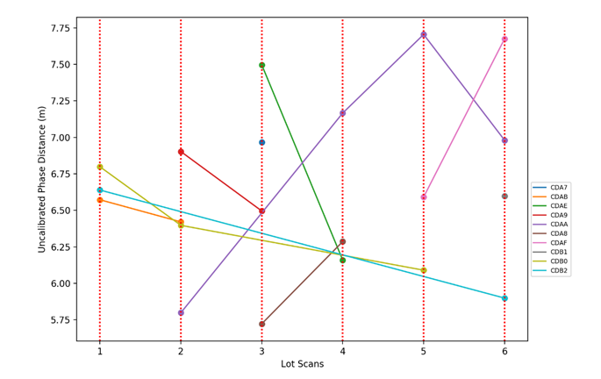
Figure 4.1.5. Graph of phase distance versus lot scans
Additional information can be stored in the database and associated with individual tags if needed. This database will hold location data for all assets within the environment and update the locations if the assets are moved between successive laps.
The team’s critical path towards creating a prototype consisted of scanner software development, locomotion software development, mounting the hardware components, testing software with hardware, and final device testing in a simulated environment. Figure 4.1.6 illustrates the key decisions and discoveries needed to integrate accurate location tracking with reliable movement.
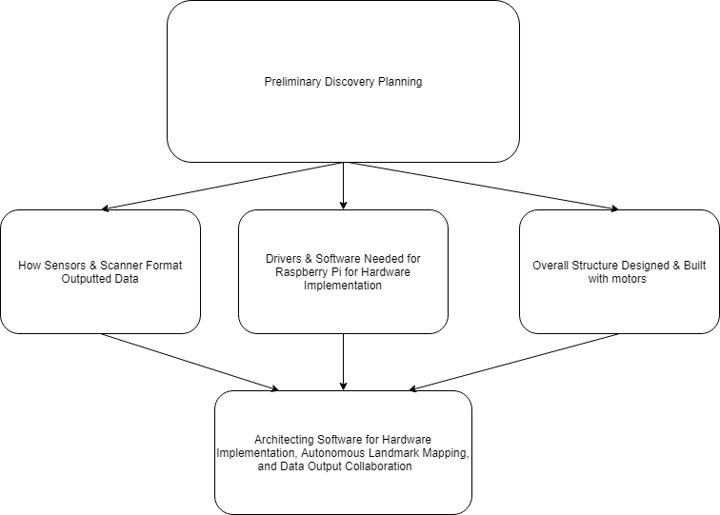Figure 4.1.6. Solution to Finishing Critical Path.

  - Codes and Standards
Radio Frequency (RF) is monitored by the FCC in Section 2.106 of the Commission’s Rules within the Table of Frequency Allocations [6]. An important restriction to consider is although Low Frequency (125–134.2 kHz and 140–148.5 kHz) and High Frequency (13.56 MHz) tags can be used globally without a license, any Ultra-High Frequency (865–928 MHz) tags could not because there is not yet just one global standard for this newer technology.
Another important standard to consider in the design of this project was IEEE 802.11 which is a popular wireless standard. It is part of the IEEE 802 set of LAN protocols for implementing Wi-Fi computer communications in various frequencies [7]. This 802.11 protocol ensures that equipment will listen to a channel for other users before transmitting by using the network multiple access method carrier-sense multiple access with collision avoidance.
The ISO approved the EPC Gen 2 Class 1 UHF standard as an amendment to its 18000-6 standard in 2006. This standard details parameters for sending and receiving data from UHF tags. This includes specifying frequencies and channels to be used for UHF as well as bandwidth and frequency hopping. The 6c amendment specifically targets item management using devices operating in the 860 MHz to 960 MHz range to help them share an interoperable interrogation and software infrastructure [8].
  - Constraints, Alternatives, and Tradeoffs
One significant constraint for this project is the power. Since it’s beyond the scope of the project to develop a new power supply, the design will have to rely on commercially available options. It was difficult finding batteries with sufficient energy capacity to power the system for the desired runtime, while being small enough and light enough as to not impede movement.
A second constraint is the locomotion of the device. Since the robot is intended for use in warehouses, a low turn radius may be desired. However, the camera mount extended far ahead of the chassis, so for compact turns, the line would leave the pixy camera’s field of vision and movement would cease all-together. In addition, skid steering naturally presents issues related to traction. As a result, the robot could only reliable navigate curves with radius around 1m. Implementation of a turning script dedicated to compact turns was attempted, where detection of certain barcodes would initiate rotation until it detected a line to track, but despite lowering PWM outputs, the rotation was too swift for the pixy camera to consistently detect the succeeding line.
Finally, the RFID scanner itself exhibit constraints. RFID scanners are inherently limited in their read distance and read angle and working outside of those ranges will significantly impact accuracy.
The first major trade-off our team considered was the use of a ultra-high frequency (UHF) scanner. This UHF can be more easily interfered with, but typically has a longer read range and faster data read rate. UHF is also a newer technology and therefore would cause the cost of developing our project to increase.
Another trade-off is the power source type of the RFID tags, of which the team has chosen passively powered tags. Passively powered tags are powered by the radiated electromagnetic waves sent from the reader, while actively powered tags have an external power source (such as a battery). Passively powered tags are less expensive, but must be close enough to the reader to maintain a sufficient power density incident on the tag.

- Schedule, Tasks, and Milestones
The GANTT Chart in Appendix A shows the tasks that must be completed. The schedule for the tasks is shown as well. Each task has been allotted a number of days to be completed based on estimated difficulty.
Those tasks in the critical path, indicated with red arrows in the PERT Chart in Appendix B, are the riskiest because they rely on the most tasks to be completed before they can be started. Therefore, they are placed on the critical path to indicate that they will take longer than all the other steps of the project.
- Final Project Demonstration
Prototype testing was done throughout the design process by carrying out measurements and trials under varying RF and mechanical circumstances. An important aspect in our design process was the interaction between the RFID scanner and compatible tags that have to be scanned from a moving robot. The prototype was developed by testing various RF interrogation ranges, reading speeds, tag collisions, optimal scanning orientations and heights, and other interference factors from the environment. Regarding the robot itself, the locomotive system was tested against its tracking system (Pixy 2 camera).
The final project was demonstrated by having the robot follow a general path in front of a series of containers shown in Figure 4.1.2. The boxes were an assortment of sizes and were placed next to one another in the arena. Each object had its own corresponding RFID tag attached, and the robot was then set to autonomously navigate and scan across the containers using dark electrical tape on the ground. This demo consisted of correctly operating DC motors, navigation, mechanical weight distribution, and capabilities of the RFID scanner. Once the scanning phase was complete, the robot entered a resting (or rescan) phase and the database containing the order of the objects was updated. This signified an accurate RFID read and correct data transfer between our microcontroller and another network accessible computer. The general methodology and process of the overall system was further verified by randomly rearranging the containers and initiating a scan by the robot to update the database accordingly.

- Marketing and Cost Analysis
  - Marketing Analysis
The target market consists primarily of warehouses and laboratories that need to keep track of large inventories. However, the idea could be scaled down to be used at other community buildings such as libraries, supermarkets, etc. The number of warehouses currently in business in the U.S is difficult to get an accurate estimate on, but it has been reported by Armstrong & Associates that the warehouse industry in the United States is valued at an estimated $40.5 billion for 2017 [9]. This implies that there is capital to invest into new technologies to improve the efficiency of these facilities. The primary objective from this initial round of marketing would be to recover the capital used to produce the product and then generate a modest profit to encourage future development and the addition of new features.
  - Cost Analysis
Table 7.2.1 Component Costs for Prototype
Part | Cost
Raspberry Pi 4 | $118.90
Pixy Camera | $60.00
Motor Driver | $25.00
Chassis | $180.00
NiCD RC Batteries | $40.00
Total | $423.90

Table 7.2.2 Time Spent per Engineer
Task | Hours
Weekly Meetings | 30
Reports | 20
Research | 15
Presentations | 4
Fabrication | 30
Assembly | 10
Testing | 10
Total | 119

Table 7.2.3 Cost per Engineer
Salary | Hours | # of team members | Total Cost
$65,000 | 119 | 6 | $22,312.50

The following assumes that the initial development above is completed and factored in. Further assume that the only labor required for scale manufacturing is assembly and testing (10 hours combined) at a laborers wage of $15/hr with overhead factored in at roughly 3 times the hourly wage based on an arbitrary model. A team of sales representatives will also need to be hired part time to sell the product, and the team will assume they will work 20 hours/week at $18/hr (also factoring in 3 times salary to account for overhead). A reach goal is set at 1000 units sold over the course of 5 years. So the total cost of the manufactured units plus the development cost and labor:
$22,312.50 + 10 hours*$43.00 dollars/hr*1000 units + 2reps* 20 hours/week*54 dollars/hr*50 weeks*5 years + $423.90 dollars/unit*1000 units = $1,416,612.50
To perform the amortization over 5 years, it is assumed that the investment is raised in a venture stage received as a loan with 6% interest. In the end, the goal is to either repeat the process over the next 5 years, or generate enough profit to grow the company and research new features.

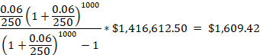
The above calculates what each robot must be sold at assuming 250 robots are sold per year over the course of 5 years at 6% yearly interest rate on the loan.
If the team wants to make double what the robot costs as profit for future investment ventures, the future value of this capital raised through robot sales assuming the team is selling each robot for $3,299.00 where i is normal inflation of ~2%:
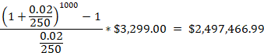
This cost puts the product at an extreme advantage over competitors as it is still an early market, and this design would be sold for almost a tenth of what the current accepted product for warehouses is.

- Conclusion
Currently, the prototype is capable of generating a 2-D mapping of assets in a given environment. Over the course of the design process, the team considered implementation of an a second independent antenna as a means to procure the height of the asset within the lot using phase-localization. However, the team was unable to achieve this goal with the chassis chosen, as attaching multiple antennas to the relatively small chassis would have destabilized the chassis. Future work will primarily be focused on perfecting independent antenna measurements to achieve a 3-D inventory map. We would also like to include LiDAR technology to create a mapping of the inventory space so that we can overlay tags on top of their physical location.
For future prototyping work, we would also like to utilize a different power supply that did not have to be charged and changed out as often. During testing, the NiCD RC batteries were sufficient; however, when the prototype was running continuously during the demo, the batteries had to be continually changed and never had time to fully charge. This would be extremely inconvenient if during a scan of a warehouse the product had to be stopped repeatedly to switch out the batteries, so if given more time and resources, the team would like to implement a different power source.
Additionally, given that the main concern regarding warehouse navigation was maneuverability and not speed, the Wild Thumper chassis selected by the group was not an ideal choice given the application. A differential drive platform consisting of two motors would have been better suited to the tight environments of warehouses, while consuming significantly less power relative to the current platform(given the reduction from six to two motors). The PID control of the system would largely be the same, with only the gains altered.
- Leadership Roles
The leadership roles for ECE4011 were split as follows:
-Shelby served the role of Documentation Coordinator for this semester. As Documentation Coordinator, she kept track of group assignments and which parts each team member was responsible for individually.
-Brandon as RFID Technology Reference Lead shared the information from and served as a sounding board for ideas about the various potential tradeoffs for the different types of RFID technology.
-Caleb as Software Team Lead coordinated the programming efforts of the team as well as setting up the bitbucket and Sourcetree that the team used to collaborate on the code as well as see the work that other team members have done.
-Dustin as Design and Testing Lead organized the team suggestions for different potential design ideas as well as the optimal environment for testing different aspects of the project.
-Jun as Webmaster coordinated the efforts for documenting the progress of the team and project on the team website.
-Calvin as Version Control/Agile Planning organized the team with Sprint planning through Jira. Calvin also served as Advisor Interface this semester asking Dr. Durgin about any questions or concerns the team dealt with during the planning stages of the project.
-Josh as Hardware Team Lead conducted research into the best and most cost effective hardware options for the prototyping of the project.
The leadership roles for ECE4012 were as follows:
-Shelby served as the Documentation Coordinator again this semester coordinating and organizing individual and group documentation of various stages of the project. Shelby also took over the role of Advisor Interface this semester to facilitate asking questions to Dr. Durgin.
-Brandon took on the role of RFID post-processing and Web/Communications Coordinator. His job was to ensure that the pieces of the project will work together across the different areas as well as leading the software efforts in the data being collected and processed between the RFID reader and the Raspberry Pi.
-Caleb served as Lead Software Developer during 4012. In this position, he led the efforts in ensuring all the code works as well as assigning different portions of the programming to different team members.
-Dustin served as EXPO Coordinator this semester. In this role, he ensured all necessary parts for the EXPO presentation were prepared as well as conducted final inspection of all the pieces of the project. He also helped to prepare the team for any questions that could have been asked at EXPO.
-Jun served as Webmaster again this semester by coordinating the efforts for documenting the progress of the team and project on the team website.
-Calvin served as RF Testing and Integration Lead this semester. He designated different tests that needed to be completed to understand the capabilities of the RF scanner as well as helped to answer questions about the technology.
-Josh unfortunately was not able to be on the team in the Fall due to an internship in Louisiana. Good luck Josh!

- References
[1] AccountingTools, “Inventory count procedure”. [Online]. Available: https://www.accountingtools.com/articles/2017/5/16/inventory-count-procedure [Accessed July 19, 2019
[2] Fetch Robotics, “RFID Tracking Transformed: TagSurveyor from Fetch Robotics”. [Online]. Available: https://fetchrobotics.com/products-technology/datasurvey/tagsurveyor/ [Accessed July 17, 2019].
[3] RF Max, “Circular Polarity RFID Panel Antenna Datasheet”. [Online] Available: https://rfid.atlasrfidstore.com/hubfs/Tech_Spec_Sheets/RFMAX/ATLAS%20RFMAX%20S9028PC%20Indoor%20RFID%20Antenna%20Version%203.pdf?t=1487108781396 [Accessed October 9, 2019].
[4] P. V. Nikitin, R. Martinez, S. Ramamurthy, H. Leland, G. Spiess and K. V. S. Rao, "Phase based spatial identification of UHF RFID tags," 2010 IEEE International Conference on RFID (IEEE RFID 2010), Orlando, FL, 2010, pp. 102-109.
[5] Joshua D. Griffin and Gregory D. Durgin, “Complete Link Budgets for Backscatter-Radio and RFID Systems”. IEEE Antennas and Propagation Magazine, Vol. 51, No.2, April 2009
[6] Federal Communications Commission, FCC S2.106 Table of Frequency Allocations. Government Publishing Office [US], 2002. [Online]. Available: https://www.govinfo.gov/content/pkg/CFR-2002-title47-vol1/pdf/CFR-2002-title47-vol1-sec2-106.pdf
[7] IEEE Standards Association, “Telecommunications and information exchange between systems Local and metropolitan area networks,” IEEE 802.11-2016, 14 Dec., 2016. [Online] Available: https://standards.ieee.org/content/ieee-standards/en/standard/802_11-2016.html
[8] M. O’Connor, “Gen 2 EPC Protocol Approved as ISO 18000-6C,” RFID Journal Jul. 11, 2006. [Online]. Available: https://www.rfidjournal.com/articles/view?2481 [Accessed July 19, 2019].
[9] Roanoke Trade, “New Report Provides Key Info on U.S. Warehousing Market”. [Online] Available: https://www.roanoketrade.com/new-report-provides-key-info-on-us-warehousing-market/ [Accessed July 19, 2019].

Appendix A- Project GANTT Chart
See next two pages for Project GANTT Chart.

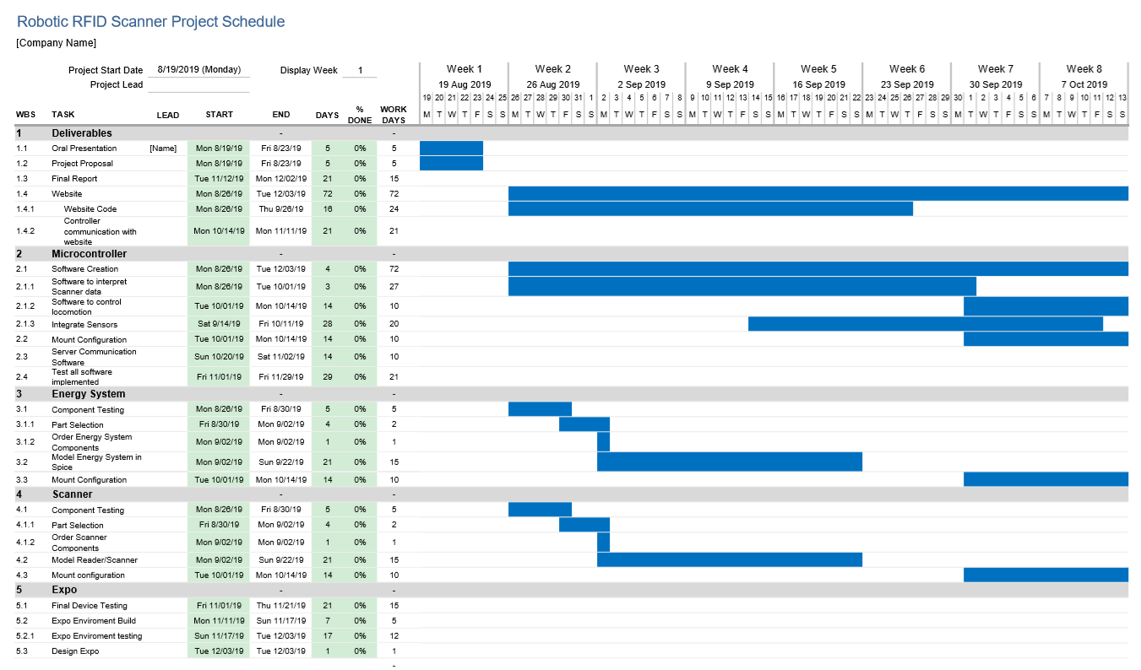
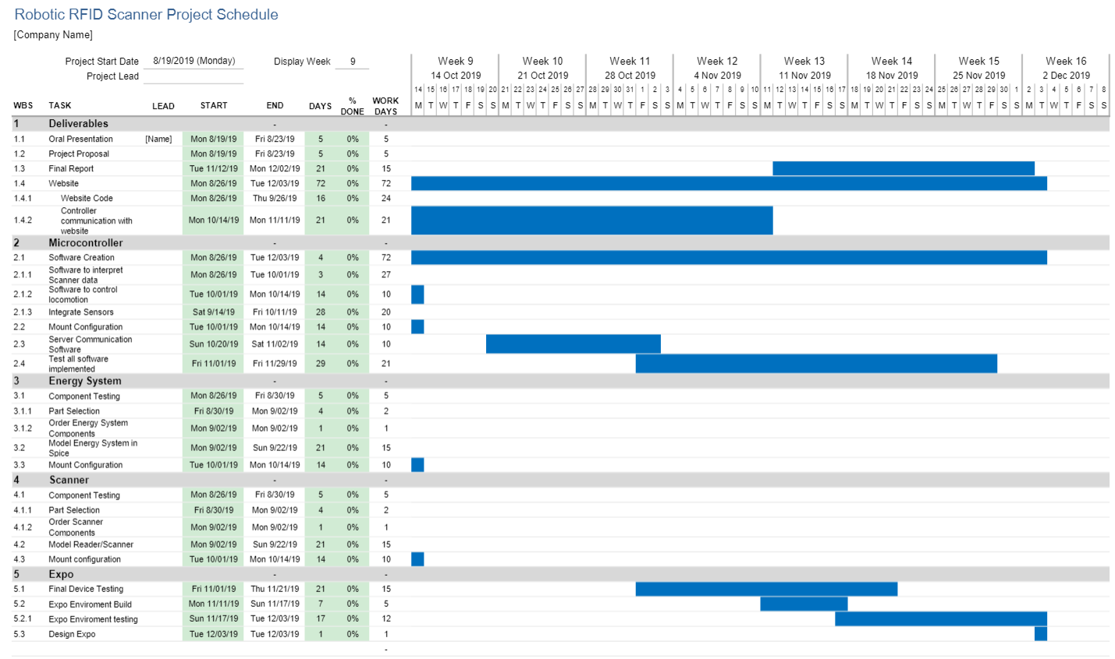
Appendix B- Project PERT Chart
See next page for Project PERT Chart
