**Ekwang: Wrapping Leaves to Help Needy Families**

ECE4012 Senior Design Project

Section L03, ECE 3882ers and Co.

Project Advisor, Dr. Moore

Team Ekwangineers:

Alha Kane, alha@gatech.edu

Curtis Cooper, ccooper78@gatech.edu

Dawit Jekamo, djekamo3@gatech.edu

Ephrem Lombebo, elombebo3@gatech.edu

Jeongmin Huh, jhuh32@gatech.edu

Zhiming Xue, zxue38@gatech.edu

Submitted

December 11, 2019

**Table of Contents**

**Executive Summary** 3

1. **Introduction** 4
   1. Objective 4
   2. Motivation 4
   3. Background 7
2. **Project Description and Goals** 7
3. **Technical Specifications & Verification** 8
4. **Design Approach and Details**
   1. Design Approach 14
   2. Codes and Standards 21
   3. Constraints, Alternatives, and Tradeoffs 22
5. **Schedule, Tasks, and Milestones** 27
6. **Final Project Demonstration** 27
7. **Marketing and Cost Analysis** 29
   1. Marketing Analysis 29
   2. Cost Analysis 31
8. **Conclusion** 37
9. **References** 39

**Appendices**

**Executive Summary**The current project was to develop a simple, low cost appliance that can manually or electronically wrap Ekwang. Ekwang is a major meal for the people of West Africa and the African diaspora consisting of a Cocoyam root that is grated into a mash and wrapped in a leaf. Our team developed a device that wraps the mash in turnip greens, which is a leaf similar to what is used in West Africa.

The goal of the design was to develop a functioning manual and electrical wrapping device that can quickly and consistently wrap the mash in turnip greens. The preparation for this meal is time consuming and labor intensive because of the time it takes to grate and wrap the ingredients; it takes two hours to prepare a meal for a standard family of five, which consists of approximately 60 Ekwang wraps [1]. Manually wrapping the mash in leaves takes 30 minutes. Developing the appliance will reduce the time needed to make the wraps, which would allow women more time to do other things and potentially the opportunity to make and sell the wraps for additional income.

The final testing resulted in an electric wrapping machine that can wrap at a rate of 8.5 seconds per wrap. This is half of the time that it takes to manually wrap the leaves. The material cost for the finished prototype was $315.67.

**Ekwang: Wrapping Leaves to feed needy families**

**1. Introduction**

Ekwangineers are requesting $1000 of funding to develop an appliance that can both manually and electrically wrap Cocoyam mash in turnip leaves. This appliance will significantly economise Ekwang preparation time.

* 1. **Objective**

The overall objective for this project was to develop an appliance that is manual or electric that can wrap Cocoyam mash in turnip leaves. The primary objective is to develop a single machine that will grate the cocoyam into mash, dispense the proper amount onto turnip leaf, wrap it into an Ekwang roll, and transfer the technology to West Africa, where the appliance will be manufactured and sold in both rural and urban areas at an affordable cost.

* 1. **Motivation**

The Ekwang wrapping machine was created to wrap mash in leaves quickly. Developing such an appliance will help significantly reduce time spent creating a staple meal for the people of Cameroon and other parts of West Africa.

[1]The current conditions in Cameroon are unstable. The country has been in a civil war for the past two years and as published by Maxwell Bone, “has displaced at least half a million people, leaving 1.3-million in need of humanitarian assistance, according to the United Nations Office for the Coordination of Humanitarian Affairs.” [2]. The country also has an electrical grid that is unreliable with frequent power outages. According to Moki Edwin Kindzeka of Voice of America, an international American broadcasting company, recently, there was an outage that lasted for two weeks [3].

The Ekwang wrapper developed in this project was inspired by an existing product, shown below in Figure 1, a grape leaf wrapper made by Dolmer. This device is two inches wide, which is not suitable for leaves more commonly used for wrapping Ekwang.

. 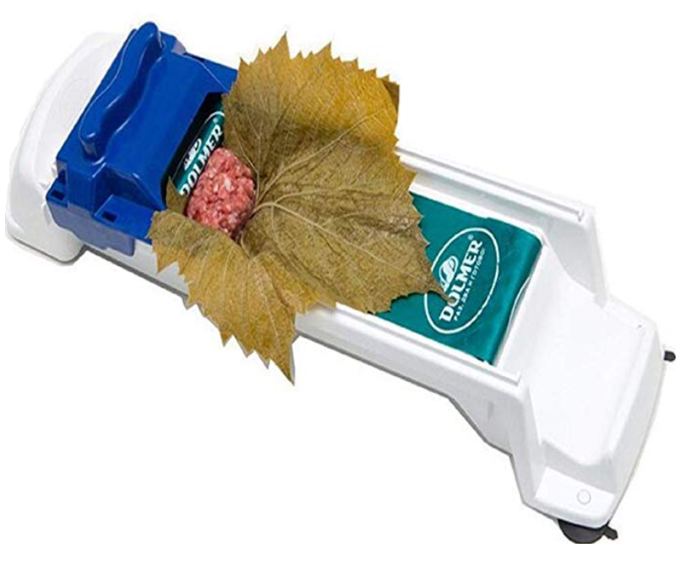

Figure 1: Manual grape leaf wrapping machine [4]

A typical turnip leaf, shown in Figure 2 below, averages about six inches in width. When tested on the Dolmer wrapper, the handle binds against the sides of the turnip leaf and pushes the leaf out or causes the handle to disassemble from the base of the machine. The product is also exclusively manually powered. The wrapping machine prototype developed in this project is wider at six inches and therefore prevents the binding of turnip leaves. The new wrapping machine is also manually actuated to accommodate the needs of the people in Cameroon without stable electricity, but has an electric option for the people that can afford it and have access to stable electricity.

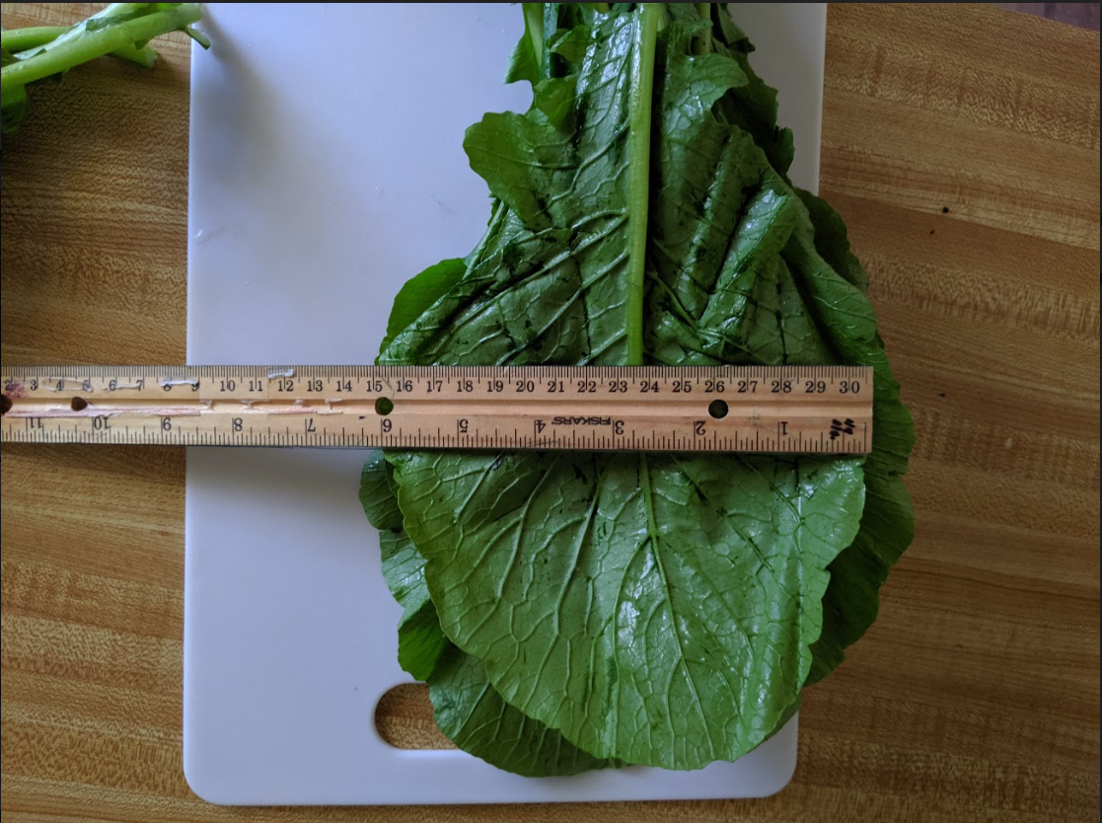

Figure 2: Turnip leaves averaging six inches in width

* 1. **Background**

When developing the Ekwang wrapper, other wrapping devices in the food industry were researched. One such example is the spring roller wrapping machine. This machine uses flaps that fold the spring rolls, but such a mechanism is not suitable for a turnip leaf because of its stem rigidity. The original prototype was based on a conveyor mechanism with a rolling mesh as shown below in Figure 3. However, the final design is based on the grape leaf wrapper shown in Figure 1.

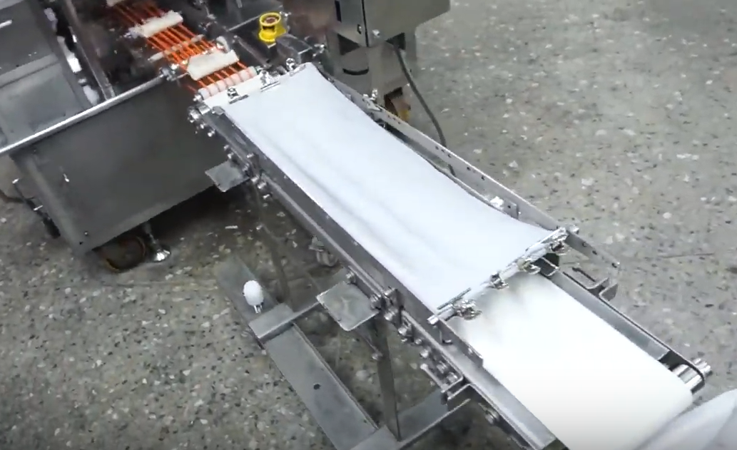

Figure 3: Conveyor with mesh above it to roll spring rolls [5]

**2. Project Description and Goals**

The objective of this project was to build a user-friendly and low cost kitchen appliance, which wraps Cocoyam mash in turnip or similar green leaves. These wraps are one of the main constituents of a staple West-African meal known as Ekwang. The target users are West African families living primarily in Africa and in the diaspora.

The following goals were set by the team to achieve this objective.

● The machine should be able to consistently make Ekwang wraps.

● The machine should wrap Ekwang much faster than by hand.

● The shape of the machine-produced wraps should be comparable to the shape of the handmade wraps.

● The electrical version of the machine should be energy efficient; its wattage should not exceed the average wattage for electric kitchen-appliances.

● The machine be lightweight for portability.

● The machine size should not exceed the average size for electric kitchen-appliances.

● The machine should be able to produce large quantities of wraps without jamming.

● The machine should be manufactured with food-safe materials.

● The electronics inside the machine should not overheat.

● The machine should allow for both manual and electrical modes of operation.

1. **Technical Specifications & Verification**

As shown below in Figure 4, food vendors and young African workers are some of the most interested stakeholders. As such, simplicity in design was considered mainly for the purpose of making this technology accessible and transferable to the stakeholders. In addition, with the expedited wrapping process, this device allows food vendors to potentially be able to sell Ekwang to make larger profit margins. The targeted market also includes the African diaspora, who are more likely to have buying power and can subsequently afford the electric version of the appliance. As for West Africans, this project could potentially align with humanitarian agencies in order to improve the quality of their lives. This qualifies the humanitarian agencies as an influential stakeholder. The least important stakeholders are large scale appliance manufacturers, the supply chain, and the farmers that grow leaves and Cocoyam.



Figure 4: Stakeholders in Ekwang wrapper development

Focusing on the key stakeholders, the requirements for this appliance was broken into three categories: functionality, safety, and practicality. To function properly, the appliance must wrap accurately in order for the food to cook properly. It must also wrap quickly to benefit the users. For the safety of the user, the appliance needs to be both electrically and mechanically safe and reliable. Practicality requirements include being low cost, portable, lightweight and easily maintainable.

The primary function of the device is to wrap mash in turnip leaves. To accomplish this function, there are two sub-functions that need to be fulfilled. Once positioned on the trench of the base, the leaf needs to be held in place to allow proper reception of the mash. After the mash is dispensed, the leaf needs to be wrapped properly. Next, the leaf needs to be removed from the wrapping surface. Below in Figure 5, the functions of the machine are broken down and the methods to accomplish each sub-function is shown.

In order for the wrapped rolls to cook properly, they must meet a few basic conditions. The leaves need to be wrapped tight enough to hold the mash but loose enough that no mash is squeezed out of the sides of the rolls. To ensure these criteria were met, a consistent diameter of about two centimeters was required. For the device to be successful, it was required to meet a 95 percent wrapping success rate.

Figure 5. Function tree of Ekwang wrapping device with the required functions to produce wraps

Due to the fact that the device will be a kitchen appliance primarily used in areas with unstable electricity, there are several constraints which arise. Refer to 4.3 Constraints, Alternatives, and Tradeoffs for further details.

* The lack of stable power in regions where device will be used
* Must fit onto a kitchen counter
* Must be lightweight to ease handling during cleaning or storage
* Must be food-safe
* Must be low cost due to the low wages in Cameroon and West African in general.

The above constraints and functional requirements led to the development of the specifications listed in Table 1, below**.**

Table 1. Specifications for Ekwang wrapping device

|  |  |
| --- | --- |
| Description | Desired Values |
| Weight of wrap (average) | 18 g +/- 2g |
| Total weight of appliance | <2lbs |
| Energy efficiency (power usage) | <25W |
| Speed of wrapping leaves (<20s per wrap) | Manual=≤ 10 s  Electric =≤10 s |
| Repeatable & predictable motions | 200 wraps with no jams |
| Ease of assembly | <5 pieces to assemble |
| Compactable into | Fits into 12” x 8“' x 4” box |
| Prevents against overheating | Circuit <50°C [6] |
| Wrap diameter | ≤ 2 cm |

The specifications listed in the above Table were developed based on the customer and engineering requirements listed in the house of quality shown below in Figure 6. Based on the house of quality, the most important specifications in respective order are: the speed of wrapping the Ekwang, repeatable & predictable motions and the diameter of the wraps. For the device to be appealing to customers, it was required to be sufficiently faster than hand wrapping, which takes 15 to 20 seconds. To ensure reliability, the motion of the appliance needed to be tested over 200 wraps to ensure no jamming occurrence. The device needed to produce wraps of the same diameter as the handmade wraps, less than or equal to two centimeters. The weight of wraps was necessary to help establish that the device is producing wraps that are comparable to hand wraps. The device must be less than two pounds and compactable to allow for easy cleaning and storage. To prevent overheating and ensure the safety of the customers, the temperature of the circuit should be less than 50 degrees Celsius. According to D&F Liquidators, a national supplier of electronics, most devices function optimally at less than 50 degrees Celsius; anything above this will start to deteriorate the device [6]. To ensure that the circuit stays cool, the maximum power requirement was limited to less than 25 watts at max current draw. Throughout the project, the design was altered, but the specifications were able to remain unchanged.

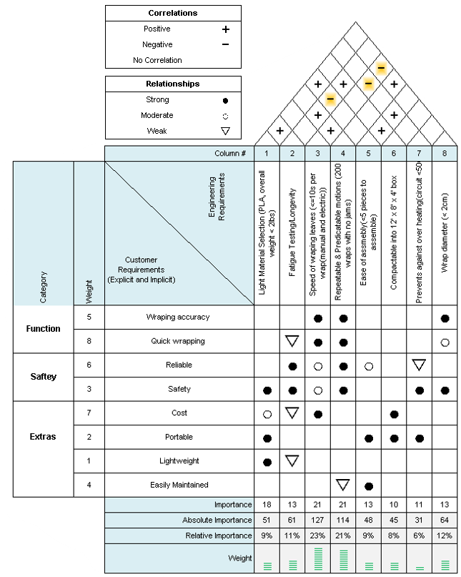

Figure 6. House of quality for the Ekwang wrapping device

1. **Design Approach and Details**
   1. **Design Approach**

In the initial stage of the design ideation process, a brainstorming period was set to allow each member to come up with an original design concept. The final design choice was derived from the proposed design concepts.

The main metrics considered to arrive at the design concept chosen for prototyping were reliability of the wrapping mechanism, cost, and time feasibility. Reliability of the wrapping mechanism was given the most weight among the metrics during the selection process because effective production of wraps is the core of the project. The wrapping mechanism of concept D (see figure 7) was very complex and hard to implement in the given time, thus was disqualified. As for design concepts A, B, and C, they followed a similar wrapping mechanism, which relied on a conveyor belt that displaces the leaf and mash, and a mesh which triggers a rolling motion. After discussing the advantages and drawbacks of these design ideas, design concept C (see figure 7) was chosen. This design was selected on the premise that it had the simplest wrapping mechanism, the lowest cost to build and allowed for both manual and electric modes of operation, which concepts B and C did not.



Figure 7: Proposed Design Concepts

After a decision regarding the wrapping mechanism was made, the functional requirements were considered along with potential design solutions to address them. The morphological chart presented on figure 8 illustrates the proposed alternatives for each section. Since the wrapping mechanism and power needs naturally followed the chosen design concept, they will be omitted in the following morph chart discussion.

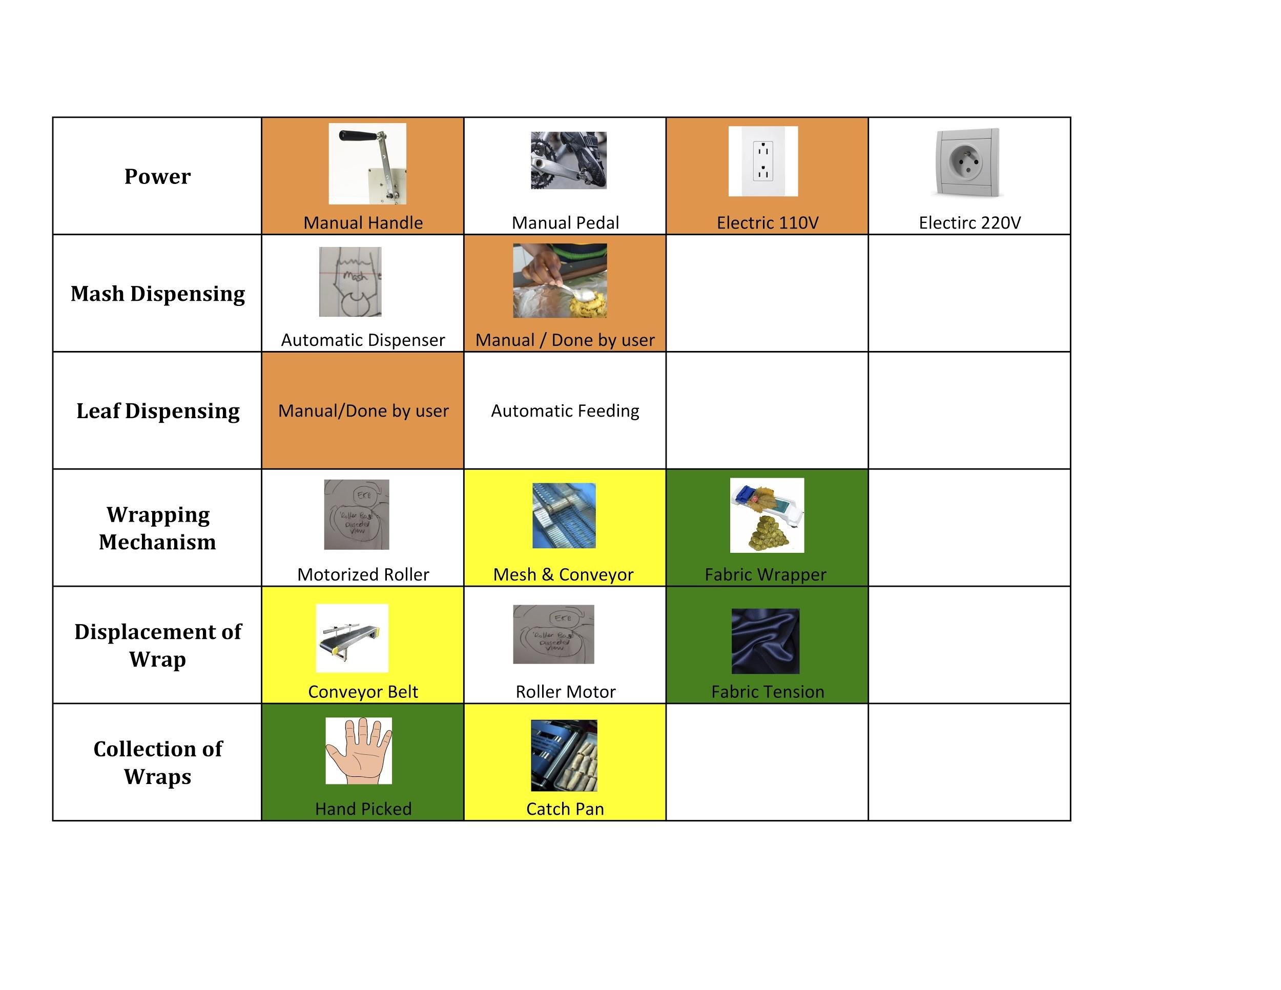

Figure 8: Morphological Chart

On the leaf and mash dispensing categories, the manual mode of operation was chosen even though it is possible to automate these processes. This decision was made in consideration of the project-deliverables-deadline constraints. Designing and building suitable leaf and mash dispensing mechanisms, while maintaining the low cost constraint of the project, was deemed unfeasible in the allotted time of three months. A subsequent team may work on automating these steps of the wrapping process. As far as the finished-wraps collection category, the catch-pan wrap collector alternative was selected since it could easily be matched with the chosen design and could also decrease the task load of the user. Note that the yellow color code represents the design choices for the initial design, the green color code represents the design choices pertaining to the final design, while the orange color code represents the choices which were not changed after a new design was adopted.

In the second stage, the team decided on the dimensions and made the CAD drawings of the selected design. After generating the initial CAD drawings for the project proposal, a proof-of-concept test ( see figure 9) was performed to gauge the feasibility of the wrapping mechanism. However, the test results were unsatisfactory. The wrapping concept failed to work as envisioned. Rather than fully wrapping around the mash, the leaf would inconsistently wrap halfway and slip down the platform. For this reason, the team decided to adopt a different design which borrowed a concept that has been proven to work for wrapping dolmas (a dish consisting of stuffed grape leaves).

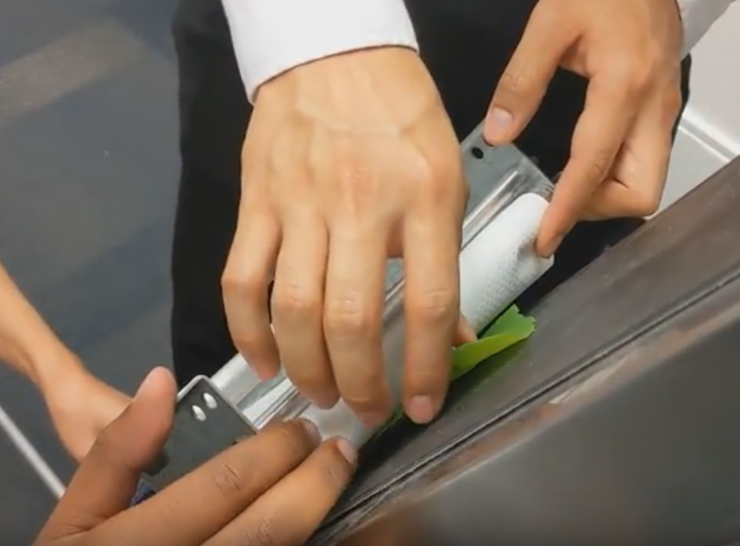

Figure 9: Proof-of-Concept Prototype

In the third and final stage of the design process, an initial prototype was built to confirm that the wrapping-mechanism can be reproduced by the team and to test for the electric mode of operation. Following the initial prototype, two design iterations with major design changes on both the mechanical and electrical sides were performed to arrive at a satisfactory prototype.



Figure 10: Initial Design Prototype

The first iteration addressed two major issues. The first issue was related to the linear actuator choice. Though the electric mode feasibility test results were satisfactory, the size of the electric-version prototype largely exceeded our size specification (see figure 10). This was mainly due to the rod-type actuator used in the assembly. To decrease the size of the device, the rod-type linear actuator was replaced by a ball-screw-type linear actuator. The second issue was related to the approach used to build the mechanical parts. 3D printing was used to print all mechanical parts. Due to the print-size limitations of the 3D printing machine, the base had to be split into two separate parts for printing then attached back together. This caused the slide track to be unsmooth. To address this issue, CNC machining was used to build the base of the subsequent prototypes.



Figure 11: Second Prototype (first iteration)

The second and last iteration addressed four major issues. The first one was on the electrical side. After the motor control and safety sensor algorithms were merged, a new issue due to the arduino microcontroller limitations arose. The delay introduced by the sensor readings were causing breaks on the stepper motor motion, occasional loss of steps and a loisy sound. It was later identified that the error stemmed from the fact that the arduino possesses a single core processor. The motor commands and the sensor reading acquisition commands could not be processed in parallel. They had to follow a sequential order. Since this issue was discovered in the final stages of the project, migrating to a multi-core microcontroller was not feasible. Thus, to mitigate the impact of this limitation, ultrasonic proximity sensors were replaced by time-of-flight proximity sensors since the latter introduced a smaller delay. The remaining major issues addressed on this iteration were on the mechanical side. First, the current handle was not appropriate for the ball-screw-type linear actuator. Therefore, a new fit-for-purpose handle had to be designed and built. Second, some of the base dimensions needed to be updated to meet the specifications. The volume size of the leaf and mash receptacle was not large enough to meet the wrap weight and diameter specifications (see figure 11). The slope of the post-wrap receptacle was not steep enough to ensure consistent wraps and proper dispensing of the finished wraps. Third, after adequate testing, it was discovered that adding a bump on the middle of the base would improve the quality of the wraps. This addition was the last major design change implemented.



Figure 12: Third Prototype (second iteration)

As far as existing products on the market, only one kitchen appliance was found to fit in the same category as the appliance built in this project. This appliance is known as the dolmer wrapper. Refer to the marketing analysis section for a detailed analysis of the similarities and differences between the Ekwang wrapper and the dolmer wrapper.

* 1. **Codes and Standards**

Table1. Standard for material used[11]

|  |  |
| --- | --- |
| **Material** | **Description** |
| PLA (Polylactic acid) | PLA is food safe.  It is the source material for the handle. |
| HDPE (High Density Polyethylene) | HDPE is food safe.  It is the source material for the base. |
| ABS (Acrylonitrile-Butadiene-Styrene) | ABS is not food safe.  It is the source material for the support of base. |
| Acrylic | Acrylic is food safe.  It is the source material for housing the electrical components and overall structure of the device. |

* 1. **Constraints, Alternatives, and Tradeoffs**

The constraints that affected the project in terms of its progress are mainly time, health, social and economic factors. The time constraint limited the exploration of certain desired experimental runs to test the machine’s jam-free operation capabilities. Originally, the plan was to use the machine to run a trial of wrapping 200 leaves consecutively without jam, but for practical purposes, 5 trials of wrapping 5 leaves each were deemed enough to test smooth operation (not a single jamming incident was reported during the entire capstone exhibition). The device was also planned to be compactable into a 12” x 8” x 4” box but ended up in having 17” x 8” x 8.3” size which negatively affected the device’s portability. This was largely due to the lack of smaller motors suitable for the purposes for this project.

Environmental constraints such as unstable electricity in the geographical area where most end users live have also affected the project. Subsequently, the device is a hybrid (can operate manually and electrically), and the support of the base was made to be detachable for just this flexibility. The support is where the motor is mounted on and is a key component in enabling the transition between manual and electric versions. So, in the case of a blackout, users should be able to easily remove the electrical version and start using the manual version.

Another constraint is health and safety. Section 409 of the FD&C Act defines an FCS(Food contact substance) as any substance that is intended for use as a component of materials used in manufacturing, packing, packaging, transporting, or holding food if such use of the substance is not intended to have any technical effect in such food[7]. The project design mainly utilizes HDPE, ABS, PLA and acrylic. But only HDPE and PLA gets in contact with the food (these two materials are approved as food contact materials by FDA, as shown in Table 1).

The safety of the user while operating the machine is also considered in this project. There are sensors mounted in the machine that, in case a human hand or any obstacles obstruct the path of operation, will immediately trigger a reversal of the handle’s motion.

The average income of a person in Cameron is $5.6/day. This information imposed an economical constraint in the project. The people in the area must afford to buy the machine. Nonetheless, the current prototype costs $285.47, which is expensive. The manufacturing process utilizes CNC machining to produce the base using HDPE and 3D printing to produce the handle using PLA and support using ABS. The usage of Computer Numerical Control (CNC) machining to make molds of all the parts needed and using the molds to injection mold a plastic (HDPE, LDPE or Polypropylene) is recommended for bulk production which could reduce the production cost, making the machine affordable.

**Manufacturing**

The manual version of the machine is mainly made from a base that is made of a CNC machined HDPE (High Definition Polyethylene) and a handle made of a 3D printed PLA material. The hybrid version adds all the electrical components that are needed to operate the machine electrically. The resulting design can also be mass produced by using a more efficient and cost effective way. One recommended way for a cost effective and quick bulk production is to CNC machine a mold of each part, except the electrical components, and blow or injection mold the plastic using the CNC machined mold.

**Societal, environmental and sustainability considerations**

The potential positive social impacts of the designed machine mainly include but are not limited to decreasing the time spent in cooking Ekwang, and creating job opportunities in Cameroon. The use of this device significantly decreases the time used to wrap cocoyam mash in a leaf. People making this food (mainly women) can save their time by using the machine and be productive elsewhere. If the production of the wrapper takes place in Cameroon, it could potentially create more job opportunities in the area. Because of the lower wage standards, one could expect a high profit margin if the company producing such a machine can expand its market internationally. The more profitable the company is, the higher the incentive is for the employees as well as the local and national economies, as buying power will be expected to become more active.

The potential negative impact is cultural. Whatever cultural value was associated with manually wrapping Ekwang could be lost with the technological substitute of a machine. The noise from the vibrations from operating the machine may be off putting and could perhaps add to the negative impact.

**Risk analysis**

Measures to relieve anticipated risks were executed as shown in the table below (Table 2). The edges of the fabric used for the machine were sewn to mitigate the risk of failing to tightly wrap Ekwang, and different tests were done to validate the action and solved the issue as a result. A fastener on the pin was installed to prevent disconnection between the handle and handle rail, a situation that would hinder the machine’s movement. Also, attachment of an acrylic, with rubber stands, to the support of the device was produced to avoid the machine from falling off a table due to repeating back-and-forth motion of the motor. As a result of the actions taken, the RPN values decreased significantly making the device safer to operate.

Table 2. Design FMEA(Failure Mode and Effect Analysis)

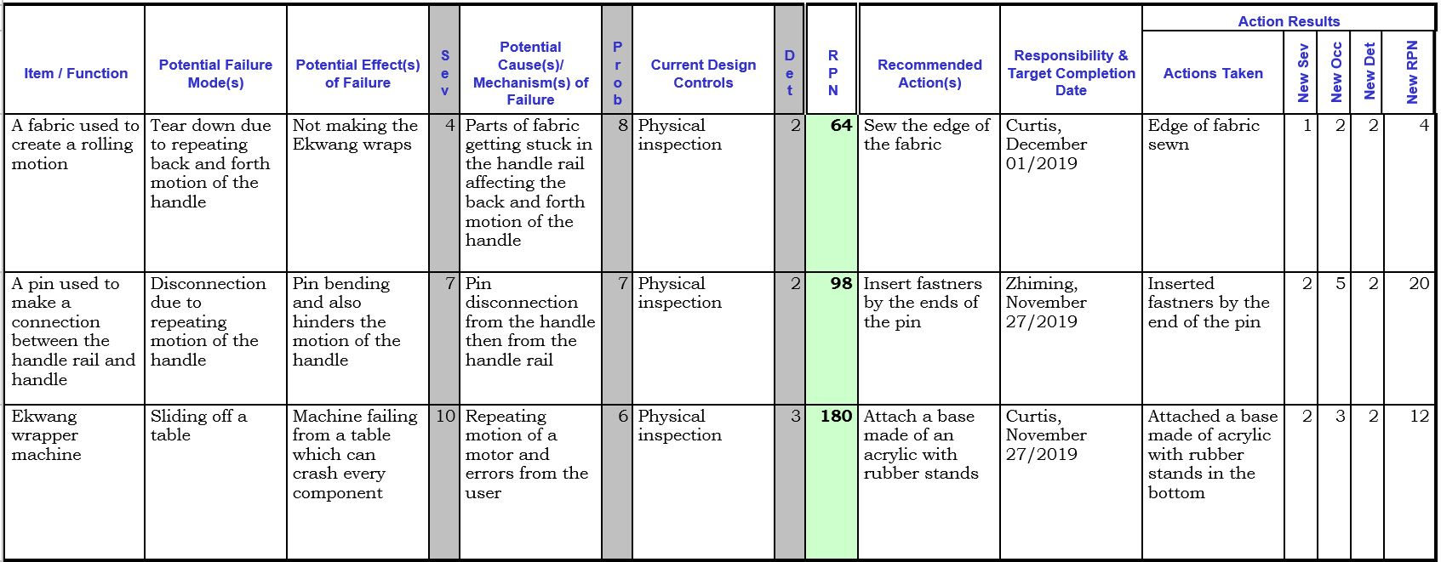

1. **Schedule, Tasks, and Milestones**

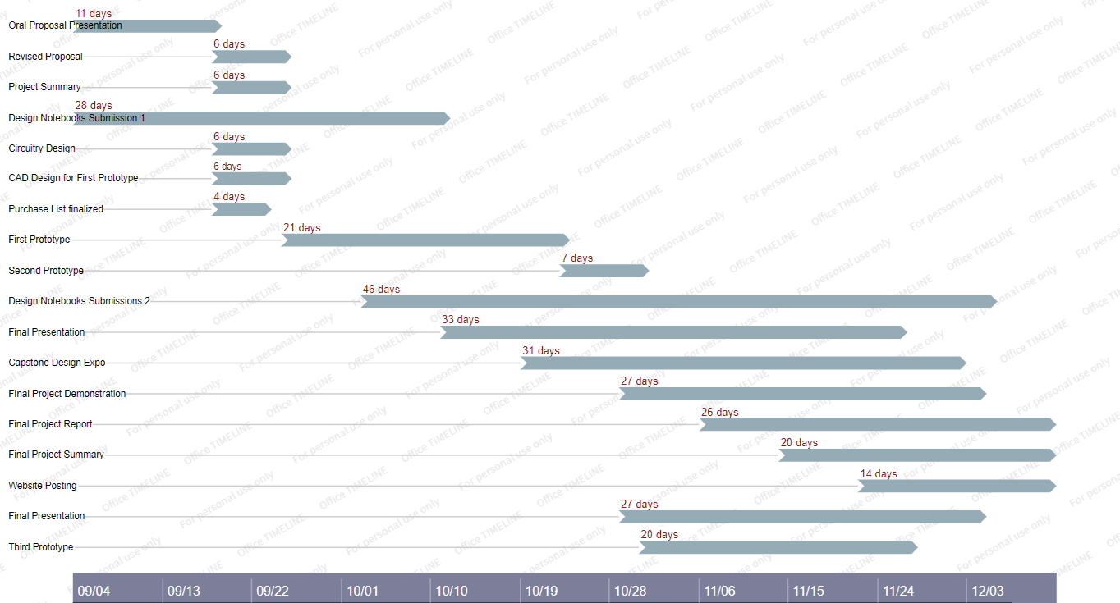

Figure 14: Schedule Gantt chart

The tasks were largely divided into three categories: mechanical, electrical, logistical. As such, the tasks were generally divided accordingly to each member’s specialization and major. For efficiency purposes, each member was responsible for a task, without dividing and sharing the workload into subtasks.

1. **Final Project Demonstration**

With the goal of emulating the standard process of wrapping by hand, the specifications were specifically set to categorically test the emulation. The main function of wrapping mashed cocoyam in leaves to produce Ekwang can be broken down into three subfunctions. Each specification was chosen accordingly for proper verification using the function modules as shown in Figure 5 during the final demonstration.

1. Hold a leaf in an appropriate position
   1. Although the desired value can be heavily influenced by the user, it was important that the machine’s operation would properly output the standard amount of ingredients desired by the user. At the same time, it was important that the machine’s operation would maintain faster wrapping speed than that of by hand. All this depends on the proper placement of leaf.
2. Wrap leaves
   1. With a major portion of the potential customer population living in places where electricity is unstable, it was important that the machine could be operated both electrically and manually via detachment. Considering the electricity constraint and safe operation of the machine, even the electrical consumption had to be reasonably similar to that of a typical home appliance.
3. Interface with customers
   1. Although not a functional module, practicality was an important factor. Achieving a level of practicality for the machine’s use meant that the machine could be lightweight and compact for portability, and that machine could be used repeatedly (which was qualitatively achieved by making the wrapping fabric detachable) and could be set up with as few components as possible.

Table 3: Specifications displaying comparison between the desired and actual values

|  |  |  |
| --- | --- | --- |
| Description | Desired Values | Actual Values |
| Weight or wrap | 18 g +/- 2g | 16.5g |
| Light weight material selection (weight) | <2lbs | 11 lbs |
| Energy efficiency (power usage) | <25W | 22.85W max |
| Speed of wrapping leaves (<20s per wrap) | Manual=≤ 10 s Electric =≤10 s | 8.48 s |
| Repeatable & predictable motions | 200 wraps with no jams | 25 wraps with no jam |
| Ease of assembly | <5 pieces to assemble | 24 pieces |
| Compactable into | Fits into 12” x 8” x 4” box | 17” x 8” x 8.3” |
| Prevents against overheating | Circuit <50°C [6] | 20.5°C |
| Wrap diameter | ≤ 2 cm | 2.22 cm |

The desired values for most of the categories were achieves. The actual weight of the machine of 11 lbs far surpassed the originally desired value of 2 lbs simply because no significantly lighter alternative with same level of functional assurance was found for the motor used for this machine. As it stands, the number of pieces to assemble the machine was significantly more than the desired value, but it is expected that a future prototype could be assembled with fewer pieces by streamlining the design for the handle, and the wire connection components. As for the wrap diameter, the actual value was determined by the user and not by the machine itself. Overall, there is potential for practical use of this machine.

1. **Marketing and Cost Analysis**
   1. **Marketing Analysis**

As traditional food, Ekwang has been named as one of the six most craved Cameroonian delicacies. However, it’s traditional recipes and methods are tedious and time-consuming, which makes Ekwang rarely prepared in homes [8]. This is a major limitation on continued consumption of these delicacies in the era of growing consumer demand for shelf-stable, ready-to-prepare and ready-to-eat. As common food for 400 million people across the world, the consumer demand for cocoyam related dishes has been kept increasing in recent years. For example, the reported production of cocoyam in the country such as Nigeria has increased from 2407 tons in 2005 to 4007.8 tons in 2015 [9]. With such growth, cocoyam related dishes such as Ekwang can become a potential future market. The successful cases can be referred from spring rolls. Spring rolls are also wrapping food which is popular in Asia. The traditional production methods are all done by hand which is time-consuming as well. But with the development of industrial machines, traditional Asian delicacies, spring rolls, have appeared on the tables of people in various countries. Furthermore, the Ekwang wrapping machine is also in line with the development trends of Cameroon. Rural women who are primarily responsible for home cooking are increasingly engaging in petty trading and other activities to supplement their family income [10]. Therefore, having a machine that can simplify the preparation processes and save most of the consumed time can help them dedicate more to other things.

Dolmer rolling machines are the only representative product which seem capable of wrapping the turnip leaf in the current market. Their market price is around $6-$15 (Amazon, 2019). Despite affordable prices, they have some problems during real-life applications. Besides the problems mentioned in the section of the introduction, Dolmade rolling machines have the excessive pursuit of lightweight during manufacturing, which results in a short product life cycle. Most of customer negative feedback are concentrated on product quality (Amazon.com, 2019). Due to limitations on size, the Dolmade rolling machines are destined only for small rolls like sushi rolls. In comparison with the manual version of the new prototype, the current designing product has more potential on the way of use. The width has been extended to 5.4 inches so that the design has enough space for larger wrappers like turnip leaf and is also capable of wrapping small ingredients. To ensure product quality, the new prototype abandons larger curvature and adopts a more straight-line design so that it can hold more stress without failure. To prevent the handle from coming apart from the base, the snap connection is replaced by bolted joints.

* 1. **Cost Analysis**

**7.2.1 Prototype Materials**

As mentioned above, the goal of this project was to prototype a kitchen appliance which can operate both electrically and manually. Electrical components have the largest share on the bill of materials (Table 4). The total cost of the electric version of the machine is roughly $315.67, and the total cost of the manual version is $149.97. The main reason for these high prototyping costs is the fact that most of the electronic components have extra features which are not needed in our application and these features drive the price of the components high. For example, some of the ball-screw linear actuator specifications such as the high torque load capability and stepping features (which may contribute to its high price) are not required for this project. For this reason, the team believes that the prototyping costs can be substantially reduced to meet the low cost device goal in the future prototypes. Significant savings can be achieved either by having the team engineer its own ball-screw linear actuator customized for the machine or by making special orders in bulks for custom parts tailored to this project. As for the base material, which also currently represents a major cost drivers, its cost will naturally decrease as larger quantities are ordered and other cheaper and durable material which meets the device specifications are found.

Table 4. Prototype Bill of Materials

|  |  |  |  |
| --- | --- | --- | --- |
| **Description** | **Qty.** | **Unit Price** | **Total** |
| Ball Screw Linear Actuator Assembly | 1 | $100 | $100 |
| 12V Power supply Adapter | 1 | $9.95 | $9.95 |
| Plastic material for Base (HDPE) | 1 | $143.51 | $143.51 |
| Fabric | 1 | $6.46 | $6.46 |
| Microcontroller: Arduino Uno | 1 | $22 | $22 |
| Time of Flight Sensors | 2 | $5.95 | $11.90 |
| MicroStepping Motor Driver | 1 | $21.85 | $21.85 |
| **Total** | 5 | $315.67 | $315.67 |

7.2.2 Prototype Development

The development costs of the project are determined utilizing an engineer normal time-based compensation of $35/hr.[12]. The team assigned tasks to each engineer based on their preferences and skillset, while ensuring a fair division of the workload.

Table 5. Labor Costs by Engineer

|  |  |  |  |  |  |  |
| --- | --- | --- | --- | --- | --- | --- |
|  | Engineer  1 | Engineer  1 | Engineer  1 | Engineer  1 | Engineer  1 | Engineer  1 |
| **Administrative** | | | | | | |
| Weekly Meetings | 20hr. | 20hr. | 20hr. | 20hr. | 20hr. | 20hr. |
| Deliverables | 15hr. | 15hr. | 15hr. | 15hr. | 15hr. | 15hr. |
| Presentation | 1.5hr | 1.5hr | 1.5hr | 1.5hr | 1.5hr | 1.5hr |
| **Technical** | | | | | | |
| Motor control coding | 75hr. | 75hr |  |  | 75hr | 75hr |
| Integration | 45hr. | 45hr. | 45hr. | 45hr. | 45hr. | 45hr. |
| 3D CAD modeling |  |  | 75hr | 75hr |  |  |
| Testing | 12hr. | 12 hr. | 12 hr. | 12 hr. | 12hr. | 12hr. |
| Total Hours | 213.5hr. | 213.5hr. | 213.5hr. | 213.5hr. | 213.5hr. | 213.5hr. |
| Hourly Rate | $35/hr. | $35/hr. | $35/hr. | $35/hr. | $35/hr. | $35/hr. |
| Amount Billable | $7472.5 | $7472.5 | $7472.5 | $7472.5 | $7472.5 | $7472.5 |

From the table 5 above, our team engineer was assigned to work roughly 213.5 hours over the course of the project. This creates an absolute work cost for the model development of $44,835 for all of the 6 engineers assigned to the project.

Table 6. Prototype Development Costs

|  |  |
| --- | --- |
| **Description** | **Amount** |
| Materials | $315.67 |
| Labor | $44,835 |
| Other Benefits (20% of labor costs) | $1,710 |
| Subtotal | $46,830.47 |
| Overhead (52% subtotal) | $24,351.84 |
| Total Development Cost | $71,212.51 |

The total development cost for the prototype is projected to be $71,212.51, refer to table 6 for the cost breakdown.

7.2.3 Five Year Profitability Plan

Within the next 5 years, we will be assuming 50% of each population are using the Ekwang machine. We will have the potential for deals and benefits for those who will use our products. We are planning to start with 6 employees. First year, we will be selling approximately 145,000 Ekwang machines for West African people in Asia [13], we will be producing a minimum of 12 units per hour with each employee working an average of 2080 hours per year. The company will have 12,480 manufacturing hours. Second year, we will be selling approximately 448,000 Ekwang machines for West African people in USA [14], we will be producing a minimum of 36 units per hour with each employee working an average of 2080 hours per year. The company will have 12,480 manufacturing hours. Third year, we will be selling approximately 600,000 ekwang machines for West African people in Canada [15], we will be producing a minimum of 48 units per hour with each employee working an average of 2080 hours per year. The company will have 12,480 manufacturing hours.

Fourth year, we will be selling approximately 1,000,000 Ekwang machines for West African people in Europe [16], we will be producing a minimum of 36 units per hour with each employee working an average of 2080 hours per year. The company will have 12,480 manufacturing hours. Fifth year, we will sell 196,000,000 Ekwang machines for West African people in Africa [17], we will be producing a minimum of 36 units per hour with each employee working an average of 2080 hours per year. The company will have 12,480 manufacturing hours. The estimation of the demand for our customers will help us get prepared for successful delivery. The cost of raw materials is anticipated to decrease by 20% due to larger volume purchases [18]. We expect the production cost per item to decrease by 15% due to a larger-scale production and lower cost of raw materials [18]. The production wages for assembly, testing, and packaging are $160/hr. Thus, the retail price of a single Ekwang machine will be $ 4.30, showing a 4% decrease from the current price. The profit margin calculated at the end of 5 years will be 34.9% per item.

Table 7. Profitability Analysis Per 100 Units.

|  |  |
| --- | --- |
| **Description** | **Amount** |
| Production Costs |  |
| Materials (Negotiated Rate) | $100 |
| Packaging | $50.00 |
| Labor (assembly, testing, packaging) | $160 |
| Other Benefits (20% of labor) | $32.00 |
| Subtotal, no overhead | $342 |
| Overhead (52% of subtotal) | $178 |
| Subtotal, Production Costs | $520 |
| Additional Costs |  |
| Sales expense (7% of the selling price) | $30.00 |
| Amortized development costs | $30.00 |
| Total, All Costs | $580.00 |
| Selling Price | $430.00 |
| Projected Profit | $150.00 |
| Projected Profit Margin | 34.9% |

1. **Conclusion**

After completing the tests, it can be concluded that the produced prototype has the capability to wrap the cocoyam mash in turnip leaves. Even in the absence of stable power source, it can be operated manually. Furthermore, since the current prototype does not need large curvature on the surface, plastic molding can be taken into consideration for future manufacturing. The work that the team has accomplished so far can reduce the preparation time of Ekwang, which is an advantage in comparison with other products in the current market. The majority of these goals were achieved except for two: the machine size and weight. The weight of the current electrical prototype is 11lbs and its size is 17” x 8” x 8.3”. However, these values can be substantially reduced in the future prototypes as parts tailored to the specifications of the device become available.

For the electrical version, subsequent work will involve the replacement of the current electronic components used in this prototype with better suited components. For example, the microcontroller needs to be replaced with a multicore microcontroller to eliminate the delays introduced by the safety sensor readings. Also, future teams should consider building a custom ball screw linear assembly tailored to the specifications of the appliance.

1. **Leadership Roles**

* Financial Manager- Curtis Cooper- Responsible for approving and purchasing materials
* Webmaster- Dawit Jekamo- Developed and maintained website
* Meeting Coordinator- Jeongmin Huh-Planned and ran group meetings
* Advising Coordinator- Alha Kane-Ensured prompt and continuous communication with all advisors
* Expo Coordinator- Zack Xue-Planned all activities leading up to the design expo
* Documentation Coordinator- Ephrem Lombebo-Ensured all required documentation was gathered and maintained

1. **References**

[1] African Bites, “Ekwang (Ekpang Nkukwo),” *Immaculate Bites*, 19-May-2018. [Online]. Available: https://www.africanbites.com/ekwang-ekpang-nkukwo/. [Accessed: 10-Sep-2019].

[2] M. Bone, “Cameroon's civil war will continue,” *The M&G Online*, 23-Aug-2019. [Online]. Available: https://mg.co.za/article/2019-08-23-00-cameroons-civil-war-will-continue. [Accessed: 11-Nov-2019].

[3] M. E. Kindzeka, “2-Week Power Outage Paralyzes Cameroon,” *Voice of America*, 16-Aug-2019. [Online]. Available: https://www.voanews.com/africa/2-week-power-outage-paralyzes-cameroon. [Accessed: 10-Dec-2019].

# [4] Dolmer, *Dolmer Rolling Machine, Multi-Function Leaves Cabbage Dolmer Machine with Rolling Sushi Tool for Kitchen Lanting*. [Online]. Available: https://www.amazon.com/Dolmer-Rolling-Machine-Multi-Function-Cabbage/dp/B073WQY8FX. [Accessed: 18-Nov-2019].

[5] E. Lin, “Cigar roll and spring roll making machine,” *YouTube*, 27-Jun-2017. [Online]. Available: https://www.youtube.com/watch?v=4dgA0nUpkgw. [Accessed: 10-Sep-2019].

[6] D&F Liquidators, “The Effect of Temperature on Electrical Enclosures & How to Keep Them Cool,” *D & F Liquidators*, 06-Apr-2019. [Online]. Available: https://www.dfliq.net/blog/effect-temperature-electrical-enclosures-keep-cool/. [Accessed: 09-Sep-2019].

[7] U.S. Food and Drug Administration. (2019). *Food Ingredient & Packaging Terms*. [online] Available at: https://www.fda.gov/food/food-ingredients-packaging/food-ingredient-packaging-terms [Accessed 8 Dec. 2019].

# [8] AFRIC. (2018). *Six most craved Cameroonian delicacies - AFRIC*. [online] Available at: https://afric.online/3166-six-most-craved-cameroonian-delicacies/ [Accessed 8 Dec. 2019].

# [9] “Nigeria: Agricultural Production. (2017). Cocoyam: Economic Indicators: CEIC,” *Nigeria | Agricultural Production: Cocoyam | Economic Indicators*, 01-Jan-1970. [Online]. Available: https://www.ceicdata.com/en/nigeria/agricultural-production/agricultural-production-cocoyam. [Accessed: 08-Dec-2019].

# [10] Nana-Fabu, Stella (2006). An Analysis of the Economic Status of Women in Cameroon.Journal of International Women's Studies, 8(1), 148-162. Available at: http://vc.bridgew.edu/jiws/vol8/iss1/11https://www.ceicdata.com/en/nigeria/agricultural-production/agricultural-production-cocoyam. [Accessed: 08-Dec-2019].

[11] Center for Food Safety and Applied Nutrition, “FDA Food Code,” *U.S. Food and Drug Administration*. [Online]. Available: http://www.fda.gov/food/retail-food-protection/fda-food-code. [Accessed: 12-Sep-2019].

[12] Salary.com, “Hourly wage for Design Engineer I,” *Salary.com*. [Online]. Available: http://www.salary.com/research/salary/benchmark/design-engineer-i-hourly-wages. [Accessed: 12-Sep-2019].

[13] “Asian Africans,” *Wikipedia*, 23-Nov-2019. [Online]. Available: https://en.wikipedia.org/wiki/Asian_Africans. [Accessed: 12-Sep-2019].

[14] J. B. C. Echeverria-Estrada and J. Batalova, “Sub-Saharan African Immigrants in the United States,” *migrationpolicy.org*, 05-Dec-2019. [Online]. Available: http://www.migrationpolicy.org/article/sub-saharan-african-immigrants-united-states. [Accessed: 12-Sep-2019].

[15] “Black Canadians,” *Wikipedia*, 08-Dec-2019. [Online]. Available: https://en.wikipedia.org/wiki/Black_Canadians. [Accessed: 12-Sep-2019].

[16] “African immigration to Europe,” *Wikipedia*, 14-Nov-2019. [Online]. Available: https://en.wikipedia.org/wiki/African_immigration_to_Europe. [Accessed: 12-Sep-2019].

[17] “Western Africa Population (LIVE),” *Worldometers*. [Online]. Available: http://www.worldometers.info/world-population/western-africa-population/. [Accessed: 12-Sep-2019].

[18] “What are raw material expenses,” *BDC*. [Online]. Available: http://www.bdc.ca/en/articles-tools/entrepreneur-toolkit/templates-business-guides/glossary/pages/raw-material-expenses.aspx. [Accessed: 12-Sep-2019].

1.