Residential Autonomous Fire Fighting Robot Smart Home System

GT 4823 Interdisciplinary Capstone Design Project

Section ECE/ME, First Response Fire Brigade

Advisor: Dr. Michael West

Oyku Deniz Bozkurt, obozkurt3@gatech.edu

Zachary Elliott, zelliott7@gatech.edu

Natalie Rakoski, nrakoski3@gatech.edu

Christopher Wang, cwang483@gatech.edu

Thomas Wyatt, thomaswyatt@gatech.edu

Ricky Marscel, rmarscel3@gatech.edu

Adrian Dole, ddole6@gatech.edu

Ryan Avery, ryanavery@gatech.edu

Submitted

2019 December 12

# **Executive Summary**

The goal of the project was to develop a robot that can respond to fires within a home before first responders have time to reach the scene. The First Response Fire Brigade team believes that this project will help bring about meaningful innovation to home fire safety by shortening first response time and reducing human risk. Currently, an average of 7 people die and 30 people are injured every day [1] from house fires in the United States, and this project stands to reduce these numbers.

A fire can spread from a small flame to encompassing a home in a manner of minutes. This means that early fire detection combined with even rudimentary fire suppression during a fire’s early incipient stage may buy very valuable seconds or minutes for residents and first responders. This extra time may be the difference between hundreds of dollars or hundreds of thousands of dollars in property damage, or even the difference between life or death of residents, first responders, or pets.

The fire detectors cost $21.40 for development models (parts only), and a similar amount as a retail product. The robot itself cost $796.92 for parts for development, not including the parts that were loaned for the prototype, and $12,043.53 including the costs of loaned parts. However, The First Response Fire Brigade team believes that the final product after going through development would cost much less, making the system an approachable and a worthwhile investment for the safety of one’s home and family.

First Response Fire Brigade team demonstrated that the robot is able to autonomously navigate to the room of the fire, find the location of the fire within the room, and extinguish it. After the demonstrations, the team determined that the prototype met the goal of contributing to the area of fire safety technologies by decreasing the first response time. Implementing a municipal infrastructure that would send critical information to the local fire department such as a floorplan of the home, the location of the smoke source, and the time since the smoke was detected, would be one of the ways the current prototype could be improved to bring more value to the users of the end product.

# **Table of Contents**

**Executive Summary** **2**

**Table of Contents** **4**

**1. Introduction** **6**

1.1 Objective 6

1.2 Motivation 7

1.3 Background 8

**2. Project Description and Goals** **9**

**3. Technical Specifications & Verification** **10**

**4. Design approach and details** **10**

**4.1 Design Approach** **10**

4.1.1 Fire/Smoke Detector 14

4.1.1.1 Sensors 15

4.1.1.2 Networking 16

4.1.2 Robot 17

4.1.2.1 Navigation 18

4.1.2.2 Fire Searching, Recognition, and Positioning 18

4.1.2.3 Fire Suppression 19

4.2 Codes and standards 24

4.3 Constraints, Alternatives, and Tradeoffs 24

**5. Schedule, Tasks, and Milestones** **25**

5.1 Task Breakdown and Contributions 26

5.1.1 Smoke Detectors 26

5.1.2 Navigation and Control 26

5.1.3 Imaging and Flame Detection 26

5.1.4 Mechanical Subsystem 27

5.1.5 Servo Control 27

5.1.6 Testing and Deliverables 27

**6. Final Project Demonstration** **28**

**7. Marketing and Cost Analysis** **30**

7.1 Marketing Analysis 30

7.2 Cost Analysis 30

**8. Conclusion** **34**

8.1 Sustainability and Contemporary Issues 35

**9. Leadership roles** **35**

**10. References** **36**

**Appendix A - Project Gantt Chart** **40**

**Appendix B - PERT Chart** **41**

**Appendix C - Smoke Detectors** **42**

Smoke Detector on chip source code: 42

Smoke detector module data sheets 45

ESP32 45

MQ2 Smoke Sensor 45

Buzzer 46

**Appendix D - Mechanical Drawings, Exploded Views, and Bill of Materials for Fire Suppression System** **47**

# 

**Residential Autonomous Fire Fighting Robot Smart Home System**

# **1. Introduction**

The First Response Fire Brigade has requested $796.92 of funding to develop the autonomous residential fire fighting robot smart home system. This system is a home automation system that aims to detect, find, and suppress a fire within a home using a ground robot during the period of time before first responders arrive to the residence. The team has developed a prototype of the system that consist of two custom-built fire detectors, a self-navigating and fire searching ground robot, and demonstration area.

## **1.1 Objective**

The objective of the project was to develop a prototype of an autonomous residential fire detection and suppression system, meaning that only battery-powered fire detectors and an equipped autonomous companion robot are required to operate the system on one floor of any building, given that the homeowner can supply a floor plan. The robot was not able to ascend/ descend stairs or open doors.

Initial fire detection occurred using a network of smart smoke detectors while the robot sat idley. Once smoke/ fire was detected, the robot woke up and then navigated to the sector of the floor plan reported by the smoke sensors. Once the robot arrived to the location while avoiding obstacles, it was able to search the room and recognize the precise location of the fire. The robot then aimed a fire extinguisher nozzle at the flames and expelled fire suppressant towards the fire in order to perform fire suppression.

## **1.2 Motivation**

On average, seven people per day die in house fires in the United States. Even with the rigorous standards for fire safety in the US, fires in buildings were responsible for over $10 billion of property damage in 2017 [1]. This project aims to lower these numbers by shortening the time between when a fire starts and when it is responded to. By introducing a new stage to fire response -- automated in-home suppression -- we hope to make it possible to reduce this loss by stopping or suppressing fires much faster than the fire department can, all without risking human life.

As it stands, even with an automated fire alarm system, the time between a detector going off and first-responders arriving at the location is on the order of several minutes. In that time, the fire can transform from a contained, manageable flame to a life-threatening blaze. In the best case scenario, someone in the building notices the fire and is able to put it out before it has a chance to spread. However, this relies on several factors: a person must notice the fire in time; the person must know how to appropriately respond to the fire (and whether it is worth the risk to attempt to put it out); the person must know where to find a fire extinguisher and how to operate it. Though this situation happens often enough, it does not apply when no one is home, or when a fire extinguisher is inaccessible, or when there is no time to spare. Even if a person is able to put the fire out themselves, it puts them in danger to do so. This project takes away the burden, risks and complications of fires response from the occupants of the home, allowing them to focus on escaping the building. It offers all the benefits of early-stage fire suppression without requiring any human risk.

Another issue is that of information. Currently, a fire department knows very little about the fire before they enter the building. A future goal of this system is to give firefighters a way to learn more information about the situation by giving them the map of the house created by the robot as well as the location of the fire in the house, letting them assess how to handle the fire from a safe distance.

This product improves the chances of survival in the event of a fire, minimizes risk for firefighters, and could reduce the physical impact of the fire substantially. It can help areas that are poorly served by local fire departments, or families worried about being able to evacuate everyone safely. It can add precious time to escape a dangerous fire, or even prevent it from getting dangerous at all. It offers substantial value to homeowners, insurance agencies, and the fire departments themselves. Insurance agencies may have an interest in leasing such a system to homeowners with particularly valuable properties as it is estimated that home fires cost $7.7 billion in property loss per year, excluding wildfires [1]. Though it will exceed the cost of a traditional smoke detector system by a substantial margin, it is the only system of its kind and offers functionality and peace-of-mind that other systems completely overlook.

## **1.3 Background**

Though there is not an autonomous and mobile fire suppression system on the residential market today, there is much research being done in the area of autonomous robotic fire suppression. Currently on the market are some other types of autonomous fire suppression tools developed for both businesses and to assist firefighters. One example is a ceiling-fixed fire suppression torrents that utilize computer vision with IR cameras to aim and suppress fires in warehouses. Fire departments can utilize remote-controlled armored ground robots to fight large, dangerous fires and aerial drones with computer vision capabilities to tackle the spread of wildfires [2].

The essential building blocks for the prototype system focused mainly on autonomous navigation, artificial intelligence for object search, computer vision for fire recognition, and a network of embedded devices for the smoke detectors. Autonomous navigation was achieved using a lidar to localize the robot and the ROS Navigation stack which is part of the Robot Operating System (ROS), a linux-based framework agreed to be the state-of-the-art of robotics framework [3]. ROS provides a low-level communications infrastructure, an open-source robotics toolset for perception and navigation that is being continuously developed by the robotics community, and a powerful development toolset for debugging and visualization. Though modifications to the ROS navigation stack allow for simultaneous navigation and mapping (SLAM) of an unknown environment, navigation of a known map, such as a floor plan, is preferred for this application over performing SLAM since presence of smoke reduces the accuracy of lidar data [4]. There are several ROS packages developed for map exploration and object search. Hector Planning in particular was developed over several iterations of a mobile robotics rescue mission competition and is applicable to this application [5]. In the realm of flame recognition, there is an algorithm that can be used with infrared cameras that identifies flames from static heat sources by looking for bright objects with rapid time-varying contours [6].

# **2. Project Description and Goals**

The team designed a system consisting of two types of components: two custom-built fire detectors and a modified Pioneer 3-AT robot. The goal of the system was to detect a fire within a room, navigate to the correct room while avoiding obstacles, search the room for fire, detect the fire, and aim the fire extinguisher to correctly suppress the fire. The battery powered smoke detectors consisted of a microcontroller with wifi networking capabilities, and a gas/smoke sensor. The modifications to the Pioneer 3-AT robot included a Hokuyo lidar for navigation, IR cameras, a Jetson TX2 embedded computer to control the robot, and a fire extinguisher with servos to aim the nozzle. The project goals included the following:

**Smoke Detectors and Web Server**

* Smoke detectors send signal over wifi to web server when fire is detected.
* Jetson listens for signals and begins navigation

**Robot**

* Navigate to correct room for triggered smoke detector.
* Search room efficiently for fire while avoiding flames.
* Recognize flames and accurately detect fire position.
* Accurately aim extinguisher nozzle to fire position and trigger fire extinguisher

# **3. Technical Specifications & Verification**

|  |  |  |
| --- | --- | --- |
| **Table 2. Robot Specifications** | | |
| **Item** | **Target Specification** | **Actual Specification** |
| Robot Range | Autonomous Traversal of Single Story | Autonomous Traversal of Single Story with open doors |
| Fire Verification Ability | Positive Identification of Flame with OpenCv | Positive identification of high heat with OpenCv and IR camera |
| Video Encoding | 2 X 4k @ 30 Hz | Not implemented |
| Lidar Range | 30m | 35m |
| Obstacle Avoidance | Avoid Obstacles using Lidar | Successfully avoided obstacles using lidar |
| Fire Extinguisher Operation | Ability to sweep 270° back and forth and 90° up and down | Ability to sweep 360° horizontally and 160° vertically |
| Fire Extinguisher Range | 10 ft | 10 ft |
| Response to Smoke Alarm Time | 5 s | < 1 s |
| Navigation Speed | 2 ft/s | 1.6 ft/s |

# **4. Design approach and details**

## 4.1 Design Approach

This project was intended to consist of three different modules, each of which has a hardware and software component. The fire detectors, the robot, and a remote device to dispatch the robot and provide a user-accessible interface. However, early in our design cycle, we decided to move the control software from a remote device onto the robot’s embedded controller in an effort to reduce the complexity of the system. The fire detectors would monitor each room for potential fires and to relay that information to the embedded controller on the robot. The control code running on this device, when activated, would autonomously navigated to the room where the fire was detected, located the fire visually, and attempted to suppress it.

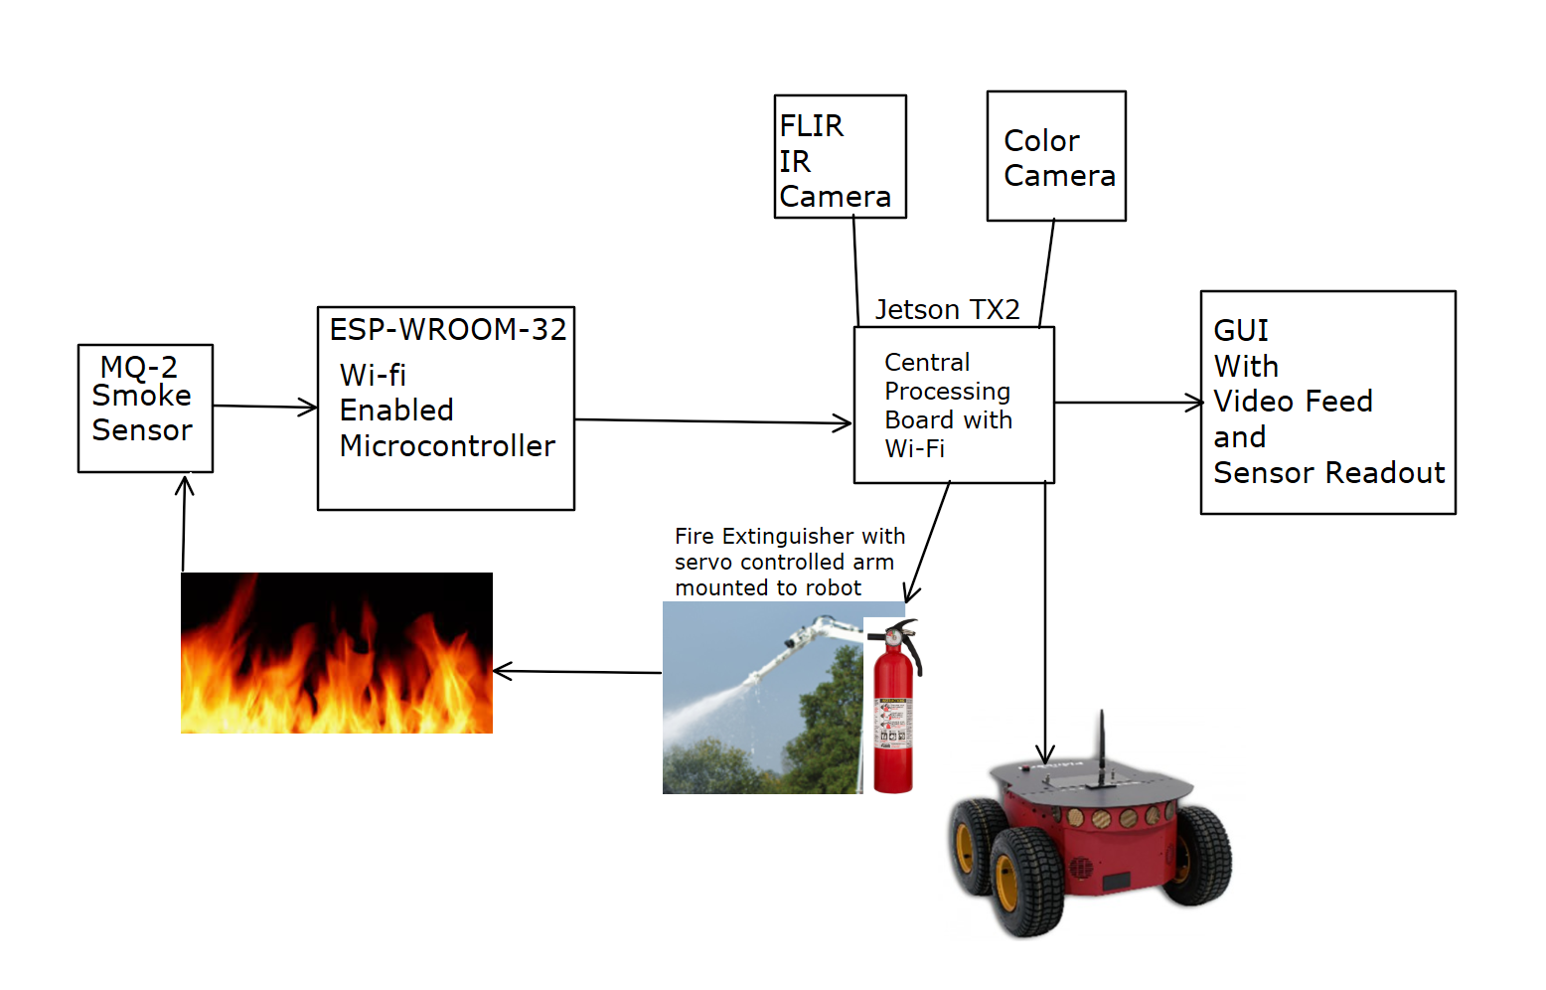

**Figure 1.** Initial block diagram.

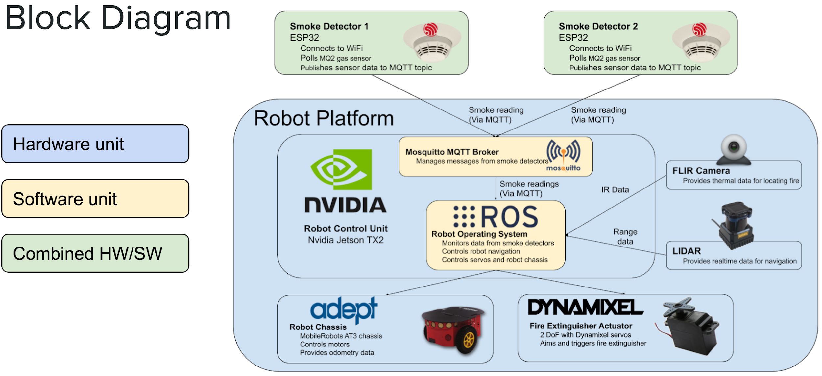

**Figure 2.** Final implementation block diagram.

Our critical paths were heavily influenced by the hardware we were able to acquire, with certain hardware enabling a much quicker design process than others. With that said, below is a list of off-the-shelf and pre-fabricated components we used, and how they simplified our design process.

|  |  |  |
| --- | --- | --- |
| **Table 1. Off-the-shelf components and software** | | |
| **Component** | **Purpose** | **Benefit** |
| Pioneer 3-AT | Robot chassis | Provided 5v and 12v power, a physical structure to mount our hardware to, and simple motor controls via a serial connection |
| Nvidia Jetson TX2 | Robot control unit | Full-featured embedded computer running Ubuntu. Enabled us to run ROS (described below) and interface with hardware components over USB |
| FLIR Lepton and PureThermal 2 | IR Camera | Allowed us to identify a fire using simple temperature measurements, rather than using computer vision to identify the flicker of the flames. This saved a substantial amount of time with algorithm development. |
| RX-28 servos and controller | Robot actuator system | Provided simplified control over the position and force of our aim servos, making them simple to integrate with our control code in ROS |
| Robot Operating System (ROS) | Robotics software framework | Provided an extensive set of libraries for sensors (FLIR, LIDAR), control (Pioneer chassis, servos), and navigation, as well as a framework for parallel execution and cross-device message passing |
| ESP32 Devkit | Wifi-enabled microcontroller | All-in-one solution for fire detector prototyping, including USB programming, networking, and GPIO for sensors and feedback devices. |
| Mosquitto MQTT broker | Messaging broker software | Allowed us to use the simple MQTT messaging protocol to pass messages between the smoke detectors and the robot (or any other networked device) |

Given the components we selected, our main tasks to accomplish were the following:

* Configuring ROS to work with the robot chassis
* Configuring ROS navigation libraries to optimize localization and path-planning for the robot
* Implementing the overarching control system for the robot’s behavior
* Interfacing with our sensors (and getting meaningful flame information from the camera)
* Developing a physical system to allow the robot to aim and spray a fire extinguisher
* Implement software to control the aim and actuation system
* Reading smoke sensor values on the ESP32 and pass messages from MQTT to ROS
* Accessing the sensor and hardware control nodes into the main control node.
* Physically mounting our components to the robot

A majority of the items above can be completed in parallel, but we did have one particular critical path that had to be addressed. Navigation and fire search were expected to take several weeks each, and the latter was dependent on the former. Final testing could not start without both of these being complete, so we needed to make sure we could finish them early enough to give us time to test before our demo. However, we would not be able to mount the Jetson to the robot until after the final physical design had been established and the necessary parts had arrived to mount it. To avoid this setback, we instead acquired a laptop to run our control code until we were able to mount the jetson. This not only allowed us to start work on navigation much earlier, but it also allowed us to develop directly on the device and to visualize the data from the localization and mapping libraries, to ensure that the robot was functioning properly. Once the navigation configuration had been optimized, we ported it over to the Jetson and were able to immediately start running more thorough tests of the system. Since the smoke detector code, camera interface, and fire extinguisher controls had all been implemented independently and in parallel by different members of our team, the system was able to be developed without waiting on the navigation or central controller components. Each of these components is discussed in more detail below, including the smoke detector hardware and software, all of the various subsystems of the robot, and a few of the limitations and compromises we had to contend with.

### 4.1.1 Fire/Smoke Detector

The fire detectors are similar in many ways to a traditional residential smoke detector. They can be mounted to a wall or ceiling, and are powered by 5v internal battery. They poll a smoke sensor and communicate with Jetson TX2 through MQTT, so a low-power chip with wireless connectivity has been implemented. See Appendix C for source code, configuration documents, and datasheets.

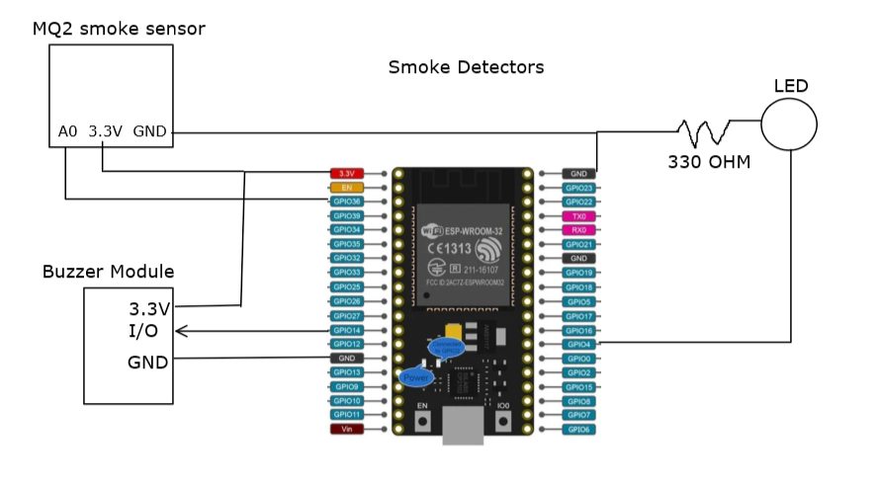

**Figure 3.** Initial block diagram of the smart smoke detector. This implementation did not work due to voltage requirements for the input pins of ESP32 and MQ2 smoke sensor.

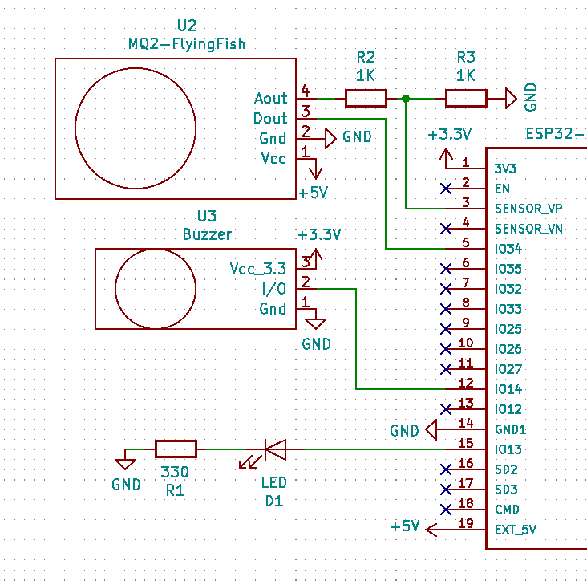

**Figure 4.** Final schematic of smoke detectors.

The voltage level issues from previous designs have been solved by hooking MQ2 sensor up directly to 5v rail from voltage input to ESP 32, and using a voltage dividing circuit to reduce the 5 v output from MQ2 into 3.3 V for the analog in pin of ESP 32.

#### 4.1.1.1 Sensors

There are a number of different sensors which could be appropriate for a smart fire detector depending on acceptable price range. A traditional smoke sensor is the cheapest option. This is only triggered after the fire has generated sufficient smoke to be detectable in the air in the room. Based on consultation with first responders, household fires generate a large amount of smoke before flames become significant, so a standard smoke sensor should perform well.

The sensor that we used was the Hanwei MQ-2 smoke chemiresistor gas sensor to sense smoke. This sensor takes 5v to power, and can output 5v analog or digital outputs. It also contains an LED, which lights up when smoke threshold is reached.

**Figure 5.** The prototyped smoke detectors on a breadboard followed by the prototype of the custom printed circuit board.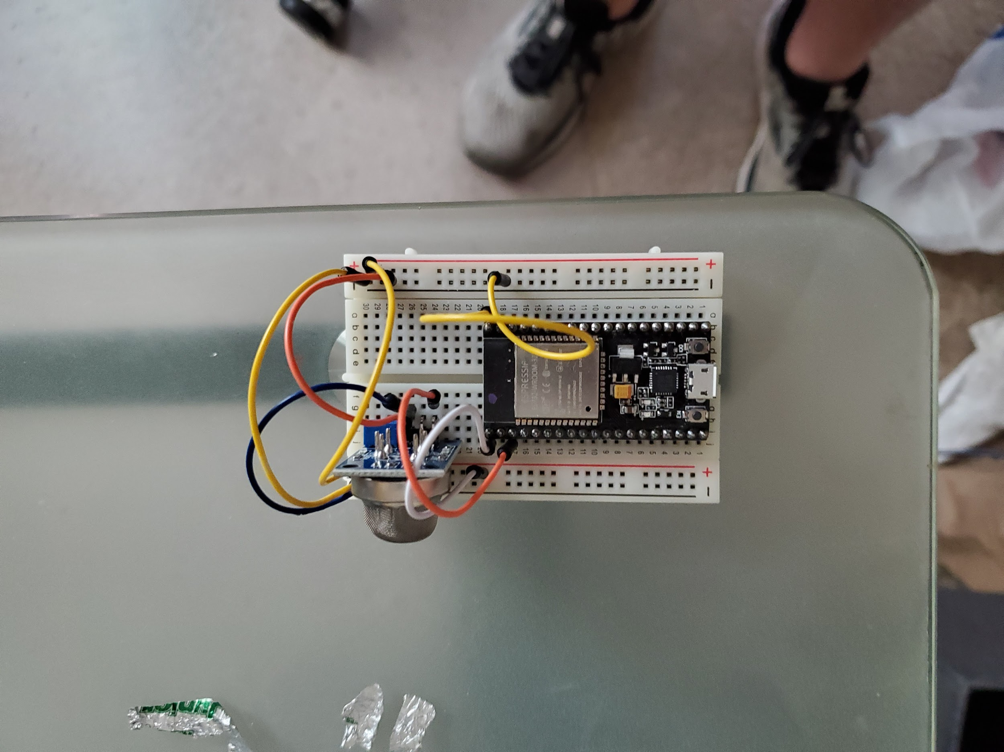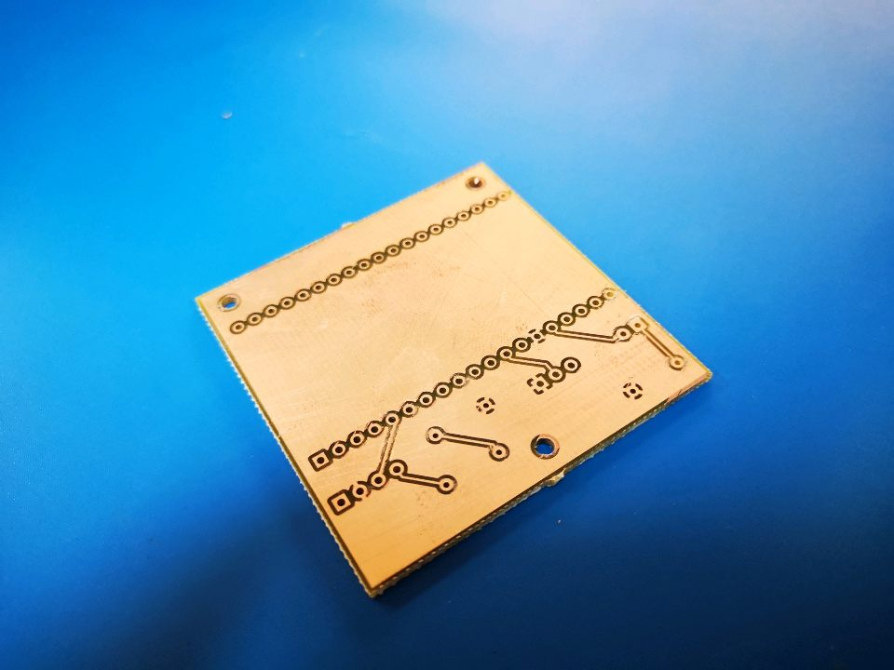

The final prototype for the fire/smoke detector was manufactured at The Hive, Georgia Tech's Electronics Makerspace. The printed circuit board layout was designed according to the final schematic of the smoke detectors. The PCB was then laser etched and drilled using double sided PCB with no solder mask. Afterwards, the components were soldered onto the PCB and all the connections were thoroughly tested.

#### 4.1.1.2 Networking

There are several wireless networking protocols available for use with household embedded systems, including Z-wave, Zigbee, and 802.11 WiFi as the top competitors. The former two offer much lower power modes of operation and can function in a decentralized mesh. The latter offers simpler integration with existing network infrastructure. Since the fire detectors will likely be wired into the house’s electrical system, power consumption will not be particularly relevant, and the ease of deployment afforded by WiFi makes it more attractive than the other two alternatives. Connecting the detectors via WiFi enables them to communicate directly with any device on the network, making it possible for the user to interface with them directly if desired. It also allows the central server device to operate with just a traditional network interface, instead of needing to incorporate a Zigbee or Z-Wave adapter.

The final design decision was to use a direct WiFi connection between the ESP32 chip and the Jetson TX2. The Mosquitto MQTT protocol is running on the Jetson as the broker, and the ESP 32 publishes to topics maintained by the broker. A challenge for this part of the design was how to convert the MQTT topic over to a ROS topic. To solve this, we used a ROS package called MQTT-Bridge. This allows an MQTT message to be converted to a ros topic or vice versa, and is configured with a .yaml file.

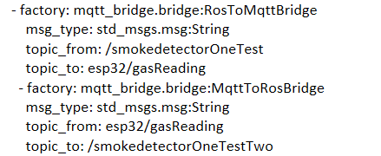

**Figure 6.** Example of the format of the MQTT-Bridge configuration file.

### 4.1.2 Robot

The robot platform was a MobileRobotics Pioneer 3-AT platform, operated by an Nvidia Jetson TX2 computer. The robot was powered by batty and hosted two 5 volt and two 12 volt ports, which we used to power the other components of our system including the Hokuyo 2D LIDAR and the Jetson TX2. By using measurements of the robot and the LIDAR with the Robotic Operating System (ROS) package AMCL the robot was able to self-localize within a known map of the home to perform navigation to a room once the corresponding smoke detector has alerted.

#### 4.1.2.1 Navigation

Navigation of the robot operates with a provided static map which can be created by either using a home floor plan or driving the robot around the house and using the LIDAR to map. The 2D LIDAR is used to localize the robot within the map and to identify and avoid unexpected obstacles using the ROS Navigation Stack. The robot localizes in the map using the ROS package AMCL, a probabilistic algorithm that gives good results for initial localization within a static map, but not while navigating. For this reason another ROS package was used for localization while navigating called Hector SLAM. The ROS Navigation stack is used to plan paths through the fixed map to the room where the fire was detected.

**Figure 7.** ROS 2D Navigation Stack planning robot path through floor plan with rainbow lines showing walls detected by LIDAR.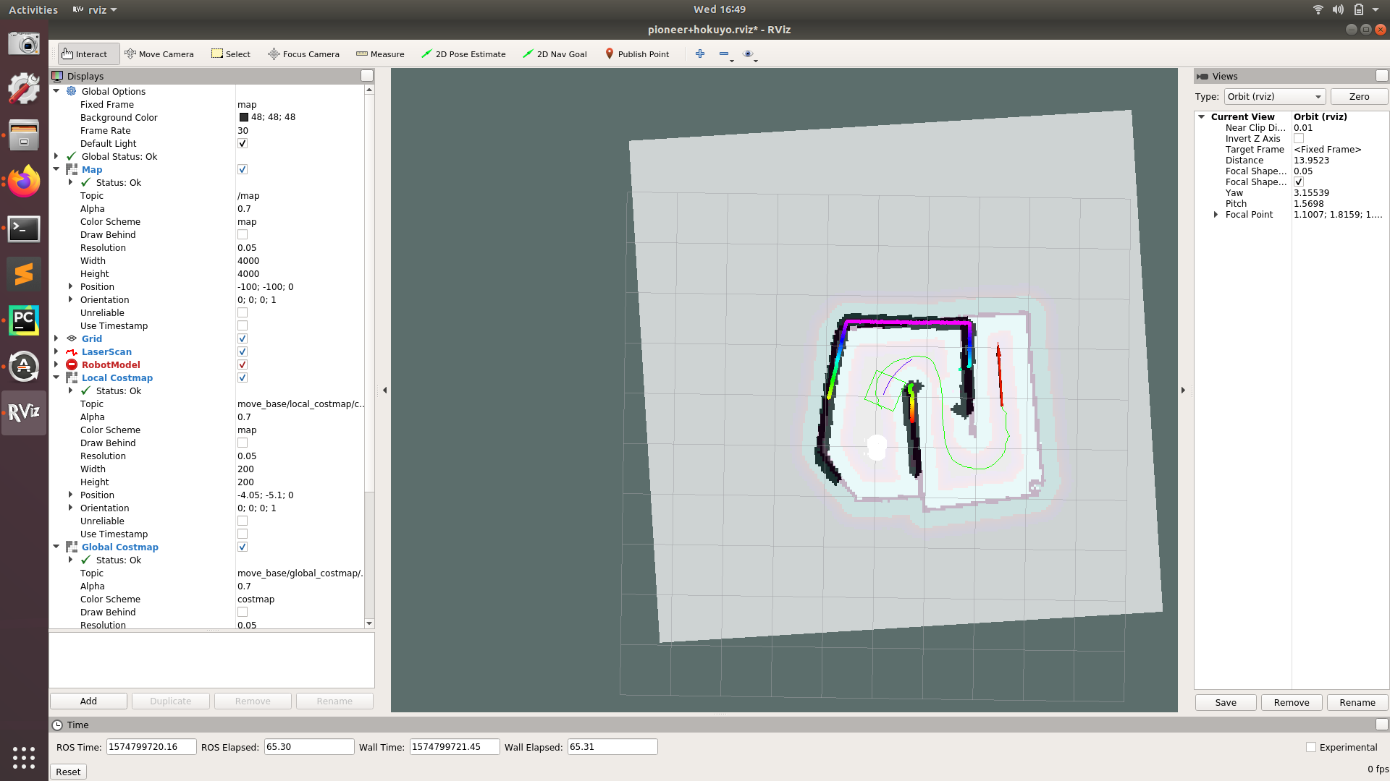

#### 4.1.2.2 Fire Searching, Recognition, and Positioning

Once the robot reaches the room where the fire detector was triggered, it needs to locate the flames and aim the fire extinguisher at them. In order to do this, it needs to be able to recognize flames and determine their approximate location in space. For this purpose, two different options were implemented and tested: an IR camera (FLIR Lepton 2.5 with a USB breakout board) and a color camera (Logitech C922).

The algorithm used for the color camera was based on the paper “A real-time video fire flame and smoke detection algorithm” [19]. Part of this algorithm was a simple flame color detection model using the HSV space. However, flame motion features were also considered to avoid detecting non-fire objects that are fire colored. Three steps of processing were used for the detection of flame motion features: frame differential method, foreground accumulation, and block image processing. Frame differential method was first used to isolate the moving pixels of the images. More specifically, the foreground image was determined by comparing consecutive frames to a selected threshold. Then, the foreground images that appear in the same regions during consecutive time windows were detected using a type of counter. Finally, block image processing was implemented using the known fire flickering frequency between 2 Hz and 12 Hz and a sampling rate of 25 frames per second.

The algorithm for the FLIR Lepton 2.5 was much simpler. Since the FLIR Lepton 2.5 is radiometric, the values that were read from the camera were already calibrated and were able to be used directly to be compared to a threshold of fire temperature determined by testing. As a result, the FLIR Lepton was able to provide the coordinates of the hottest part of the fire efficiently. When compared to the color camera, both in terms of efficiency and accuracy, it proved to be superior and our final design used the FLIR Lepton for fire search, recognition and positioning.

#### 4.1.2.3 Fire Suppression

In order to effectively respond to and suppress a fire, the robot needed to be fitted with a fire suppression device and be able to aim the device at the fire and activate the device. The first design decision was selecting what kind of device to use. The device needed to be able to fit on the robot, weigh less than the robot’s maximum payload of 20 kg, and be able to be used or deployed while the robot is 10 feet away from a fire. Potential solutions are shown in the morph chart Figure ?. One possible suppression device is a conventional fire extinguisher for use in a home or industrial setting. Another possible device is a fire extinguisher ball that bursts upon contact with a fire, releasing a fire suppressing powder.

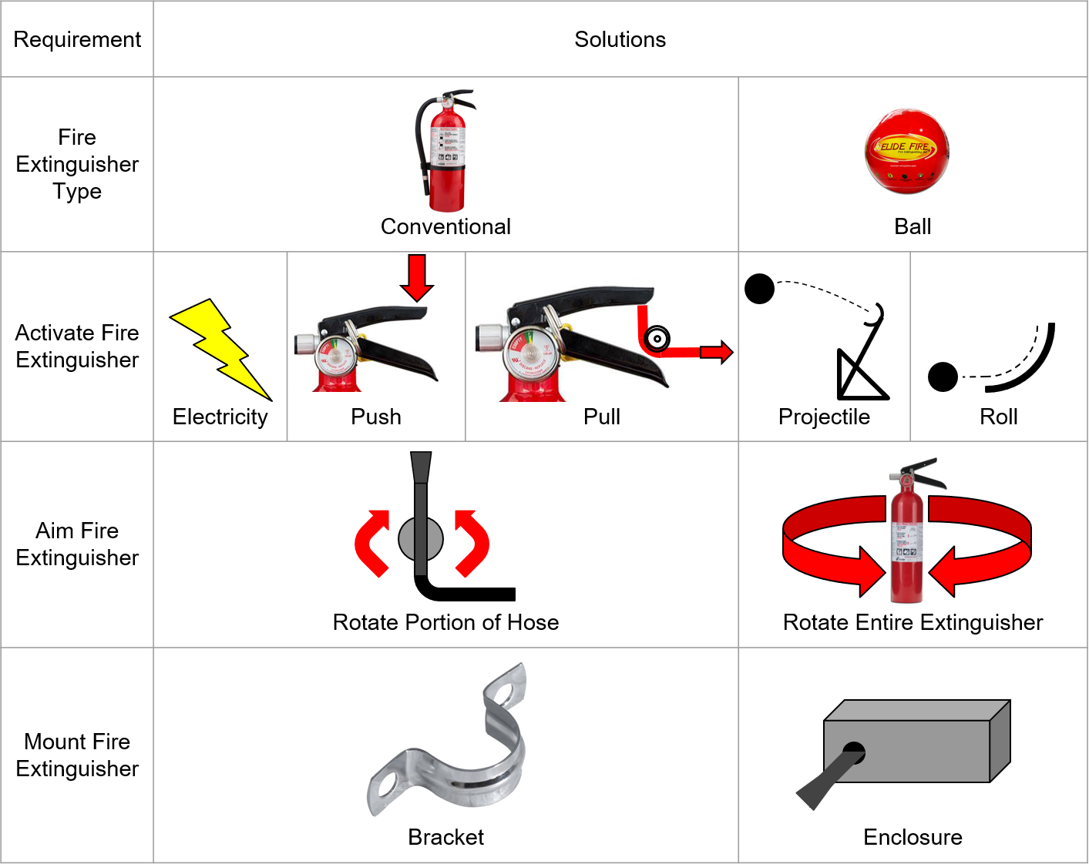

**Figure 8.** Fire Suppression Morph Chart.

A 5 lb ABC dry chemical fire extinguisher was chosen as the fire suppression device for the robot since it is a cost-effective solution that can reach fires located at height, and is easier to aim reliably than a projectile device. Additionally, it can be refilled and reused after deploying, and also enabled the team to test the aiming system without activating the extinguisher.

Aiming the fire extinguisher was accomplished by mounting the nozzle to a servo oriented to tilt the nozzle up and down while the robot’s wheel rotated to direct the nozzle at the fire. This aiming sequence was made possible with the help of IR camera that was attached onto the nozzle clamp, which provided feedback of the hotspot coordinate in respect to its field of vision. With the data obtained from the IR camera, both the servo and the wheels pan and tilt the nozzle and the camera aligning the hotspot to the designated coordinate that represent the nozzle aim, which was X = 300 pixels and Y = 220 pixels with 20 pixels of error margin. The P-type feedback control used in the servos helped counter any motion produced by the extinguisher while deploying. Additionally, the frame was also made out of aluminum, a stiff material, to prevent deflection. Once the nozzle was aligned, the extinguisher was activated using a servo fitted with a reel of cord which pull the handle. The extinguisher was mounted to the robot using a bracket design to mount to vehicles.

The aiming subsystem required a mechanism that could secure the nozzle of the extinguisher to the servo and elevate the servo to ensure the nozzle could rotate fully without hitting the robot. An overview of the subsystem is shown below, in Figure 8 and mechanical drawings for each part are shown in Appendix D.

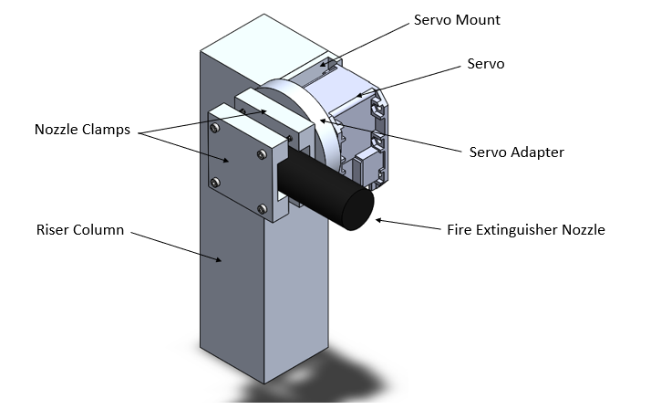

**Figure 8. Aiming Subsystem**

The activation subsystem needed to be able to squeeze the fire extinguisher handle to activate the extinguisher using a servo. In order to accomplish this, servo-mounted reel was designed and attached to the robot using the same servo mount shown above. An overview of the activation subsystem can be found in Figure 9 and a picture of the completed Fire Suppression Assembly is shown in Figure 10.

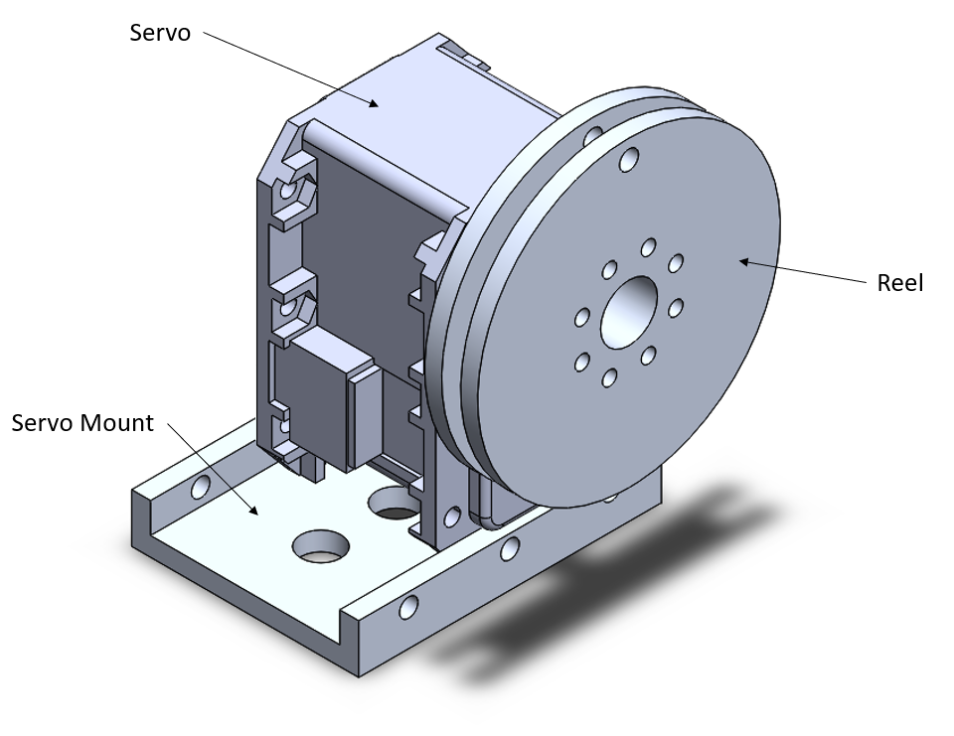

**Figure 9. Activation Subsystem**

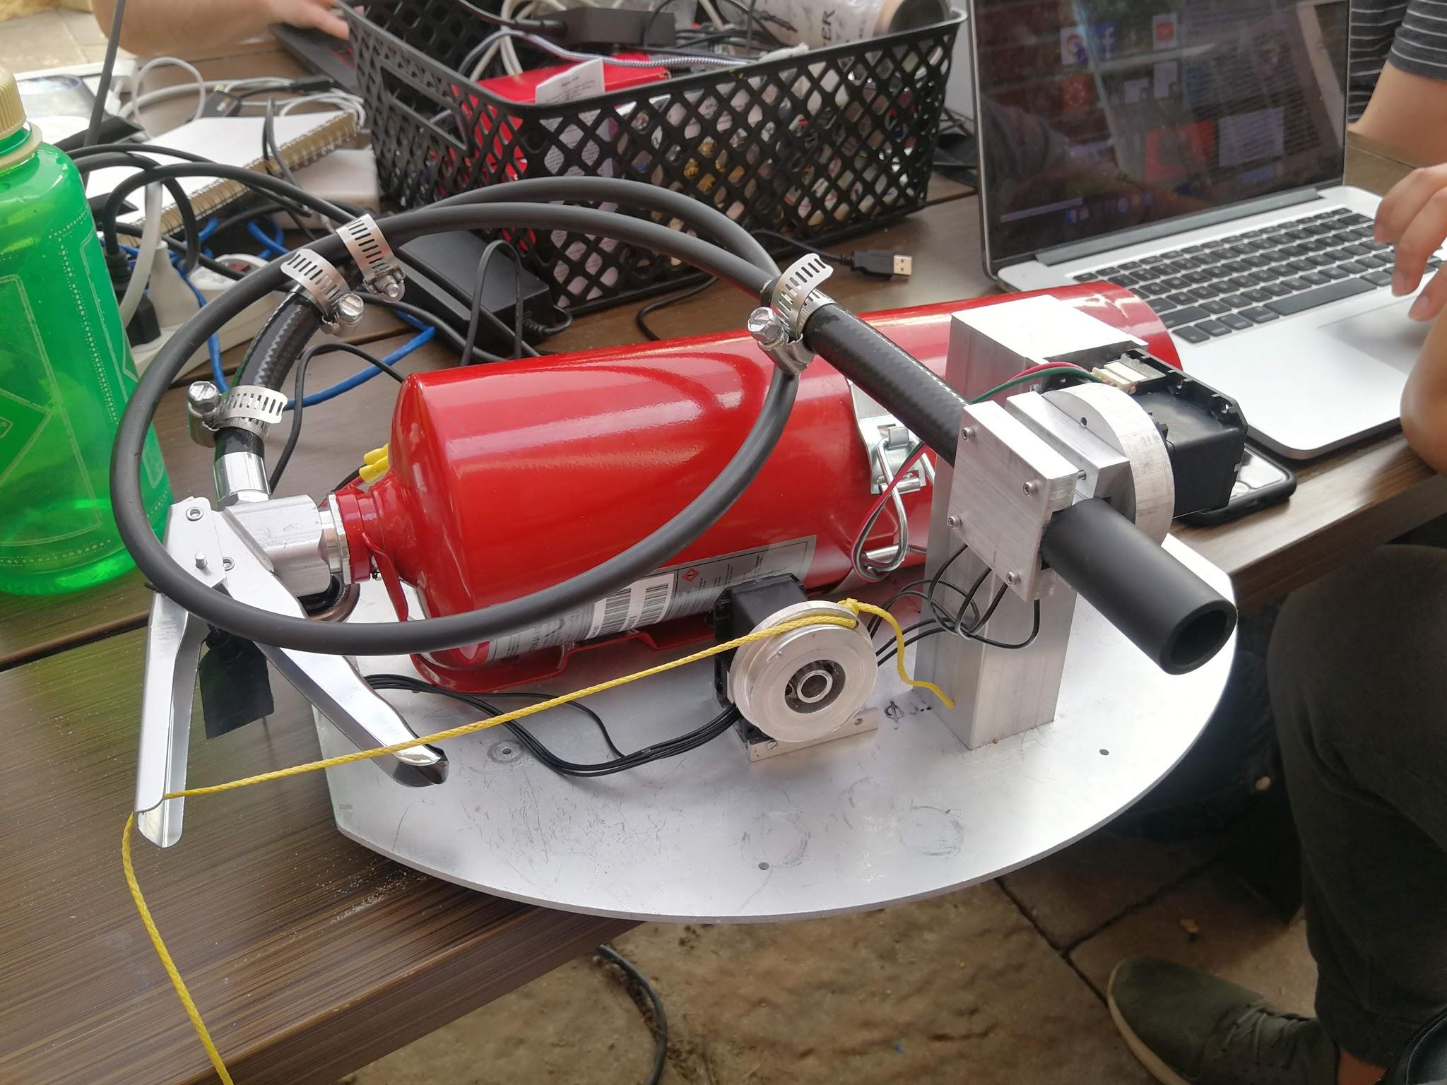

**Figure 10. Completed Fire Suppression System**

## 4.2 Codes and standards

The available wireless standards for networking are ZigBee, Z-Wave, IEEE 801.22 WiFi. Reviewing each standard characteristics led us to choose the Espressif ESP32 chip for the wifi smoke detectors. The National Fire Protection Association (NFPA) codes and standards also need to be adhered to. This is what led us to choosing to use an actual fire extinguisher, rather then trying to build a pump and a reservoir to manually pump fire suppressant onto the fire. Lastly, the Robotic Operating System (ROS) has a standard for how ROS packages are written which will be followed for our project’s software development as it will be deployed as a ROS package. Also for any open source software that is used, like ROS, its license must be included in our project.

## 4.3 Constraints, Alternatives, and Tradeoffs

There have been a number of limitations imposed on this project to maintain a realistic scope, and several tradeoffs have been implemented to accommodate. To restrict cost and potential development time for the robot chassis itself, the scope for the proof-of-concept has been restricted to handling fires in single-story areas without closed doors. A multi-story space would require the robot to traverse stairs, and closed doors must be breached in some manner. By restricting the project to exclude those scenarios, a cheaper, less mobile platform can be used, and no development time must be spend on a manipulator for door handles.

A tradeoff that our team encountered was the method of localization used when the robot is navigating to the detected fire location and searching for fire. Our first inclination was to explore the option of using lidar and a Simultaneous Localization and Mapping (SLAM) algorithm for localization during navigation. However, upon further research, we realized that lidar performs poorly in smoky conditions and so our team decided to switch from a SLAM approach to performing navigation by localization via a fixed map of the home floor plan preloaded to the robot beforehand. The tradeoff for this design decision was having to completely change the method of navigation and obstacle avoidance in order to increase system reliability.

For the computer vision part of this project, using a webcam was considered because of the lower cost of a webcam compared to the FLIR Lepton 2.5. However, after an algorithm consisting of frame differential method, color detection, foreground accumulation as well as block image processing was tested and compared with the performance of the FLIR Lepton, the color camera was deemed insufficient for our purposes.

Some constraints were also met when working on the fire suppression system. The two major constraints in regards to the part design were the amount of physical space available on the robot and the flexibility of mechanically interfacing with the Dynamixel RX-28 servos used for aiming and activation. These servos were selected for their ability to provide high torque in a very small footprint, proportional feedback control, and availability to the team. Additional constraints considered included price, the robot’s maximum payload, and ability to withstand heat. The material used for parts was chosen using these criteria and 6061-T6 aluminum was selected due to its high melting point and strength, ease of machinability, and low weight and cost.

# 5. Schedule, Tasks, and Milestones

The Gantt chart in Appendix A shows the tasks that we completed through the course of this project plus the start and end dates for each. The PERT chart in Appendix B shows our original expected flow and dependencies with optimistic, most likely and pessimistic time estimates for each task. Using the PERT chart, the critical path was determined to be 85 days, due to the expected complexity of fire search. Following our actual timeline, the critical path was along the navigation and executive control path, which took a total of 96 days due in large part to unforeseen issues with localization.

## 5.1 Task Breakdown and Contributions

### 5.1.1 Smoke Detectors

The smoke detector work was not risky in the sense of timing, but was integral to the function of the system as a whole. On the critical path for this section, we had to hook up the parts, get data from the sensor, connect the microcontroller to the network, and transmit the sensor data over MQTT. The first two steps were completed before the beginning of the semester, so the majority of the time during the semester was spent on networking. There were also a number of adjustments that had to be made to both the sensor connections and the code to improve the accuracy of the smoke detection. These items were all handled by Zack. Off of the critical path for the smoke detectors was the development of a custom PCB and enclosure, which was a joint responsibility of Chris and Thomas.

### 5.1.2 Navigation and Control

The robot navigation and control was one of the riskiest sections of this project. It was already expected to be on the critical path, and it was vital to our final product. The navigation configuration and testing was predominantly handled by Natalie and the executive control code was a joint responsibility of Thomas and Adrian. Though we expected the search and navigation to be the longest sections, navigation proved to be even more complicated than we expected and was constantly beset by issues with our serial connection to the robot, forcing us to shift some time away from fire search and into troubleshooting navigation.

### 5.1.3 Imaging and Flame Detection

Cameras and image processing was completely handled by Deniz. This work was fairly evenly split between troubleshooting/testing the various cameras we tried and developing algorithms to extract meaningful data from them. Unfortunately, the FLIR cameras we initially tested experienced issues with connectivity, and the color cameras both had serious issues with exposure. This was a relatively risky section of the project, since we could not test the fire search code until flame detection was working, but fortunately the code written to test the buggy FLIR cameras worked almost perfectly on the replacement we bought. Adrian then adapted the code to interface with our control node, allowing us to start testing fire search.

### 5.1.4 Mechanical Subsystem

The mechanical system to aim and actuate the fire extinguisher was predominantly Ryan’s responsibility, with input from Ricky. This was an important, but not particularly risky section. Ryan’s timeline was very reasonable and gave plenty of time to design, machine and mount the parts. One of the longest hangups for this section was in trying to source a solenoid-controlled fire extinguisher, which we ended up giving up on. Fortunately, Ryan had already developed a design to allow us to trigger a traditional extinguisher, so he was able to implement that quickly when the time came.

### 5.1.5 Servo Control

The electrical side of the aim and actuate system was Ricky’s responsibility, with Adrian and Thomas helping with ROS integration. He sourced the servos and worked with Ryan to determine the appropriate way to mount everything so as to avoid overloading them. Once the servos and their controller arrived, he set up an interface to allow us to control them through ROS and wrote a ROS node to aim and trigger the extinguisher based on the data from the camera. Most of the delays in this section were because the code could not be tested without the camera and servo mounts installed.

### 5.1.6 Testing and Deliverables

The final testing, troubleshooting, and demo phases were a group effort, as was the majority of the work on the deliverables. Each member contributed to the presentation, proposal, demo, poster, presentation, and final report. With that said, the website was exclusively handled by Chris, and most of the diagrams in the deliverables were generated by the people assigned to the appropriate area of the project.

# **6. Final Project Demonstration**

During final testing, the following capabilities were validated:

* navigating a space with a preloaded fixed map while avoiding obstacles
* correctly identifying the location of the fire using the FLIR Lepton
* using a fire extinguisher to respond to the fire.

Navigation as implemented nearly met the desired specifications. Lidar range was adequate as the specification was chosen knowing that a specific lidar would be used. The robot successfully avoided obstacles and navigated a static map. The only shortfall was regarding navigation speed, which was reduced to 1.6 ft/s from the target of 2 ft/s to improve localization reliability. Given that the robot already slows down to navigate corners and avoid obstacles, a slight reduction in peak driving speed did not meaningfully affect the robot’s capabilities.

Because of time constraints, we did not meet any of our stretch goals regarding sending live updates to firefighters. The robot does not include a video camera and does not send map updates.

It was not possible to demonstrate all of these steps live during the Design Expo because of safety concerns and space constraints. However, multiple videos were recorded to show the full operation of the robot.

Indoor navigation and obstacle avoidance of the robot was conducted at a team member’s house. Depending on which of the two fire detectors was triggered, the robot was shown to be able to navigate autonomously to the corresponding room in the house.

To simulate a house, an obstacle course made out of plywood was built outdoors. One portion of the course was preset as a room, where a controlled fire was started. In the video of this demo, the robot can be seen starting navigation around the plywood space. After searching for, detecting, and aiming at the fire, the robot triggers the extinguisher to extinguish the fire.

Fire extinguisher aiming was tested independently of navigation. Before the system was assembled, our aiming strategy was validated by testing it only on the x-axis. Once the servos were connected, two-axis aiming was tested. A video was recorded to show the fire detection and tracking done with the infrared camera. In this video, the camera detects the fire source and publishes its coordinates. Servos aim the fire extinguisher nozzle on the y-axis and the robot chassis is rotated to aim the x-axis.

Demo references:

* Simulated house: <https://drive.google.com/file/d/1TA5q66Cg6hRbFG6dTxBxzhVrYnGpFc9L/view?usp=sharing>
* Static map: <https://drive.google.com/file/d/14hh5mqV23r9nwNQl2PuEcb8It_KwS375/view?usp=sharing>
* Final demo - ground view: <https://drive.google.com/file/d/17wPbhudX7xUhC9A6TNTZuv2cQo4cTH2T/view?usp=sharing>
* Final demo - expo video: <https://drive.google.com/file/d/1o4_NYj-cTK-lObqmImZoduCSgZTmsHy1/view?usp=sharing>
* Fire search testing: <https://drive.google.com/file/d/1onaxvKfHbzela0LZOFsVsos6t4FgXUeR/view?usp=sharing>

# **7. Marketing and Cost Analysis**

## 7.1 Marketing Analysis

Following the fact that, on average, seven people died in U.S. home fires per day, according to a report published by the National Fire Protection Association (NFPA), between 2012 to 2016, 355,400 incidents of home structure fires are responded annually, causing an annual average of 14,230 civilian fire deaths and injuries, and $6.5 billion in direct property damage [7]. Furthermore, according to the data collected by NFPA, 25% of residential fire spread beyond the room of origin [8], which indicates the need for an efficient residential first responder. Combining with the data that 42% of all reported firefighter injuries occurred at the fire ground, which include muscular pain, wound, cut, bruise, bleeding, smoke inhalation, and many more physical strain [9], the need of robotic fire responder seem to be even more prominent. Some companies do offer similar product, such as the Turbine Aided Firefighting machine (TAF 20), which cost AUD$ 310,000 (~USD$ 230,000) to build [10]. However, this robot is designed to be suitable for professional use rather than residential, since it needs to be piloted by a trained operator, such as the fire fighter, through remote control, has a size of approximately a golf cart, and, not to mention, the high building cost that might not fit commercially. These in turn make our prototype to be the ideal product for residential use since it is smaller and autonomous.

## 7.2 Cost Analysis

The total cost of developing an autonomous residential fire fighter robot prototype is estimated to be $49,096.92 involving a team of 8 engineers being paid with typical engineer starting salary, which was assumed to be $70,000.00 ($35.00/h). Factoring out the labor cost, the total cost in parts and components, which prices are estimated and obtained through various suppliers that are available to the institute, needed while developing the prototype are estimated to be $796.92, which is lower than the true cost of $12,043.53. This cost differences happened because some of the expensive components are available as loanable resources, which are free of charge. Table 4 and Table 5 summarized the cost of developing the prototype:

|  |  |  |  |  |  |
| --- | --- | --- | --- | --- | --- |
| **Table 4. Prototype Components Cost** | | | | | |
| **Item** | **Type** | **Qty** | **Unit Price**  **($)** | **True Cost**  **($)** | **Actual Cost**  **($)** |
| **Fire Detector** | | | | | |
| ESP-WROOM-32 [CA1] | Microcontroller | 2 | 3.80 | 7.60 | 7.60 |
| Grove MQ-2 [CA2] | Smoke Sensor | 2 | 6.90 | 13.80 | 13.80 |
| **Fire Suppression System** | | | | | |
| Dynamixel U2D2 [CA3] | Motor Controller | 1 | 49.90 | 49.90 | 49.90 |
| FLIR Lepton 2.5 [CA4] | Thermal Camera | 1 | 239.95 | 239.95 | 239.95 |
| PureThermal 2 [CA5] | Smart I/O Module | 1 | 99.99 | 99.99 | 99.99 |
| Dynamixel RX 28 [CA6] | Servo Actuator | 2 | 209.90 | 419.80 | Loaned |
| 5.0 Ah LiPo Battery [CA7] | Power Supply | 1 | 32.81 | 32.81 | Loaned |
| **Robot** | | | | | |
| Powered USB 3 Hub [CA8] | USB Hub | 1 | 18.99 | 18.99 | 18.99 |
| Hokuyo UTM-30LX [CA9] | Lidar | 1 | 4,500.00 | 4,500.00 | Loaned |
| Nvidia JETSON TX2 Developer Kit [CA10] | Embedded Computer | 1 | 299.00 | 299.00 | Loaned |
| Pioneer 3-AT [CA11] | Robot Chassis | 1 | 5,995.00 | 5,995.00 | Loaned |
| **Custom Parts’ Material** | | | | | |
| Aluminum Bar 3/8" x 1-1/2" x 2 ft [CA12] | Material | 1 | 10.28 | 10.28 | 10.28 |
| Aluminum Disc 2" Diameter x 1/2" [CA13] | Material | 4 | 4.21 | 16.84 | 16.84 |
| Aluminum Bar 1-1/2" x 1-1/2" x 1 ft [CA12] | Material | 1 | 19.06 | 19.06 | 19.06 |
| **Miscellaneous** | | | | | |
| Plywood 4 ft x 8 ft. [CA14] | Demo materials | 8 | 13.23 | 105.84 | 105.84 |
| Lumber 2 in. x 6 in. x 8 ft [CA15] | Demo materials | 4 | 5.57 | 22.28 | 22.28 |
| 5lb ABC Dry Chemical Fire Extinguisher [CA16] | Fire Extinguisher | 3 | 64.13 | 192.39 | 192.39 |
| **Total Cost ($)** | | | | **12,043.53** | **796.92** |

|  |  |  |
| --- | --- | --- |
| **Table 5. Prototyping Labor Cost** | | |
| **Prototype Development Task** | **Labor Hours** | **Labor Cost [$35.00/h] ($)** |
| Robot Navigation Design | 300 | 10,500 |
| Fire Search and Detection Infrastructure | 320 | 11,200 |
| Fire Detection Processing Implementation | 330 | 11,550 |
| Servo Control System Design | 130 | 4,550 |
| Fire Extinguisher Enclosure and Mechanism Design | 70 | 2,450 |
| Testing/Debugging | 70 | 2,450 |
| Group Meetings | 160 | 5,600 |
| **Total (Group of 8)** | **1,380** | **48,300** |
| **Total (Individual)** | **172.50** | **6,037.50** |

To estimate an appropriate selling price for this product, assumption is made that 5000 units of the autonomous robots are to be sold in a period of five years, and the total development cost of $49,096.92 are to be amortized over all of these units. Labor cost is estimated to be $50.00 for each unit assuming 5 labor hours are needed to assemble and test each unit. 30% of Fringe benefits and 120% of overhead will also be a factor in. In addition, it is estimated that $500,000.00 sales expenses will be spent to market the product. It is expected that a profit of $1,337.43 (5% of the total cost) is to be made from each unit.

|  |  |
| --- | --- |
| **Table 6. Product Selling Price** | |
| **Development Component** | **Cost**  **($)** |
| Assume: 5000 units sold in 5 years | |
| Parts Cost | 60,217,650.00 |
| Labor Cost (Assembly and Testing) | 250,000.00 |
| Fringe Benefits, % of Labor | 75,000.00 |
| **Subtotal** | 60,542,650.00 |
| Overhead, % of Material, Labor, and Fringe | 72,651,180.00 |
| **Subtotal, Input Cost** | 133,193,830.00 |
| Sales Expense | 500000.00 |
| Amortized Development Cost | 49096.92 |
| **Subtotal, All Cost of 5000 units** | 133,742,926.92 |
| Profit (5% of Total Cost) | 6,687,146.35 |
| **Selling Price (Per Unit)** | **28,086.02** |

# **8. Conclusion**

The primary aim of this project was to make a positive impact on society by reducing loss of life, harm, and property damage to victims of house fires and first responders. In order to accomplish that goal, we sought to develop an autonomous fire suppression robot that would respond to fires in homes before first responders would be able to arrive and without any intervention from the occupants of the house. In many ways, we reached our goals for this project, but there are specific areas where our final result falls short. We successfully met the majority of our specifications, responding to fires in a matter of seconds, and nearly met our desired navigation speed. Our fire detectors promptly notify the robot when smoke is present, and the robot reacts as intended. However, there are caveats and areas of improvement associated with all of these successes.

Our navigation, though fairly quick and often effective, is not completely consistent. Due to the robot chassis’s poor odometry and our limited array of sensors, the robot has a hard time localizing in the map consistently and will sometimes have trouble getting around corners. The fire detectors, though very effective, still rely on smoke, meaning that they may not be able to detect certain types of smokeless fires in the home, and may not be able to detect them as early as a more expensive thermal sensor could. Our fire search was limited by the capabilities of our camera and by the time we had, and may not be effective in rooms larger than 15 feet in radius or in rooms without clear lines of sight (eg, lots of furniture or an island).

To extend this project, or to attempt it again, a future team should start by explicitly laying out their intended scope and then selecting sensors, hardware, and team members to meet the scope, rather than limiting the scope to meet the hardware’s capabilities. The issues we faced could have been at least partially avoided by setting out from the start with a clear sense of what sensors we would need to use to accomplish the various tasks. The proper tools for the job may be more expensive, but they will also enable the final result to be much more effective and generalizable, whereas our product is somewhat limited. We have met our intended goals, but the next level of this project would need to be effective in a broader range of cases and should be reliable enough to work in the real world. The project would likely need a larger budget or access to a broader array of hardware to borrow, otherwise the system will still be limited by its chassis and sensors, and only incremental improvements will be possible. Progress can be made by simply investing more time into the project that we have started, but it is not likely to make a real difference in the world without a substantially expanded scope.

## 8.1 Sustainability and Contemporary Issues

The use of aluminum parts in the design allows the material to be recycled at the end of service life, reducing environmental impact. Additionally, all parts purchased for use in the project comply with RoHS (Restriction of Hazardous Substances Directive) ensuring that hazardous materials, particularly lead containing electronics, are not present.

# **9. Leadership roles**

Team Lead/Navigation: Natalie Rakoski

Network Integration: Zachary Elliott

Documentation/Control System Design: Ricky Marscel

Sensor Integration/PCB design/Webmaster: Chris Wang

Expo Coordination/System Integration: Thomas Wyatt

Computer Vision Lead: Deniz Bozkurt

Mechanical Component Design/Production: Ryan Avery

# **10. References**

[1] E. Evarts, “Fire Loss in the United States During 2017,” nfpa.org, 2018. [Online]. Available: www.nfpa.org/-/media/Files/News-and-Research/Fire-statistics-and-reports/US-Fire-Problem/osFireLoss.pdf

[2] B. Lattimer, “Robotics in Fire Fighting,” *sfpe.org*, 2015. [Online]. Available: https://www.sfpe.org/page/FPE_ET_Issue_100/Robotics-in-Firefighting.htm. [Accessed: April 18, 2019].

[3] E. Tsardoulias and P. A. Mitkas, “Robotic frameworks, architectures and middleware,” 2017. [Online]. Available: https://www.researchgate.net/publication/321180717_Robotic_frameworks_architectures_and_middleware_comparison. [Accessed: March 1, 2019].

[4] J. W. Starr, B. Y. Lattimer, “A Comparison of IR Stereo Vision and LIDAR for use in Fire Environments,” 2013. [Online]. Available: https://ieeexplore.ieee.org/document/6411591. [Accessed: March 5, 2019].

[5] S. Wirth, J. Pellenz, “Exploration Transform: A stable exploring algorithm for robots in rescue environments,” 2013. [Online]. Available: https://www.uni-koblenz.de/~agas/Documents/Wirth2007ETA1.pdf.

[Accessed: March 7, 2019].

[6] A. Çetin, B. Merci, O. Günay, B. Töreyin and S. Verstockt, Methods and techniques for fire detection.

Academic Press, 2016.

[7] M. Ahrens, “Home Structure Fires,” *nfpa.org*, Dec. 2018. [Online]. Available: https://www.nfpa.org/News-and-Research/Data-research-and-tools/Building-and-Life-Safety/Home-Structure-Fires.

[8] M. Ahrens, “ Reported Structure Fires by Extent of Fire Spread, Occupancy and Loss Rates,” *nfpa.org*, Mar. 2013. [Online]. Available: https://www.nfpa.org/-/media/Files/News-and-Research/Fire-statistics-and-reports/Building-and-life-safety/OSStructureFiresbyExtentofFlameSpread.ashx?la=en.

[9] B. Evarts and J. L. Molis, “United States Firefighter Injuries 2017,” *nfpa.org*, Nov. 2018. [Online]. Available: https://www.nfpa.org/-/media/Files/News-and-Research/Fire-statistics-and-reports/Emergency-responders/osffinjuries.pdf.

[10] S. Gerathy, “Australia's first fire-fighting robot unveiled for summer bushfire season,” *adc.net.au*, Dec. 9, 2015. [Online]. Available: https://www.abc.net.au/news/2015-12-10/australias-first-fire-fighting-robot-unveiled-for-summer/7017660.

[CA1] “ESP32-WROOM-32,” *mouser.com*. [Online]. Available: https://www.mouser.com/ProductDetail/Espressif-Systems/ESP32-WROOM-32?qs=chTDxNqvsyltcwz%2FUUJDtQ%3D%3D.

[CA2] “Grove - Gas Sensor(MQ2),” *seeedstudio.com*. [Online]. Available: https://www.seeedstudio.com/Grove-Gas-Sensor-MQ2.html.

[CA3] “U2D2,” *robotis.us*. [Online]. Available: http://www.robotis.us/u2d2/

[CA4] “FLIR Radiometric Lepton Dev Kit,” *sparkfun.com*. [Online]. Available: https://www.sparkfun.com/products/14654

[CA5] “PureThermal 2 - FLIR Lepton Smart I/O Board,” *sparkfun.com*. [Online]. Available: https://www.sparkfun.com/products/14670

[CA6] “Dynamixel RX-28 Robot Actuator,” *trossenrobotics.com*. [Online]. Available: https://www.trossenrobotics.com/dynamixel-rx-28-robot-actuator.aspx

[CA7] “Turnigy 5000mAh 4S1P 14.8V 20C Hardcase Pack,” *hobbyking.com*. [Online]. Available: https://hobbyking.com/en_us/turnigy-5000mah-4s1p-14-8v-20c-hardcase-pack-1.html

[CA8] “Powered USB Hub 3.0, atolla USB Hub with 4 USB 3.0 Data Ports and 1 USB Smart Charging Port, USB Splitter with Individual Power Switches and 5V/3A Power Adapter,” *amazon.com*. [Online]. Available: https://www.amazon.com/dp/B07MQDJLSF/

[CA9] “Hokuyo UTM-30LX Scanning Laser Rangefinder,” *robotshop.com*. [Online]. Available: https://www.robotshop.com/en/hokuyo-utm-03lx-laser-scanning-rangefinder.html

[CA10] “JETSON TX2 Education Discount,” *nvidia.com*. [Online]. Available: https://www.nvidia.com/object/jetsontx2-edu-discount.html

[CA11] “Educational Price List,” *cse.sc.edu*, Nov. 11, 2004. [Online]. Available: <https://cse.sc.edu/~matthews/Courses/510/Kits/EduPrices.pdf>

[CA12] “Multipurpose 6061 Aluminum Sheets and Bars,” *mcmaster.com*. [Online]. Available: https://www.mcmaster.com/aluminum-alloy-6061

[CA13] “Multipurpose 6061 Aluminum 2” Diameter,” *mcmaster.com*. [Online]. https://www.mcmaster.com/1610t15-1610T114

[CA14] “11/32 in. x 4 ft. x 8 ft. Rtd Southern Yellow Pine Plywood Sheathing,” *homedepot.com*. [Online]. Available: https://www.homedepot.com/p/11-32-in-x-4-ft-x-8-ft-Rtd-Southern-Yellow-Pine-Plywood-Sheathing-112590/100003677

[CA15] “2 in. x 6 in. x 8 ft. #2 Prime Ground Contact Pressure-Treated Lumber,” *homedepot.com*. [Online]. Available: https://www.homedepot.com/p/WeatherShield-2-in-x-6-in-x-8-ft-2-Prime-Ground-Contact-Pressure-Treated-Lumber-253921/206967808

[CA16] “Dry Chemical Fire Extinguisher,” *mcmaster.com*. [Online]. Available: https://www.mcmaster.com/6430t14

[19] C. Yu, Z. Mei and X. Zhang, "A Real-time Video Fire Flame and Smoke Detection

Algorithm", Procedia Engineering, vol. 62, pp. 891-898, 2013. Available: 10.1016/j.proeng.2013.08.140.

# **Appendix A - Project Gantt Chart**

# 

# **Appendix B - PERT Chart**

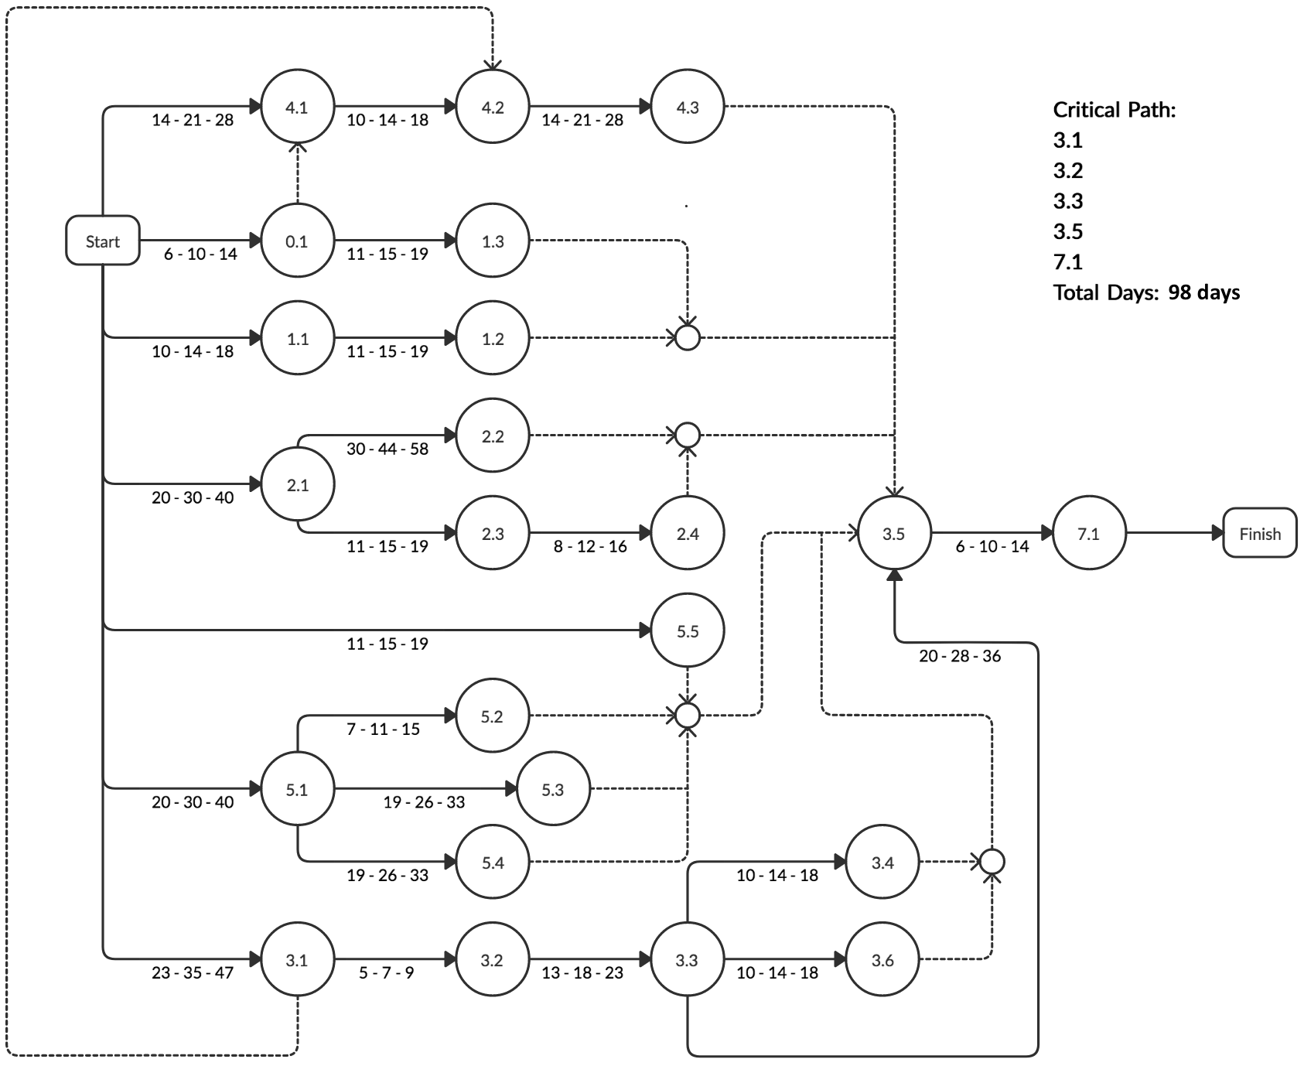

# **Appendix C - Smoke Detectors**

## Smoke Detector on chip source code:

#include <WiFi.h>

#include <PubSubClient.h>

#include <Wire.h>

#include <Adafruit_BME280.h>

#include <Adafruit_Sensor.h>

//Wifi network for ESP32 to connect to

const char* ssid = "wifiNetwork";

const char* password = "wifiPassword";

//MQTT Broker IP address:

const char* mqtt_server = "MQTTBrokerIPAddress";

WiFiClient espClient;

PubSubClient client(espClient);

long lastMsg = 0;

char msg[50];

int value = 0;

float gasReading = 0; // Declare and Initialize the Gas Sensor code.

// Define the Pin numbers for various devices.

const int ledPin = 13;

const int PushButton = 23;

const int gasSensor = 36;

const int buzzerPin = 14;

const int gasSensorDigital = 34;

int freq = 2000;

int channel = 0;

int resolution = 8;

char initializationString[24] = {'{', '"', 'd','a','t','a','"',':','"','0','"','}'};

char fireDetectedString[24] = {'{', '"', 'd','a','t','a','"',':','"','1','"','}'};

void setup() {

Serial.begin(115200);

ledcSetup(channel, freq, resolution);

ledcAttachPin(buzzerPin, channel);

setup_wifi();

client.setServer(mqtt_server, 1883);

client.setCallback(callback);

pinMode(buzzerPin, OUTPUT);

pinMode(ledPin, OUTPUT);

pinMode(PushButton, INPUT);

pinMode(gasSensor, INPUT);

pinMode(gasSensorDigital, INPUT);

}

void setup_wifi() {

delay(10);

// We start by connecting to a WiFi network

Serial.println();

Serial.print("Connecting to ");

Serial.println(ssid);

WiFi.begin(ssid, password);

while (WiFi.status() != WL_CONNECTED) {

delay(500);

Serial.print(".");

}

Serial.println("");

Serial.println("WiFi connected");

Serial.println("IP address: ");

Serial.println(WiFi.localIP());

}

void callback(char* topic, byte* message, unsigned int length) {

Serial.print("Message arrived on topic: ");

Serial.print(topic);

Serial.print(". Message: ");

String messageTemp;

for (int i = 0; i < length; i++) {

Serial.print((char)message[i]);

messageTemp += (char)message[i];

}

Serial.println();

// If a message is received on the topic esp32/output, you check if the message is either "on" or "off".

// Changes the output state according to the message

if (String(topic) == "esp32/output") {

Serial.print("Changing output to ");

if(messageTemp == "on"){

Serial.println("on");

digitalWrite(ledPin, HIGH);

}

else if(messageTemp == "off"){

Serial.println("off");

digitalWrite(ledPin, LOW);

}

}

}

void reconnect() {

// Loop until we're reconnected

while (!client.connected()) {

Serial.print("Attempting MQTT connection...");

if (client.connect("Detector1Client")) {

Serial.println("connected");

// Subscribe

client.subscribe("esp32/output");

} else {

Serial.print("failed, rc=");

Serial.print(client.state());

Serial.println(" try again in 5 seconds");

// Wait 5 seconds before retrying

delay(5000);

}

}

}

int digitalGasReading = 0;

int mqttInitialized = 0;

int warmUpComplete = 0;

void loop() {

gasReading = analogRead(gasSensor);

digitalGasReading = digitalRead(gasSensorDigital);

while(!warmUpComplete){

if(digitalGasReading){

warmUpComplete = 1;

sleep(30);

}

digitalGasReading = digitalRead(gasSensorDigital);

}

if (!client.connected()) {

reconnect();

}

long now = millis();

if (now - lastMsg > 2000) {

if(!mqttInitialized){

Serial.println("publishing initializationString");

client.publish("esp32/gasReading", initializationString);

mqttInitialized = 1;

sleep(2);

}

if(digitalGasReading == 0){

Serial.println("Are in the smoke threshold block");

ledcWriteTone(channel, 2000);

client.publish("esp32/gasReading", fireDetectedString);

digitalWrite(ledPin, HIGH);

}else{

digitalWrite(ledPin, LOW);

ledcWriteTone(channel, 0);

}

lastMsg = now;

// Convert the value to a char array

char tempStringTwo[8];

Serial.print("Gas Reading: ");

Serial.println(fireDetectedString);

Serial.println(digitalGasReading);

Serial.println(gasReading);

}

client.loop();

}

## Smoke detector module data sheets

### ESP32

<https://www.espressif.com/sites/default/files/documentation/esp32_datasheet_en.pdf>

### MQ2 Smoke Sensor

<https://www.pololu.com/file/0J309/MQ2.pdf>

### Buzzer

<https://www.electrokit.com/uploads/productfile/41015/Active_Piezo_Buzzer.pdf>

# 

# **Appendix D - Mechanical Drawings, Exploded Views, and Bill of Materials for Fire Suppression System**

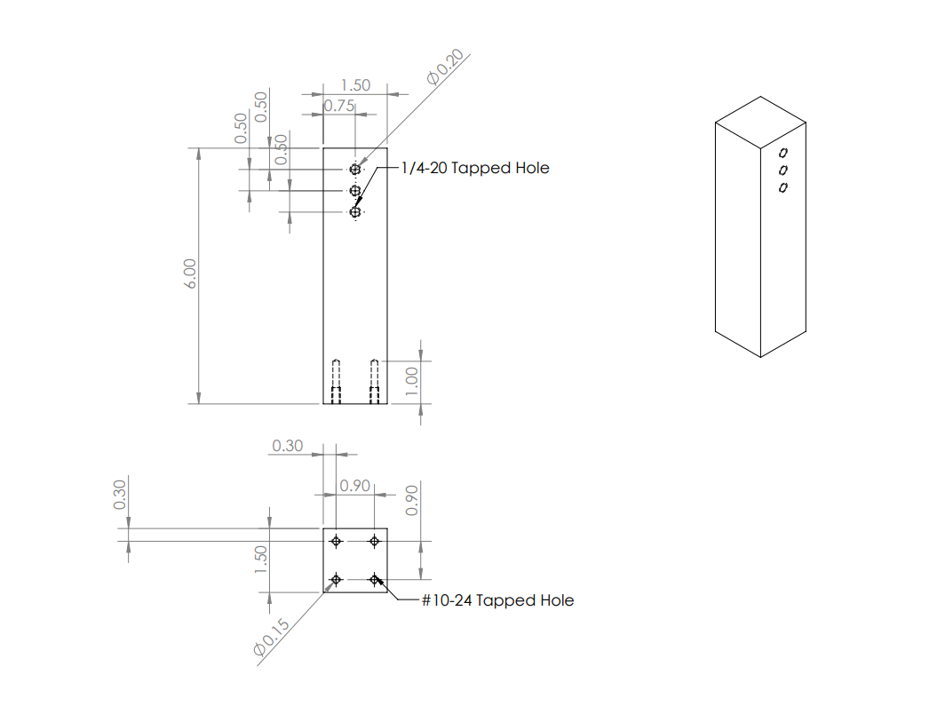

Riser Column

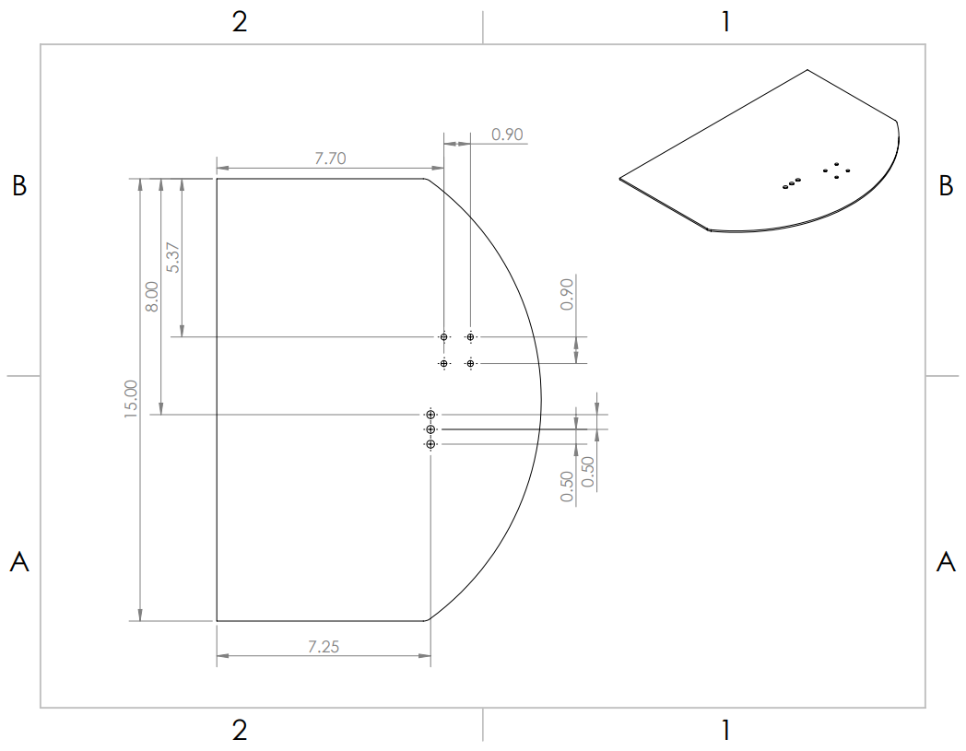

Robot Mount Plate

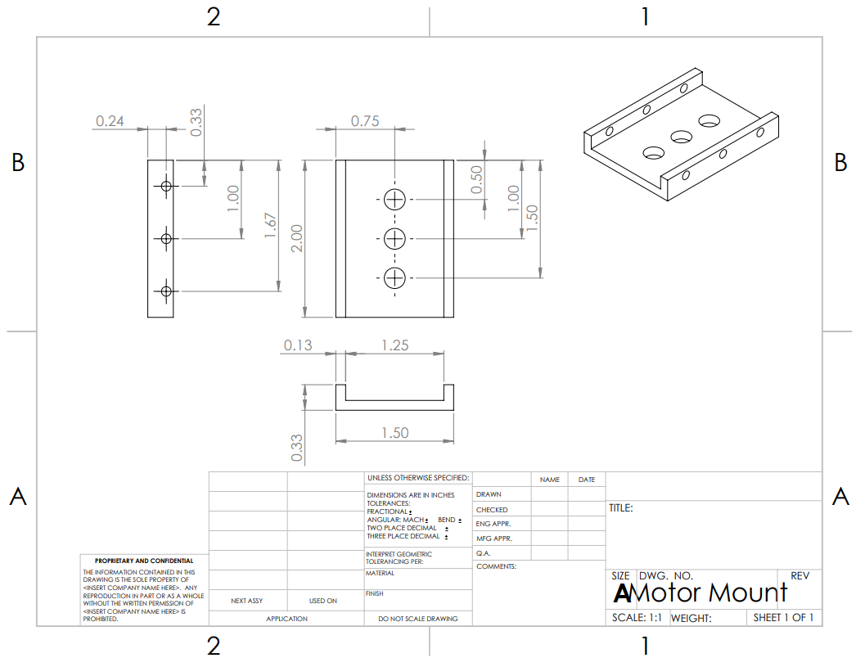

Servo Mount

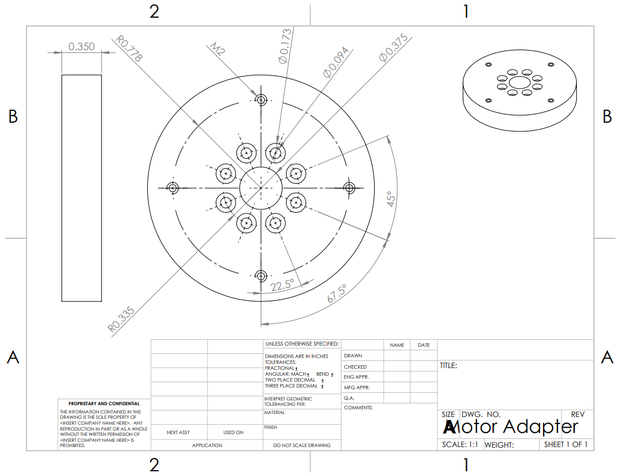

Servo Adapter

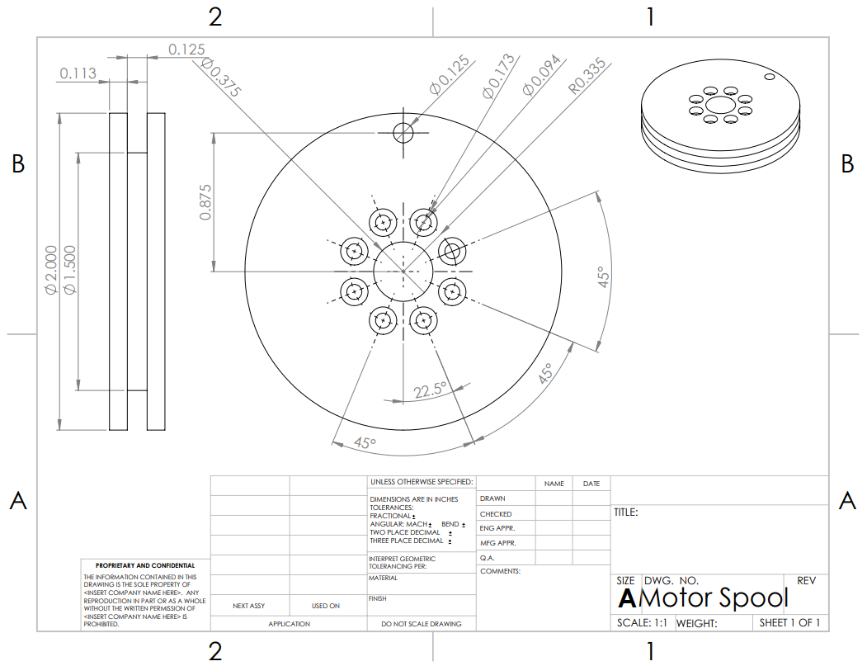

Servo Reel

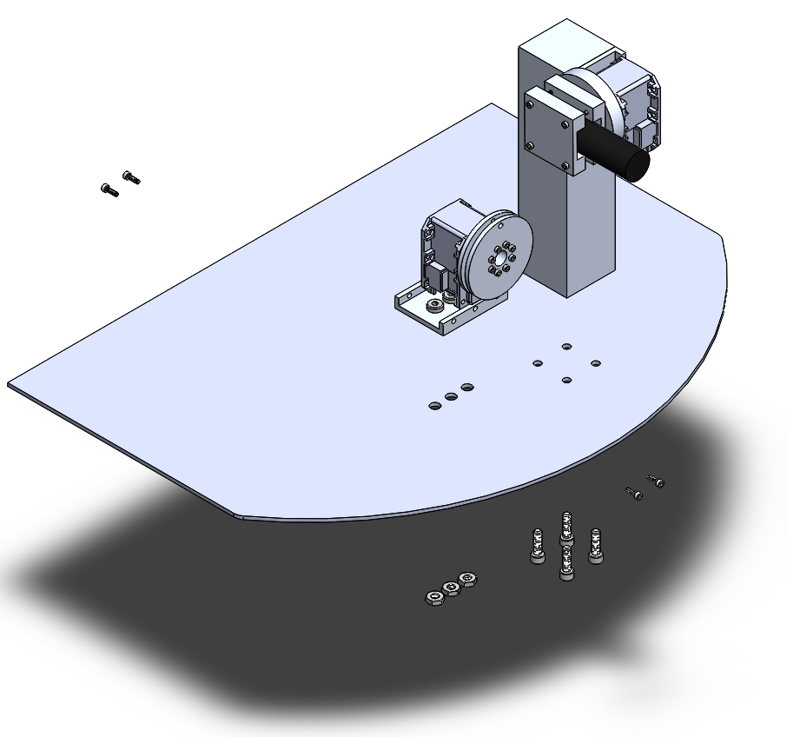

Assembly Exploded View

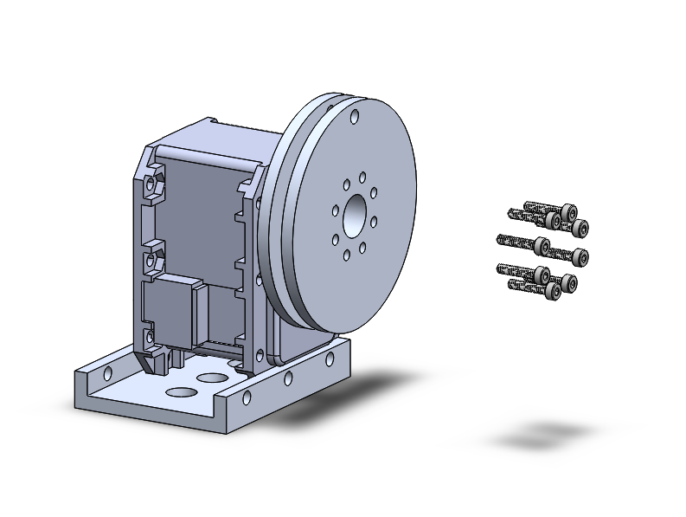

Activation Subassembly Exploded View

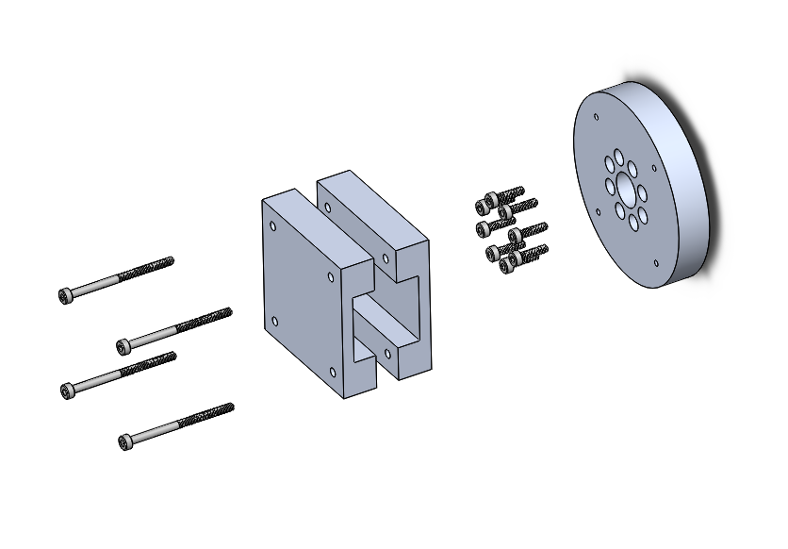

Aiming Subassembly Exploded View

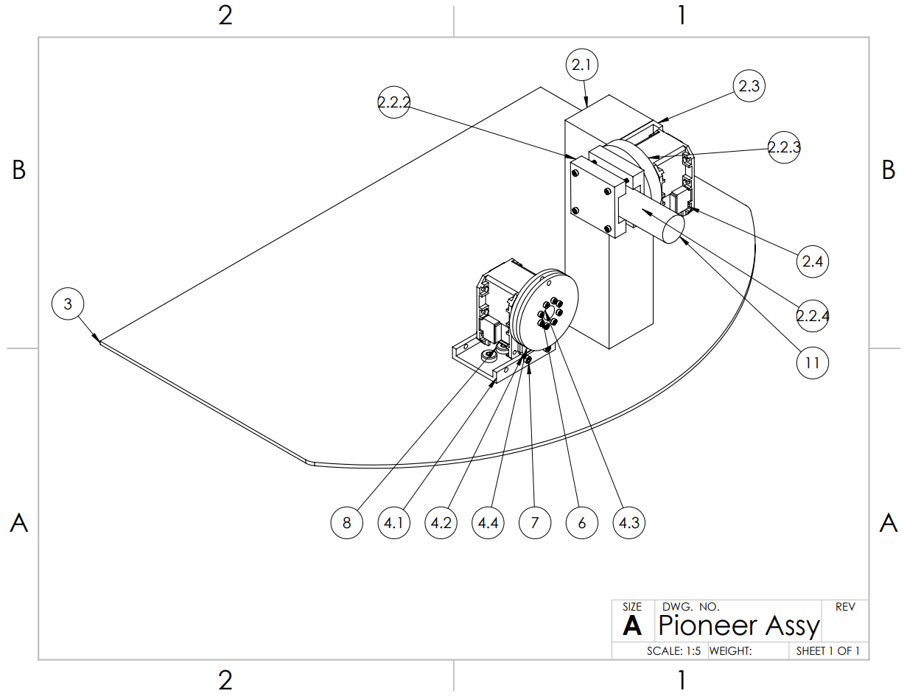

Fire Suppression Assembly Drawing

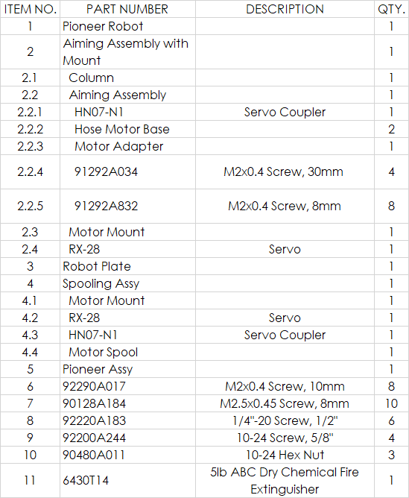

Fire Suppression Bill of Materials